|  |
| --- |
| University of Reading  Ph.D. Dissertation  on |
| The Transmission of Wireless Power by Magnetic Resonance |
|  |
| Submitted by |
| Christopher A. Tucker |
| c.a.tucker@pgr.reading.ac.uk  Thesis Advisors  Prof. Kevin Warwick & Dr. William Holderbaum  School of Systems Engineering, University of Reading  23 March 2012 |
|  |

|  |
| --- |
|  |

Acknowledgements

For all those people who stood by me as I formulated what was to become this work. I especially would like to thank my lovely D.

Abstract:

The wireless transmission of power first surfaced in the late 19th Century in America. Exhibited in public venues as a marvel of wonder, it found no practical application at the time. After Marconi’s radio system became standard-bearer of wireless communications, wireless power was forgotten. The concept remained largely unexplored scientifically until the last ten years when it enjoyed resurgence. Since then, numerous persons have examined it at great length. However, few researchers currently undertake to specialize on the subject, which does not aid in maturation of the concept. In order to improve maturity and to hasten development, this document proposes a research project utilizing mid-range efficient inductive-transfer for the purposes of removing wired connections and electric contacts on spacecraft and equipment used in spacecraft. The method suggests possibilities of powering space compartments of fractionalized spacecraft, by powering devices on the other side of barriers, or any scenario where line of sight is not possible. It also implies that power could be projected to grid-coordinate positions in hermetically sealed circuits and systems. The project will contextualize research by a type of wireless power non-deleterious to human tissue, greatly aiding wireless recharging of life-support systems increasing the amount of time for space walks. It would also improve the capacities of available energy to tools and localized equipment tied to the spacecraft fuselage and work areas. The work involves investigation of a specific type of wireless power system wherein analysis will yield the construction of a prototype modeled as a singular technological artifact. It is through exploration of the artifact that forms the intellectual basis for not only its prototypical forms, but suggestive of variant forms not yet discovered. Through the process it is greatly clarified the role of the artifact, its most suitable application given the constraints on the delivery problem, and optimization strategies to improve the artifact.

The following has purpose to investigate the transmission of electrical currents manifest at a distance without wires. In expounding upon the role of magnetic resonance in a historical and modern sense, it will suggest several scenarios where it can be usefully applied.

This document will discuss the phenomenon of magnetic resonance and demonstrate valid methods to enhance coupling between electric-magnetic components, as well as magnetic-magnetic components.

Keywords:

Wireless power by magnetic resonance, loop antennas, circuit and field theory, wave propagation, power systems, human factors.

Contents

1 Introduction 8

1.1.1 Maxwell 9

1.1.2 Tesla 14

2 Magnetic resonant modes in a wireless-powered circuit 15

2.1 Coupled-modes 22

2.1.1 The coupling coefficient 26

2.1.2 Coupled-mode power 33

2.1.3 Efficiency, qualities, and losses 37

2.2 The circuit model 39

2.3 The propagation model 48

2.3.1 The receiving antenna 53

2.3.2 Radiated power 58

2.3.3 The field emissions 62

2.4 Multiple loop receivers in human proximity 66

2.4.1 Coupled-power modes 71

2.4.2 ac mode 72

2.4.3 dc mode 73

3 Conclusions 77

3.1 Comments on the subject matter 80

3.2 Future research 81

4 Appendix 81

4.1.1 Large figures and tables 82

4.1.2 RWG computational files 84

4.1.3 A short discussion of a dipole model 84

5 Literature survey 91

# Introduction

James Clerk Maxwell first theoretically predicted and proposed numerical solutions to Faraday in his *A Treatise on Electricity and Magnetism* to what later became known as radio waves in 1873. Within twenty years, Poynting further developed the mathematical context of the free-space field concept in 1884, Hertz first experimental confirmed the existence of electromagnetic waves in 1886, and Tesla, using more refined devices at higher potentials, demonstrated this work to the public at the IEE in London in 1892 and at the Chicago World’s Fair in 1893.

This sequence of events sparked a revolution: a revolution in the mechanization of generation, distribution, and transportation schemes of energy according to the laws of electromagnetism. Although electricity had been known in antiquity: The Parthians, during their occupation of Baghdad, had utilized electrical current for electroplating gold onto sliver statues between the 248 BCE and 226 CE, known to archaeologists as the Baghdad Battery. However, it remained a curiosity until the Renaissance; not until the 19th Century did it start to form as a field of science.

Electrical engineering, as it has evolved out of 19th Century science, has shown an extraordinary versatility as a means to describe the revolution in seemingly limitless technological archetypes: power, energy, heating, lighting, signaling, communications, and computation; as well as the expressions, those subsequent devices interfacing—either directly or indirectly—to the human form. It is the author’s belief humanity’s exploitation of electromagnetism is its most poignant accomplishment; the diversity of its manipulation will determine its fate.

As the reader will be no doubt familiar with the myriad archetypes of electromagnetism, this work will examine a single archetype: the wireless transmission of power and a single expression: the interfacing of wireless power to the human form. While a short historical introduction is due, the symbolic importance of the concept is relevant.

In the period preceding the First World War, several expressions of the interfacing between humans and wireless power appeared. One of the more common was direct interfacing at the hands where the energy was projected a light in order for it to be observed, similar to imagery appearing in the wizardry mythos, not unlike the stories of individuals purported to command the environment, casting thunderbolts as a sign of their power. The imagery served an important function in human society: 1. that the human form is more than the sum of its parts, and, 2. by clever manipulation, machines could be constructed to control the environment. Two embodiments are shown in Fig.1.1.

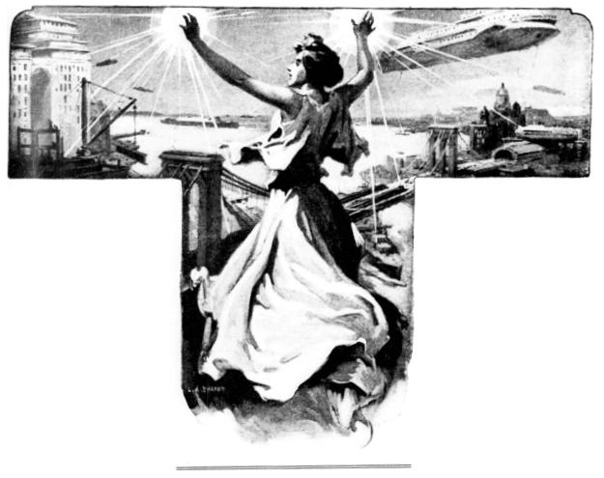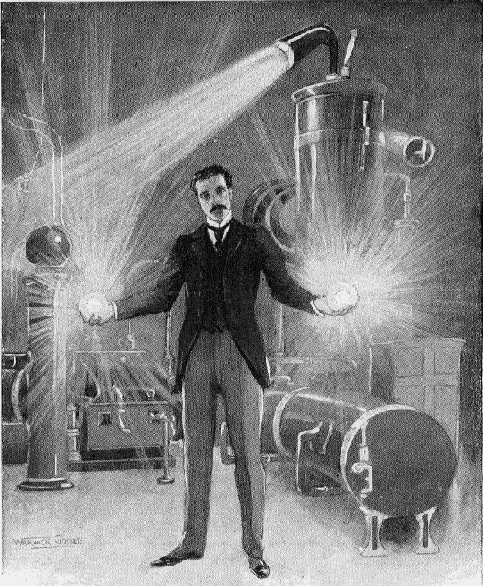

Fig.1.1. Wireless power as an extension of the human form.

Another expression, more deliberate and technical, was to interface the clothing to a source of energy to provide various lighting effects. The theme of each of the expressions is the same, the extension of human influence over the environment; it is this ability to control environmental forces, which facilitates survival.

While more than a hundred years have passed since the invention of wireless power and its introduction into society, the symbolism remains powerful and diverse. Meaning is derived from the symbolism that directly affects what form the machine will take. The challenge of encapsulating a single symbol and expressing easily transferable meaning is the dominant problem in this thesis. Because the topic is so open and calls into question many aspects of physics, including influences from quantum mechanics, it is prudent to focus attention around a single form of wireless power suggested to be universal. It is not intended the universality to be transferrable, rather, by choosing a simple model of fewest electrical components it is *inferred* to be a candidate for universality. Why spend the time for such an interest? By focusing attention around the simplest and most obvious expression, the topic is more clearly explained and more effectively mathematized while not sacrificing any intuitive essence.

The concept can be reduced to contain a majority of work expressed in theory by Maxwell and experimentally verified by Tesla.

### Maxwell

Maxwell’s equations have been widely discussed in the literature since the publication of *Treatise*. To focus attention, those components of Maxwell’s equations used define the electromagnetic quantities in this work are:

* The electric field  (in V/m).
* The magnetic induction  (in T).
* The density of electric charge  (in C/m3 ).
* The density of electric current  (in A/m2 ).

They currently take the vectorial form



while the electromagnetic constants are tied by the relationship



consisting of:

*   is the electric permittivity of the vacuum (in F/m).
*  is the magnetic permeability of the vacuum  (in H/m).
*     is the speed of light in a vacuum, termed Einstein's constant (in m/s).

It is one of the purposes of the author to bring to light an eccentricity of Maxwell’s concept visualized in a physical model first realized by Poynting. It is the hope of this work to advance a theoretical and specific singularity of the concept to start on an evolutionary path. This is not to imply that the author will introduce unorthodox postulates to account for the phenomenon in question, rather, to point out the correct descriptive language and accompanying scientific paradigm, which should be most centrally applied. One such immediate and rather pervasive conundrum is the notion of Maxwell’s equations. In their present and modern form, the vectorization by Heaviside describes moving charges sufficiently but does not describe the rotations of the energy in the field. The notion of the magnetic potential is a derivation from Lorenz when simplifying Maxwell’s equations. The original equations—20 equations with 20 unknowns—can be found in *Treatise*. While the reasons for Heaviside’s modification of Maxwell’s equations, in cooperation with Fitzgerald, Lorenz, and Hertz, suited engineering and physics in the 19th Century, modern methods and tools allow a reexamination of Maxwell’s mathematization of Faraday’s experiments; a foundation of electromagnetism with profound implications. One such is that tangible phenomenon described in Hamilton’s quaternions were left out in the truncation. One of the immediate and pressing questions is what forces counteract the permeation of magnetic fields between resonant objects. While it is clear such objects exchange energy across free-space, how does the nature of the disturbance define what is manifest? Additionally, what are those forces rotating in phase space, which support the potential field? Such fundamental if not altogether esoteric questions are posed in the hope to glean a pure understanding of the concept of wireless power using magnetic resonances, not only for the topic of the phenomenon itself, but also start to explore what constitutes free-space.

Such a colorful illustration is expected to provide detailed references on how the yield is a rudimentary model of the transportation of energy across free-space by magnetic resonance. Reasoning will be structured:

1. introduce an architecture of a particular scheme for form an effective model,
2. describe the model and its components,
3. propose methods to understand how the model is manipulated,
4. propose an experiment to test the methods,
5. discover the measurement criterion of performance of a prototype over a distance, and,
6. compare and contrast experimental results with other similar attempts.

Presentation following in its due course of an engineering-flavored scientific investigation demands the material be organized into a flow appropriate for oscillating system. The features are divided into three categories: circuits, fields and waves. As the author is aware of the thorniness of the paradigms between circuit and field analysis, the circuit model will be tested in an experiment of a working prototype. This will not only provide a concrete expression for the theoretical ponderings, but to also make the concept more tangible. For such an abstract concept, a cast of the meaning of the expression should exhibit both a form and a function. This process will enumerate

1. a circuit designed to emit electromagnetic radiation in a geometric pattern,
2. as a field pervasive in free-space with the ability to transmit modulated power and,
3. a wave description.

The wireless transmission of power is the result of individuals building machines that manipulated electrical currents and magnetic fields, therefore, it is interesting to also discuss a history of understanding the role of associated free electrons to construct radio waves. A stark reality is that everything to be invented already has been invented and all that remains are novel ways to mix the ingredients in a recipe. Since the recipe is relatively easy to create, what is missing is the context in which the purpose of the recipe is ultimately revealed. The mechanisms for understanding, however, are notoriously difficult.

The old masters deserve more direct attention [[1]].

The work of the Maxwellians, between the years after Maxwell’s death in 1879 to Hertz death in 1894, and the acceptance of Maxwell’s theory as widely understood by the scientific community is well documented [[2]]. Heaviside and Hertz banished the vector and scalar potential functions from electromagnetism as part of the truncation of Maxwell’s 20 equations with 20 unknowns. During the early 20th Century, the concept of the displacement current fell out of favor with numerous physicists calling them “useless concepts” [[3], [4]], as the displacement current did not deal with moving charges, espoused by J.J. Thomson during the discovery of the electron in 1897. Rather, it dealt purely with moving lines of force or a time-varying electric field, as its magnetic analog has the same function. Maxwell’s derivation is unrelated to the modern day derivation for displacement current in the vacuum, which is based on consistency between Ampère's law for the magnetic field and the continuity equation for electric charge. Maxwell imagined the displacement as a sea of molecular vortices existing in free-space. His interpretation, mechanical in nature, operates on the assumption of a luminiferous ether. However, when considering polarized circuits, the ambiguity in Maxwell’s derivation clears. The consequence of accepting the clarity is that there is a mechanical ether, rather, merely an exchange of forces, whose periodicity, suggests the ability to create artificial electrical structures with a polarization.

Once Maxwell's sea of molecular vortices had been abandoned in the 20th Century, along with the ether, an interpretation of displacement current evolved that treated free-space explicitly as a separation of free-space from material media, unlike Maxwell's original concept.[5] This is a feature associated with the potentials, relative to free-space [[6], [7]].

To begin simply: The magnetic field, given Lorentz calculated the magnetic field intensity, as a property of retarded time,



where  is relativistic time from the special theory. Equation does not need the displacement current to find an accurate solution. Velocity inhibition is one consequence, the other a contraction along the potential vector. Poynting commented on this important point in Maxwell’s theory [[8]]:

I am not sure that there has hitherto been any distinct theory of the way in which the energy developed in various parts of the circuit has found its way thither, but there is, I believe, a prevailing and somewhat vague opinion that is some way it has been carried along with the conductor by current. Probably Maxwell’s use of the term ‘displacement’ to describe one of the factors of the electric energy of the medium has tended to support this notion. It is very difficult to keep clearly in mind that this ‘displacement’ is, as far as we are yet warranted in describing it, merely something with direction which has some of the properties of an actual displacement in incompressible fluids or solids. When we learn that the ‘displacement’ in a conductor having a current in it increases continually with time, it is almost impossible to avoid picturing something moving along the conductor, and it then seems only natural to endow this something with energy-carrying power. Of course it may turn out that there is an actual displacement along the lines of electromotive intensity. But it is quite as likely that the electric ‘displacement’ is only a function of the true displacement, and it is conceivable that many theories may be formed which this is the case, while they may all account for the observed facts. … It seems to me then that our use of the term is somewhat unfortunate, as suggesting to our minds so much that is unverified or false, while it is so difficult to bear in mind how little it really means.

I have therefore given several cases in considerable detail of the application of the mode of transfer of energy in current-bearing circuits according to the law given above, as I think it is necessary that we should realize thoroughly that if we accept Maxwell’s theory of energy residing in the medium, we must no longer consider a current as something conveying energy along the conductor. A current in a conductor is rather to be regarded as consisting essentially of a convergence of electric and magnetic energy from the medium upon the conductor and its transformation there into other forms. The current through a seat of so-called electromotive force consists essentially of a divergence of energy from the conductor into the medium. The magnetic lines of force are related to the circuit in the same way throughout, while the lines of electric force are in opposite directions in the two parts of the circuit—with the so-called current in the conductor, against it in the seat of electromotive force. It follows that the total E.M.I. round the circuit with a steady current is zero, or the work done in carrying a unit of positive electricity round the circuit with the current is zero. For work is required to move it against the E.M.I. in the seat of energy, this work sending energy out into the medium, while an equal amount of energy comes in the rest of the circuit where it is moving with the E.M.I. This mode of regarding the relations of the various parts of the circuit is, I am aware, very different from that usually given, but it seems to me to give us a better account of the known facts.

It may seem at first sight that we ought to have new experimental indications of this sort of movement of energy, if it really takes place. We should look for proofs at points where the energy is transformed into other modifications, that is, in conductors. Now in a conductor, when the field is in a steady state, there is no electromotive intensity, and therefore no motion and no transformation of energy. The energy merely streams round the outside of the conductor, if in motion at all in its neighborhood. If the field is changing, energy can pass into the conductor, as there may be temporary E.M.I. set up within it, and there will be a transformation. But we already know the nature of this transformation, for it constitutes the induced current. Indeed, the fundamental equation describing the motion of energy is only a deduction from Maxwell’s equations, which are formed so as to express the experimental facts as far as yet known. Among these are the laws of induction in secondary circuits, and they must therefore agree with the law of transfer. We can hardly hope, then, for any further proof of the law beyond its agreement with the experiments already known until some method is discovered of testing what goes on in the dielectric independently of the secondary circuit.

The scheme illustrated in this thesis attempts an indirect test of what “goes on” in the dielectric of free-space. Poynting’s comments infer that plane waves propagate on a transmission line driven by the currents and its field is distributed along a surface, even is the line and surface are virtual. The length of transmission is dependent upon the intensity at the field and the permittivity of the waveguide. In free-space at 20C and one atmosphere, attenuation of the field past the mid-field region occurs at a ratio of the coil radius to the distance, typically sixteen times [[9]]. The number is a conservative estimate. A simple experiment showing a measurably-powered state of a loop and receiver illustrates the propagation of a free-space field containing a periodic structure created by the presence of the coils [[10]] and that the field it emits can be quantized [[11]].

Experimental verification of the theory was to be undertaken by Tesla as early as 1892 [[12]].

### Tesla

Tesla was to focus his efforts on wireless power transmission, first through stationary waves then by signaling, to remotely light bulbs and turn motors. In a body of research over a period of years from 1894 to 1908 at his laboratories in New York, Tesla would formulate much of the experimental evidence that supports this work. Tesla’s method was to project waves by magnetically coupling coils acting as an interface between the oscillator circuit and free-space.

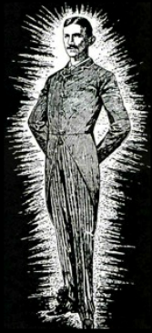

The imagery and inspiration for this work is due wholly to Tesla who was the first to focus his efforts on wireless power transmission. He set out to wirelessly power light bulbs and turn motors in a body of research over a period from 1894 to 1908 at his laboratories in New York and Colorado. Tesla’s macroscopic vision was to use stationary waves to broadcast between antipodes on the surface of the planet as a means to send wireless power. This strongly differed from the radiative model invented by Hertz. Tesla’s notion of wireless power transfer was to use the planet as both a source and a conductor with a tower at a position of an antipode to excite kinetic energy dispersed in the ionosphere while the wave conducted along the surface of the planet. Receivers were constructed with simple antenna and would absorb the current wirelessly. If history had unfolded as Tesla had envisioned it, the modern electrical grid would look like Fig.1.2.

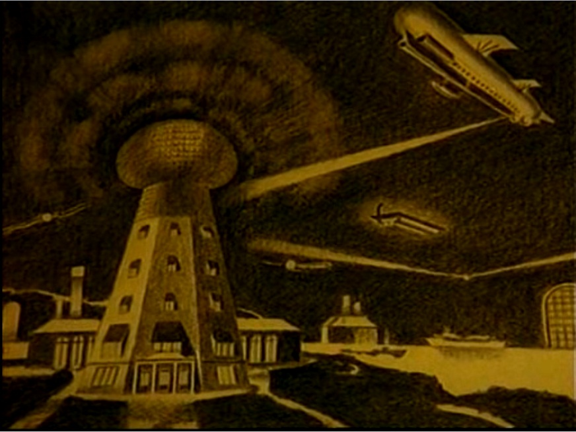

Fig.1.2. Tesla’s vision of wireless power.

After experimental trials at Wardenclyffe, the work went unfinished. Afterwards, Tesla went on to experiment with radiative models in what he termed “radiant energy” [[13]]. The prevailing attention was toward Marconi’s broadcasting system. After the publication of the work on the Yagi antenna [[14]] and the development of shortwave [[15]], wireless power would fade from view.

Forty years passed before interest in wireless power resurfaced. In the 1960s, short-wavelength transmission experiments [[16]] and the modeling of prototypical forms showed positive results [[17]]. A rethinking of inductive transfer began to surface in solving problems associated with subcutaneous implants [[18]]. While many divergent types of wireless power transmission have resulted, especially in the last five years, the idea in this document will involve a singular method and means for wireless energy transmission of high efficiency at short distances (≤ 15 cm) operating at frequencies less than 1 MHz, shown to be safe in a human proximity [[19]].

This thesis will explore the phenomenon of wireless power, how it is useful, and how is it expressed by one person’s imagination—namely, the author’s. The view will be toward a general description of the features of a theory and an experiment. There will be a mathematical discussion of each feature but it is not intended to provide a full proof, that is left for future research. Rather, an engineering-level rigor and the use of visual examples keep the material more accessible to a wider audience.

# Magnetic resonant modes in a wireless-powered circuit

The circuit is made up of two distinguishable parts: a transmitter and a receiver. The transmitter is comprised of a regulated amplification and timing components connected to a loop antenna and a capacitor. The amplifier is connected to a source of direct-current (dc) power. The receiver is comprised of a loop antenna, a capacitor, and a load such as a lamp or motor. The receiver is placed at a distance away from the transmitter. The circuit will transmit radio-frequency electrical energy into free-space the form of photons exchanged between two or more coupled resonators, depending how they are chained together. At certain distances and antenna orientations, the energy can be observed at a receiver by lighting a lamp or turning a motor. A pair of circular loops of the same radius set at a distance form a closed induction circuit illustrated in Fig.2.1. Coupled to a capacitor, these loops form a resonant circuit wherein energy is transported from one to the other. When a current is introduced into one of the loops, it is received by its companion. This is due to the propagation of magnetic waves through the medium, in this instance, atmospheric air of a characteristic impedance.

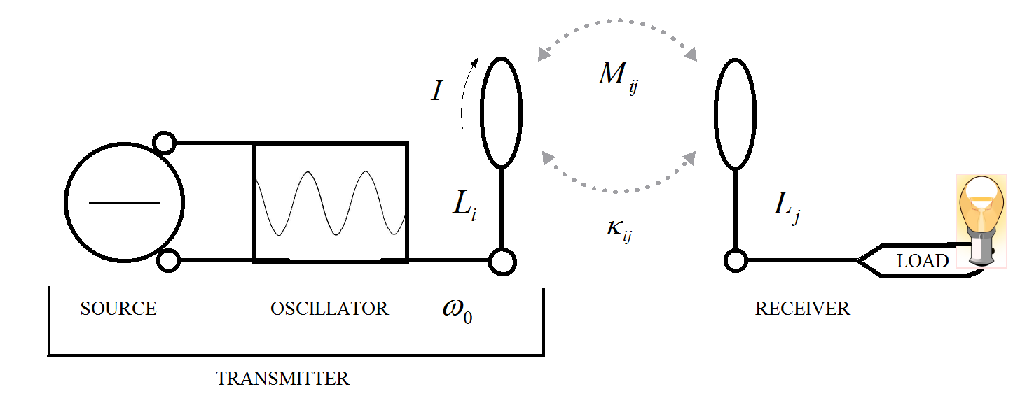

Fig.2.1: Circuit model for the wireless transmission of power by magnetic resonance.

On examination of Fig.2.1, energy flows from the source to the oscillator to coil loop  where it is projected into free-space at a specific resonance frequency . At a distance, coil loop  absorbs energy from the field where it is converted to work powering a load. The transport of energy is divided into two distinct processes:

1. The transfer of energy between the field contained in the coil wire of the transmitter and the air dielectric, and,
2. the transfer of energy between the air dielectric and the coil wire of the receiver.

The transfer of energy implies a time domain in the equations, at boundaries where the energy ceases to be a member of the field. There are the places at the loop and where the field is “contiguous enough” or where . At both places, each will be considered a surface  of the field at the loop and boundary of the medium of free-space. Since the boundary is defined loosely but are meant as abrupt, the parameters , , and  will be invariant with position at all points in space except right at the boundaries themselves [[20]].

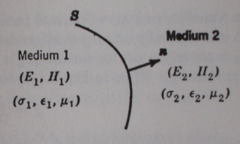

Since electric charge is conserved, a difference in the flux of current through two surfaces sharing the same border must imply a change in the total electric charge contained in the volume between the surfaces. Current density flowing from one surface is the displacement of energy from one position to the next. The field is homogenous across the space between the coils with charges evenly distributed with a uniform motion. The coils of the circuit create the disturbance itself which is responsible for the displacement of currents. Because of Fitzgerald’s proposition of the identity of electromagnetic radiation [[21]],



when,



that Maxwell's equations imply that *any* electromagnetic component  satisfies the wave equation



The conclusion suggests the field is subject to uniform external forces under certain conditions of temperature and pressure, has a susceptibility to those forces. By this fact, it is expected that certain input energies and frequencies share a “golden ratio” that achieves equilibrium. Gauss’s theorem says that this translates into a changing flux of the electric field through the closed surface formed by the two open surfaces. More precisely, the “missing” flux of the current density  is balanced by the flux of the vector . This could be extended to the potential vector .

An energized circular loop emits a magnetic field of a given intensity and geometry according to the Biot-Savart law. This law proposes that the contribution of each  piece  of the wire contained in the loop varies inversely as the square of the distance.  Over the entire length of the wire, each contribution adds up to a total field which varies inversely as the distance from the loop.  The contribution to the magnetostatic field at the origin of a current element at position is



in diagram form as,

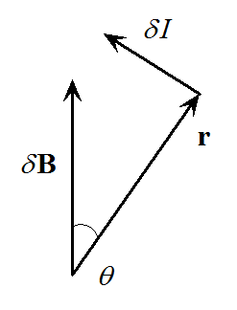

The quantity, , is the current multiplied by the length of travel resulting from integrating the current density  along the surface over a small element of volume. In particular, for a thin wire circuit whose length element  is traversed by a total current , positively in the direction of , . The Biot-Savart law is for steady currents only, in the case of the circuit under discussion, the oscillator driver swings through 180° phases meaning the current changes directions. In this case, the radiation experiences a fall-off at a distance by .

The inductive-link model of wireless power transfer by magnetic resonance utilizes a pair of coils, one acting as a transmitter or primary coil, the other as a receiver or secondary coil to realize its coupled-modes [10]. The arrangement is not unlike that for a Helmholtz coil, however the coils are not connected by wire, rather, utilize the dielectric of free-space as a means of propagation. Some of the pertinent questions in this case will involve realizing the geometry of the scheme, the manner in which energy is stored, and its boundary conditions. To address the latter question, a key assumption will be made: that the area of free-space between the coils is treated as a restricted-class domain wherein the magnetic susceptibility is nearly uniform.

In the model the magnetic field is assumed to have a simple symmetry as in the case of free-space fields. Ampère’s Law yields the value of the magnetic field throughout the space without complex integrations, which efforts are served better when solving for mutual inductance. Gauss’ theorem will shape the magnetostatic field in cases with spherical symmetries, generally applied here.  However, for the special case of magnetic induction on the axis of a circular current loop, several assumptions will undergo the geometry of either or both coils  and .

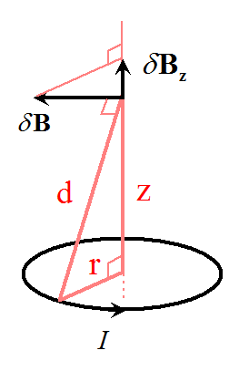

In this case, all radial contributions will cancel out, so the resulting magnetic induction  is oriented along the axis . Because of the similarity of the relevant triangles, the contribution  is   times the Biot-Savart law:



As the elements, , add up to the circumference,



while the field at the center of the loop, where , is



It is well-known that Maxwell’s partial differential equations and the boundary conditions along a waveguide are convertible into a set of independent ordinary differential equations. Each equation describes a “mode of propagation” in terms of concepts well understood in circuit theory. A waveguide, for the purposes here, is considered as an infinite system of transmission lines and the waves traveling along these lines away normal from the source a constant-frequency wavefront as an infinite series of parallel planes of constant peak-to-peak amplitude normal to the phase velocity vector.

Analogous to a pair of Helmholtz coils, consider two loops shown in Fig.2.1 sharing the same horizontal axis, or in axial alignment.  Let their respective latitudes be  and  Magnetic induction along the axis of axial alignment at distance ,



The second derivative of with respect to  at , is



The value  is the largest value where the magnetic induction has a single maximum value along the axis. When values of  are large,  is positive at the center where  indicating a minimum value there. The configuration where the separation between the two loops is equal to their radius, , yields a magnetic induction which is almost uniform near the center of the loop, as,



The scalar potential of the magnetic field at the loop at the center where it is or equidistant between the two loops, more or less, are examples of a current-free region, is a multivalued function whose gradient is the magnetostatic induction. For a simply-connected region under coupled-modes, such a potential is well-defined up to a uniform additive constant. Otherwise, an ambiguity arises whenever the region contains loops which are interlocked with loops of outside current.  In that case a continuous potential can only be defined modulo a certain number of discrete quantities, each of which corresponds to one interlocking outside current.

The magnetic scalar potential, , for the induction  created by the loops illustrated in Fig.2.1, is proportional to the current,  in the loop and to the solid angle  subtended by the south side of the loop facing toward the observer, as,



The ambiguity arises in the solid angle,  defined modulo  it is an approximation that becomes less accurate each time the value is taken. The sign convention is such that the south side of a small loop is seen at a solid angle which exceeds a multiple of by a small positive quantity. This is a concise way to express the Biot-Savart law while demonstrating that in static distributions all currents must circulate in closed loops where . Neither this approach nor the Biot-Savart law itself can deal with dynamic distributions where local electric charges may vary according to the inbound flux of current. A more sophisticated method is required.

By the Kelvin-Stokes formula, the circulation of a vector around an oriented loop is equal to the flux of its rotational (curl) through any smooth oriented surface bordered by that loop yields Ampère’s law in integral form



which is the same as



The simplest and most fundamental direct application of Ampère’s law is to first formulate under the Biot-Savart law; then extend the flow of magnetic induction  analogous to a straight wire or a waveguide keeping in mind the intensity is inversely proportional to the distance.

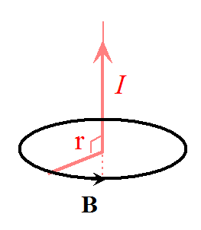

Consider a circular loop of radius  whose axis is a straight wire carrying a current .  The magnetic induction  on the loop is tangent to it; the projection of the motion tangential is constant. The magnetic circulation and Ampère’s law then gives



or equivalently,



In 1861, Maxwell amended the static law of Ampère into the following generalization which holds in all cases including changing charge distributions,



which agrees with Faraday’s law



The curl of a vector field , the vector characteristic of a rotating component of field . The curl is this representation. It can be visualized in the following diagram.

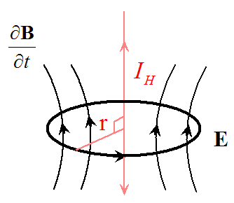

The term  is the directional current (group velocity) along the magnetic field propagation, whose intensity  linearly decreases with distance.  couples to perform work where  can flow in a second coil. The measurement of the intensity  will be determined by the group velocity of the of the field flow. An example is: Let  be the velocity field of a fluid flow. At a given point of the flow there is placed a small wheel with blades whose axis is oriented in the direction of at that point. Then the angular velocity  of the wheel’s rotation from the action of the current will be maximum, and its value will be equal to . If the field  has the arbitrary coordinates *P(x*, y, *z), Q(x, y, z*), and *R(x, y, z)*, then the curl has the coordinates



This will be repeated once for each group velocity direction. When discussing the magnetic field and for tidiness in the equations, the  field will be discussed in terms of . Generally, this is given inclusive of the magnetization of the surrounding space in terms of the magnetic dipole moment ,



The boundary condition will be made simple to keep the equations reasonable. As in the case of the thin current sheet, the assumption that the thickness of the loop structure is negligible and the use of Ampère’s law for a closed contour,



Where  is the current enclosed within the contour,  is the field inside and  outside the coil wire, and  is the wire length. If the medium of propagation is homogenous and isotropic and the surface impedance of the boundary approaches zero, then method of separating the variables obtains a set of normalized potential modes of propagation. This implies that a medium such as free-space can be considered a primitive waveguide. Any discontinuity in the waveguide facilitates a coupling between some or all the desirable modes. Only a single discontinuity will be discussed, namely, a deformation resulting in the projection of a free-space wave exchanging energy between resonators consisting of a current impressed on a magnetic dipole antenna by the acceleration of electrons. The losses associated with the emission of photons appear as radiation of a particular resistive quality to the displacement and direction of motion, taken as an exchange of force

The PDE description of the system will be elliptic, where 

The quantization of the field components will be the aim of the next sections in this document.

## Coupled-modes

Two electrical objects, consisting of inductive and capacitive components of relative value to each other, form a closed circuit. The linking phenomena which exists between attractive resonators in a waveguide of characteristic impedance can be imbued, purely by inspection, with a property analogous to transmission-line resonator with small losses [[22], [23], [24]]. To filter a single coupled-mode from all others, the scheme must be highly selective so as to have a single frequency response . Such a system will maximize the amount of electromagnetic photons from a transmission loop to a receiving loop relative to the permittivity  and permeability  of the dielectric.

The small loop antenna  is a closed loop which has a low radiation resistance and high reactance; as such, the impedance is difficult to match to a sinusoidal oscillator. The closer the impedance of the circuit is matched to that of the medium, the more efficient the scheme. Impedance is important to consider when designing a wireless power circuit and is determinate if the scheme is to function at all. To overcome this, the loop antenna  is connected in parallel to a capacitor and this package tied to an amplifier. Comparably, the loop antenna  is also connected in parallel to a capacitor of equal value tied to a load.

Because of the architecture of the scheme, it is prudent to briefly examine the wave characteristics of the medium based on the impedance, which in this case is free-space. The scheme emits electromagnetic fields which are assumed to have a tangible geometry based on the dispersion of the radiation. The geometry is observable as long as the circuit is energized in the form of a disturbance within the free-space between the loops. The disturbance is derivative from the loops; the current is the disturbance.

The wave impedance of an electromagnetic wave is the ratio of the transverse components of the electric  and magnetic  fields. For a transverse-electric-magnetic (TEM) plane wave traveling through a homogeneous medium, at a given temperature and pressure, the wave impedance is everywhere equal to the intrinsic impedance of the medium. In particular, for a plane wave travelling through free-space, the wave impedance is equal to the impedance of free space. Thusly, the wave impedance in terms of fields is



Disassembling the fields into finer parameters, the free-space impedance is



where  is the magnetic permeability,  is the electric permittivity and  is the electrical conductivity of the medium. In the equation,  is the imaginary unit, and  is the angular frequency of the wave. In the case of a dielectric where the conductivity is zero, the equation reduces to



Calculated at 20C and one atmosphere,



As it is important for solutions in electrical problems, the value defined is used as a calculation reference. Without sacrificing clarity in the equations, it would be interesting in future research to examine the behavior of the wave function at the boundary as well as under time and spatial contraction. The following description will provide an overview of the dilemma of the field in free-space at its boundary.

For any waveguide in the form of a hollow metal tube, such as circular guide, the wave impedance of a traveling wave is dependent on the resonance frequency , but is the same throughout the guide. For transverse electric (TE) modes of propagation the wave impedance is



where  is the cut-off frequency of the mode. For transverse magnetic (TM) modes of propagation this value is



Above the cut-off , the impedance is real (resistive) and the wave carries energy. Below cut-off the impedance is imaginary (reactive) and the wave is evanescent, the latter shown to be an affective scheme [28]. These expressions neglect the effect of resistive loss in the walls of the waveguide. For a waveguide entirely filled with a homogeneous dielectric medium, similar expressions apply, but with the wave impedance of the medium replacing . The presence of the dielectric and the shifts in its impedance through  modifies 

For a waveguide or transmission line containing more than one type of dielectric medium, such as complex microstrip [[25]],in terms of the boundary conditions, the wave impedance will in general vary over the cross-section of the line, as a waveguide transient [[26]].This arrangement is most analogous in the case of free-space.

To keep selectivity as narrow as possible, the system is designed to emit a single frequency. The choice comes at a cost: impedance is not a function of the properties the circuit, but is combined with that of free-space. The radiation pattern exhibits a topological surface as long as the oscillator is energized. The field is quantifiable at certain lengths from the antenna but has a fractal dispersion geometry, similar to task of calculating the length of a shoreline, so what constitutes the observable boundary is relative to the technical sophistication of the laboratory of the experimenter. Herein, the observable free-space electromagnetic field has its boundary at the edge where the energy stored at the horizon vanishes, as . Depending on the geometry of the coils and the intensity of energy stored, the boundary shifts.

The quasi-static boundary has an arbitrariness from the placement of the coils relative to each other. At 20C and one atmosphere, the energized field experiences a linear decay between transmitter and receiver at , where  is the radius of the loop. The loops form a single coupled-mode. The magnetic energy is evenly distributed around the transmitter coil and the potential is at the boundary. A similar notion, investigated by Aharonov-Bohm, suggest such a scheme at lower temperatures reveals interesting conclusions about the nature of the charge and its relation in free-space [[27]]. The dipole, as the supporting phenomenon of coupled-modes, in both its real and imaginary components, exists *adjunct* to the coil interacting with the space surrounding the loop.

Referring to Fig.2.1, consider a system of resonators consisting of a pair of magnetic dipole antenna separated by a distance which contain a single coupled-mode [21]. The antenna are set on a work-plane as to contain a periodic structure. To perform an analysis, a software package called *Comsol Multiphysics* is used to simulate the electromagnetic characteristics of the scheme. The work-plane consists of two circular loops of a material with conductivity  and radius . These loops are aligned in such a way so that the center of their radii share a common axis or an axial alignment. The arrangement of the scheme is illustrated in Fig.2.2.

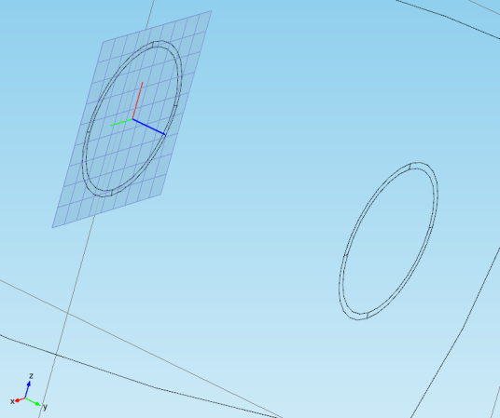

Fig.2.2. Distant resonators describing coupled-modes.

The investigation is interested in studying antenna sizes that is considers small. The reason is solely to ascertain how compactly the scheme could be modeled. The parameters of the model are given arbitrary values: the loops have a radius of 3 cm and set a distance apart to a maximum of 6 cm. The loop surface lies on the  plane while  forms the axial line, discussed in §2.

From the viewpoint of energy transfer, the receiving antenna, to the right of Fig.2.2, collects electromagnetic photons—given the area over its surface and the influence it imposes on the space surrounding it. With the introduction of a voltage gap, electrical energy is extracted in the form of power. Although work is somewhat performed in this method, a considerable amount of energy is reflected back across free-space [[28]].

Considering that the surrounding free-space is a periodic locally-approximated waveguide with implicit time-dependence  has, uncoupled, the spatial dependences  and . In coupled mode, the spatial equations [21] are



given their coupling with a weak time dependence,



relative to the coupled state of the resonators,



is a weakly-coupled system, where . This is in contrast to a “strongly-coupled” scheme [[29]]. The attention on weak-coupling is referring to the weak time dependence for a system taking an assumption low coupling coefficient  affects efficiency  weakly and properties of the circuit affect  strongly.

### The coupling coefficient

In consideration Fig.2.1, to shape both the geometry of and the efficiency manifest within the scheme, the variables to be solved are: the coupling coefficients , the mutual inductance  the quality factors  and  expressed by coils  and , and the contributions of their fields  and  The relationship is illustrated in Fig.2.1 and Fig.2.17.

To understand the effectiveness of the scheme and the work done at a distance, the energy-storage ability of the system is determined by coupling coefficients in transfer mode. The flow of the energy across the distance is determined by  between coils  and at a distance  When a current  is applied to coil , the power transfer flows from coils  to , and  to .

The coupling coefficient in , is solved for a coil of a characteristic size and geometry. The linkage between magnetic resonant coils is defined as



where  is the mutual inductance,  and  are the self-inductances of the loop coils. The inductance can be calculated since its size and geometry are already specified, by the approximation of the inductance of a circular loop [[30], [31]]:



where  is the loop radius,  the wire radius,  the number of turns, and  the flow constant of the skin-effect of the emitted radiation, which is the same for both coils since the assumption is for power to flow in both directions.

The resonance frequency of the system



is comprised of the resonance frequency  of each of the coils,



and the frequency error between each half of the circuit



A consideration of the design is not only to keep the antenna small but to keep the resonance frequency  low enough as to not to be deleterious to human tissue. Studies have shown that a frequency spectrum between 100 kHz and 4 MHz is suitable [[32]]. The theoretical specification of the antenna will be calculated where



The material properties of the coil is for an insulated copper wire wound in concentric loops so the total loop surface is comprised of a number of turns, which is equated to a Litz winding. Since the loop is comprised of a Litz winding with each turn insulated from the other, the contribution of  approaches a minimum skin effect.

The winding has legs as to allow the loop to be mounted into a circuit board and projected along a plane linear to the earth. The additional inductance of the legs is taken into consideration. Using a C#.NET program, called *Circuit calculator*, built specifically for performing and visualizing the relationships of the values for each loop. Given , a capacitance of 100nF is chosen. This is shown in Fig.2.3. The table of values for the model loops  and resonance frequencies  is shown in Table 2.1‑1.

Table 2.1‑1. Loop coils theoretical specification.

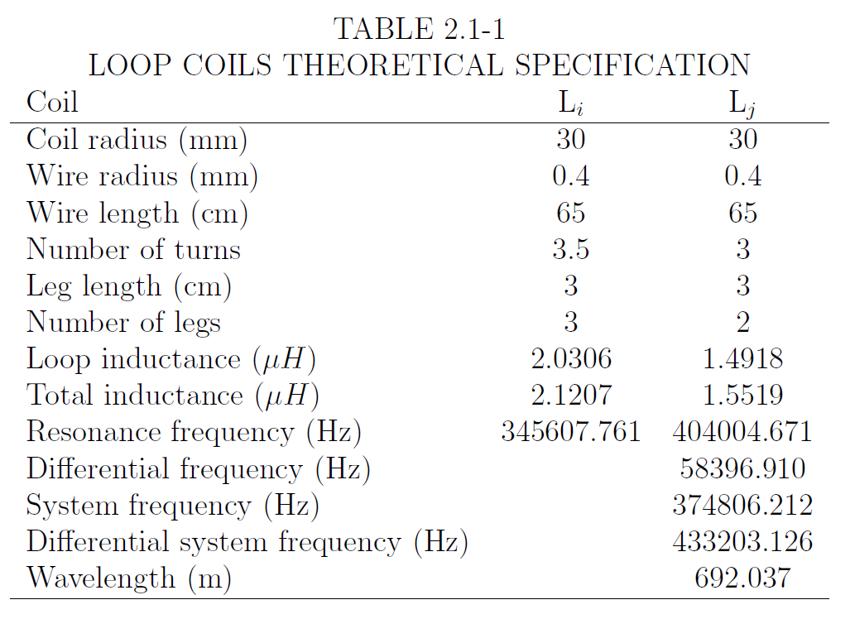

In terms of the prototype, a frequency of approximately 440 kHz is expected to be the resonance frequency when the loop antenna are constructed accordingly. Considering , the mutual inductance is next to be solved for.

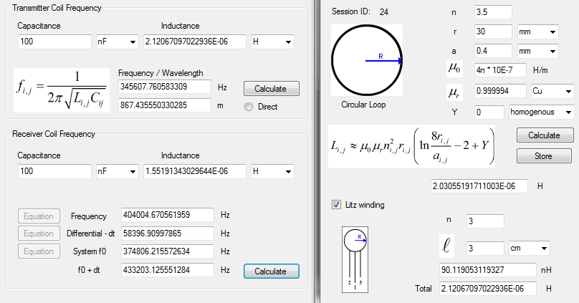

Fig.2.3. Calculator values for (a) system resonance frequency, and (b) inductance of the transmission loop.

*Mutual inductance*

The mutual inductance between two coils is dependent purely on the geometry of the scheme. An energized loop affects action at a distance. Its attraction, or mutual inductance, is given by the Neumann formula [[33]]



The infinitesimal positions  and  in are derived under the assumption that the magnetic field is evenly distributed, more concentrated toward the center of the loop than in other places, and in a mostly linear distribution. In this form, the loop wire is considered to be contained of coaxial circular filaments [29].

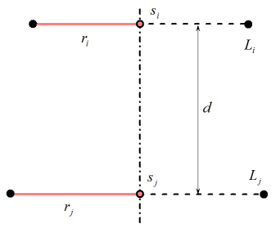

Mutual inductance is exclusively the property of coupling between coils  and . The magnetic flux intercepted by one coil is analogous to a unit of current flowing in the other [[34]], the mutual inductance of the and  elements and the integration over the Poynting surface  demonstrate mutual inductance is also



where **B** is the flux intercepted by the receiver coil, is the current passing through the first coil, **n = ** is the unit surface normal vector, and  is an infinitesimal area element. It is possible to transform the surface integral in into a simpler line integral by using the magnetic vector potential



together with Stokes theorem, which states that a surface integral of the curl of a field equals the closed line integral over the rim of the surface



where **t** =  is the unit tangent vector of the curve  and *dl* is an infinitesimal line element. The mutual inductance, then, depends upon the parameters  , , and is proportional to the radii,



where  and  are elliptic integrals and  is obtained by



Using [29] to find the value



where  is determined as depending on the variable



from Table 3.2‑1. A calculation was performed in *Circuit calculator* for the mutual inductance  based on from the specifications listed in Table 2.1‑1,



where the result is used in to calculate



The coupling strength between resonators is described by the coupling coefficient. Besides what has been described as methods for calculating the coupling coefficient. Another method [[35]] is to consider the bandwidth of the transmission, as



where  and  are the split resonance frequencies of the resonators. In the sense of the arrangement illustrated in Fig.2.17, there is shown a separation of the resonators, physically exhibited as coils, into their electric and magnetic components. A narrowband scheme will be the goal. To maintain cohesion in the beam between  and , insights into the *why* the coupling is so significant to power transmission by magnetic resonance and what factors affect it. A novel approach [[36]] called the perturbation method, strives to glean insights those components which most affect the overall coupling. The following equation, modified,



implies that the motivation to understanding the coupling coefficient is where  makes the strongest contribution toward the intensity of and what circuital components would support the transfer. It also suggests that increasing the amount of magnetic field at the loop would result in additional improvements. In its most basic sense, answering these subtle questions takes time and experience and they will be addressed as a motivations in this thesis; they will irrevocably remain a most important topic of future research. However, the author can identify that it is the *contribution of a potential magnetic vector decomposition on the interface* which is of greatest importance to grasp if understanding of the scheme is to advance.

The interface is described as the loop in situ with free-space. The magnetic field is radiated by the transmission loop and the “amount of magnetic lines” crossing the receiving loop is a typical description. A multiphysics plot is shown in Fig.2.4.

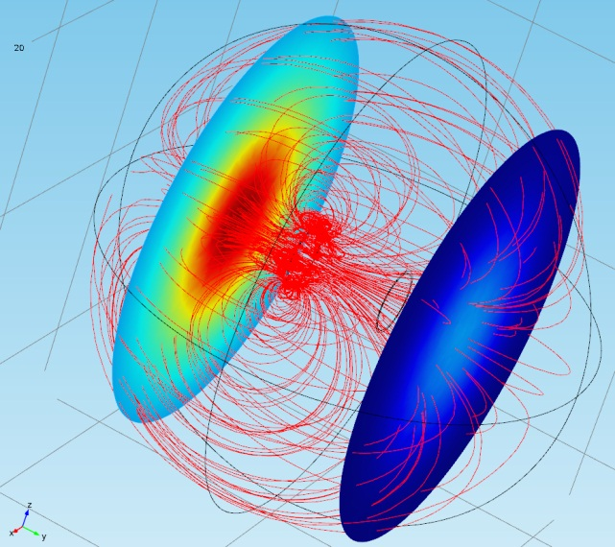

Fig.2.4. Magnetic coupling of low- modes of distant resonators in space and time.

As noted in [[37]], the distance does not affect the modal coupling, rather, spatial extensions in the direction relate more closely to the transport of electrical power, expressed in terms of the **E** and **H** fields. In such effects, broadcast power is subject to attenuation over the impedance of free-space if the potential is expected to have minimum contribution to the field. Nevertheless, it is important to keep in mind that the wave amplitude, at a minimum when energy is not applied, *does not describe* and is independent of the sinusoid as well as its wave function. Therefore, the presence of the antenna *and* the presence of a physical free-space structure constitute the entirety of the signal. If one considers the argument that the waveform separated from a conductor, in the manner of induction described by Faraday as well as the quaternion expressions of Maxwell, the disturbance opens the door to questions of what in free-space is allowing the equilibrium of the emission of currents at distances greater than those described for the skin effect.

To model the relative position and motion of the energy, in terms of electromagnetic photons, the rate of exchange is represented by the density of “magnetic lines”, illustrated in Fig.2.4.

As a more focused examination of the scheme setup in Fig.2.1, the antenna—by the nature of its size, geometry, and symmetry—couple the magnetic component of the energy on the coil-wire surface to an interface. Under closer examination and consistent with the circuit architecture, the presence of the impressed wave is wholly due to the properties of the inductor  with its cousin  and the potential of free-space given its impedance . The magnetic loop, at a ratio to its quarter wavelength, contains the effects of a full ac cycle impressed on it by the incident wave. This is discussed in greater detail in §2.3.

As the purpose of the arrangement is to transport energy efficiently, the numerical solution of the circuit power is intended to measure the quantity of energy stored between the resonators and the dissipated power at the receiver available to a load. Therefore, the coupled modes in space will disclose the distribution of the energized field while modes in time will give the rate at which it is transported is wholly the function of parameters of the antenna.

### Coupled-mode power

The energy stored and dissipated between two coupled objects describes a power distribution system. While the pursuit of a wired analog is desirable to some applications, for the purposes here, it is more effective to consider the coupling purely in terms of energy transport by magnetic resonance. This methodology will yield greater insights not only about the model under investigation, but also about the environment where the model is operating.

Energy transfer is an observable result in the context of forces moving charges. In the driven case, one can quantify forces due to amplification. In more subtle cases, the distribution of forces on charges is described by the Lorentz-Fitzgerald transformation [[38], [39]] used in special relativity and the source of Minkowski light cones and other innovative spatial geometries with moving forces [[40], [41]].

The Lorentz force transfers energy between the field and the charges. The power of the force equation is .  Thus, the power received by the electric charges per unit of volume is  Charge carriers convert the power on the receiver side from the local electromagnetic field into other forms of energy, including the kinetic energy of particles.  Conversely,  can be negative, in which case there is a transfer of energy from the charge carriers to the field.  One process can be seen as a time-reversal of the other.  In this, it is essential to retain both the retarded and advanced solutions of Maxwell's equations; the motion of the sources and the changes in the field may cause each other.

The quantity  may be expressed in terms of the electromagnetic fields by taking the dot product of the current density into  to both sides of the Ampère-Maxwell equation



The identity



and Faraday’s law yield



Finally, the potential for a balance of the energy densities



results to what is commonly known as Poynting’s theorem



This means the density of the power is released by the loop to the field. It is consistent with the energy for the electromagnetic field



The Poynting theorem states that the variation of this energy in a given volume comes from power that is either delivered directly by inside sources or radiated through the surface, as the flux flowing through the cavity. It will be this formulaic method which will be applied to solving the case of the circuit loops in §2.3.1. These cavities, while homogenous in free space, maintain a total internal reflection. To sustain the obvious state of equilibrium of the field, an opposing force is allowing the suspension. Since the quantification of what constitutes this force is not widely discussed in the literature since the early history of electromagnetism, the author seeks a most insightful answer. As the force and the energy is quintessential, contrastingly, the potential of the force is equally so.

*The magnetic potential*

A brief description of the magnetic vector decomposition is due to come to terms with the nature of the field object between the resonators as a result of the forces that shapes the object. A model about field composition as an extension from a circuit model.

The model contends the magnetic vector potential **A** =  is used to construct a finite solution by casting the projection  as the dot-product of the tangent vector and the magnetic potential



is the response of the potential to the disturbance of the wave. Its magnitude is relative to the energy stored in the field object. While not appearing inside the field, it occurs at the limit of the field at its boundary and is symmetrical along the space between coupled-mode objects. The field has a dispersion dependent on the geometry of the antenna; the transmitter and receiver placed at separations in all three Cartesian directions. The unity of the potential in context with the field object is observable under measurement of an unpowered antenna and is extant at the nulls to the left and right minor lobes. Modal magnetic resonance coupling is more effective at describing magnitudes of magnetic flux density in terms of the potential. It has the correct mathematical approach. One such is the description in terms of the displacement currents. The antenna loop carries a harmonic current



which is confined to the loop near its surface but not within it. The vector potential from the loop is expressed as



where . To simplify the appearance of the harmonic current in the following equations, it is expressed as



By inspection of , the evaluation of the potential depends of the location where  is being observed, as anticipated by the assumptions. Expansion of the exponential form



illustrates the technique to absorb the approximation of a loop which is small compared to the distance  between the center of the loop and where it is observed. Under such a construction, the method is similar to the approximation of the electric dipole [19]. So, is written as



Essentially, the second integral in is zero since all it indicates is to continue moving the observation around the circle to the beginning point. Evaluation of the first integral in yields, by vector identity [[42]],



to convert to a surface integral. The scalar  is equal to the inverse of the amplitude , the unit vector  since the loop is wholly in the  plane and projecting along . This results the vector to be decomposed into the two forms



where the surface integral yields the factor . Because it is expected by geometric inspection the shape to be homogenous and elliptical, the result in spherical coordinates is needed. Taking the vector relation



gives



Using the result and evaluating reveals the interaction of the vector potential with the field object is



Equation suggests there are effects on the boundary between the field object and the potential. The result was simulated and is shown in Fig.2.5.

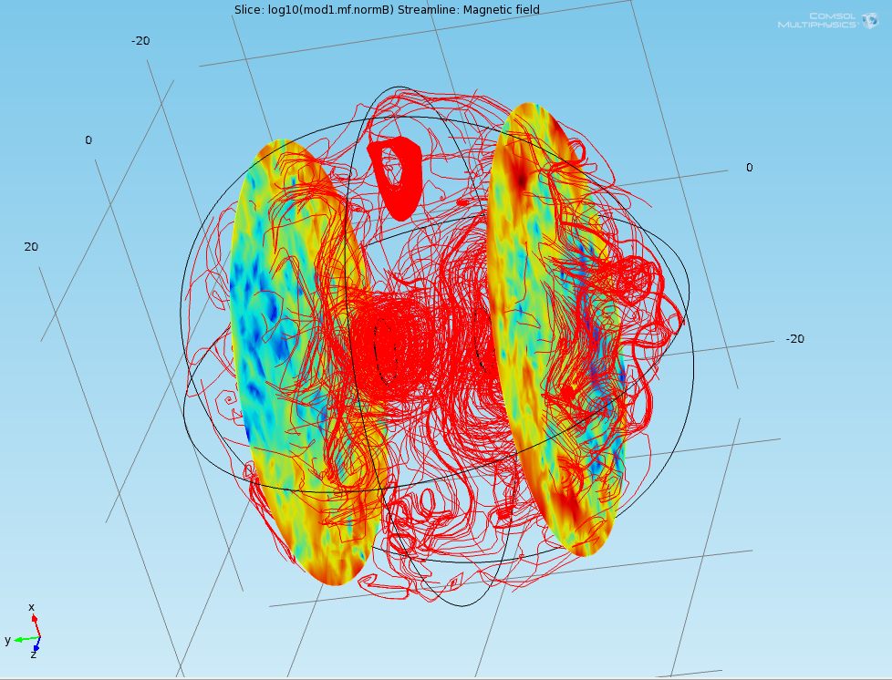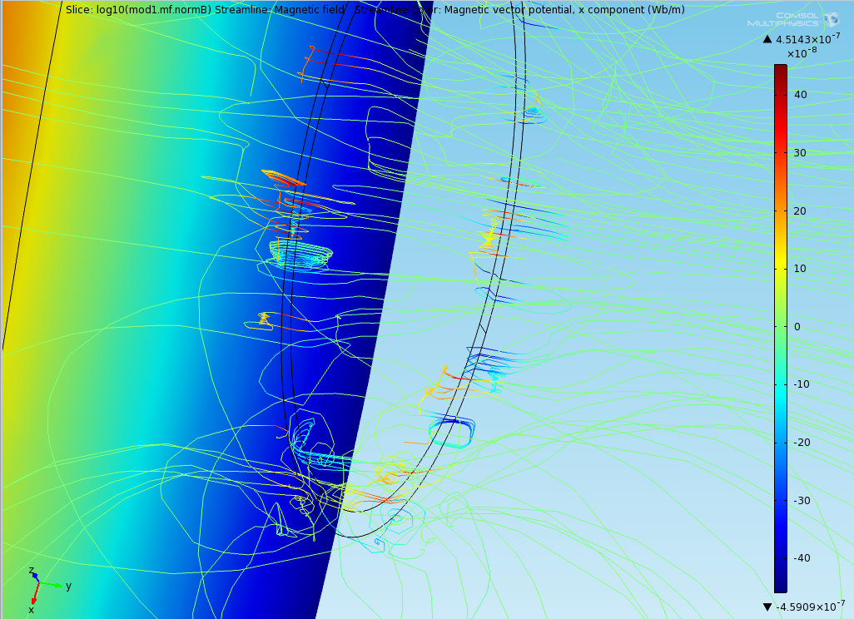

Fig.2.5. (a) The vector potential in the magnetic field, (b) the potential component on the loop interface.

The simulation shows that the electromagnetic potential in enmeshed in the field, as predicted, but also is in motion at the boundary between the field and free-space following the  plane of the loops. What is interesting is that motion is closely connected to the interfacing of the loop and the medium and that it occurs in differential degrees of magnitude which appear to be nearly chaotic, as shown by the appearance of spiral motions over the loop along with streamers of near zero magnitude following the direction of the magnetic field. Two questions asked are: is the potential  a component of the magnetic field , in that it is tightly coupled to it? Is it a property of the medium inferring a transfer of force between  and ?

The use of the Maxwell displacement current  is taken as to map the forces between the antenna, into a convenient package called a field object [[43]].

What helps to reveal the quandary is the inclusion of the coupling of the coils in . It is the author’s contention that greater insights can be gleaned by an investigation of how the consistency of the magnetic field strength is dependent upon the coupling between coils.



One can understand that if two objects are not coupled then there is minimum force between them, one can also understand that if two objects are weakly coupled then there is some degree of potential between them. What becomes difficult is when trying to decompose the potential vector on the interface to quantify the dependence of the potential on coupling, this is especially difficult when there is no definition, outside of the impedance, of what constitutes free-space. We have free-space in the sense of that on a planet and we have free-space in the sense of the vacuum of outer space, are the disparities between these resolved by the Minkowski cones of Einstein’s special theory? Are electromagnetic forces and the charges that populate them strictly dependent on the quantum effects, i.e., the duality of the electron [[44]] and its esoteric properties? Photons traverse free-space constantly, can the duality be harnessed to paint energized structures? It could very well indicate evidence of such properties, only visible in the quantum universe, are also available to be experienced in the macro world [[45]].

The author contends this provides sufficient material to support the notion of free-space waveguides [22, [46]], constructed by the scheme, and energy can be transmitted across them. Topologically as a waveguide field, () [[47]], contributors to closure of currents in an open circuit.

### Efficiency, qualities, and losses

To shape an understanding of how the coupled-mode characteristics, described in §2.1.1, are used in real-world problems, a suitable model needs a criteria to judge if it is “worthy” to pursue. The worthiness is the model in terms of its overall efficiency, that is, by a comparison between the energy stored at the input to the energy dissipated in losses. The efficiency of the model is measured by the equation [[48]],



where  is dependent on the coupling coefficient , but also by the qualities  and  of the coils  and . The quality of a coil is obtained



as a property of the energy stored in the angular frequency  and inductance , to the energy dissipated by the resistance of the  and  coils. The quality factor is determined by [[49]]



comprised of the inductance , resistance and capacitance  of the  and  coil in the oscillator and receiver circuits. The scheme is defined so that the system is performing work, the unloaded quality  is neglected,



for both cases of a series and parallel configuration in an ideal circuit arrangement. The coils are arranged within their respective circuits as to maximize the amount of energy stored between the inductances and the capacitances. The arrangement of coils  and  are discussed in terms of the oscillator Fig.2.1.

The maximum energy stored in  and  is



which is discussed in greater detail in §2.3.1. The loop can be treated as a standard oscillator in coupled mode defining as



An example of the application of a theoretical estimate of the quality factor of the system will be discussed in detail in §**Error! Reference source not found.**. It is well-understood that quality factor has a direct consequence upon the efficiency of an electrical transmission circuit.

The remaining component relevant to the properties of coupled-modes are the losses in the system resulting from the materials used in the construction of the loops. Losses in the system are observed as dissipation of the energy stored. For the losses due to ohmic resistance [53],



where  is the conductivity of the material,  the number of turns,  the wire length of the coil and  is the wire radius. The calculation of the quality factor and the losses for the system are shown in Table 2.1‑2.

Table 2.1‑2. Energy, quality, and loss specification.

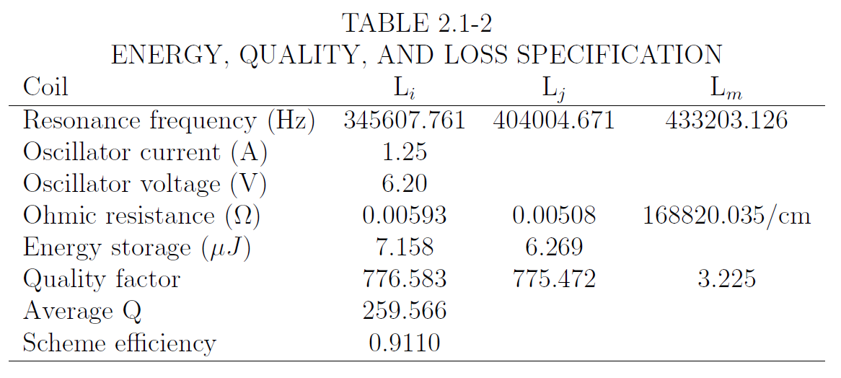

A calculation in Table 2.1‑2, column , is provided for the object impressed on free-space as a function of the inductance and resistivity of the medium. Averaged, the potential efficiency is very high for the coupled-mode, although it will be shown in experiments that it is transformed solely on the properties of the material consisting the antenna. In *local* space, the efficiency is observed to be very high but it refers to the ability of the loop to transform the acceleration of electrons into photons, not including any of those quantum considerations here. Efficiency of the transmission over distance is merely the linear decay of power over . This is discussed in terms of radiated power of the antenna in §2.3.2. Energy storage is shown per cycle.

With these baseline criteria for the expected properties of the antenna as a function of the materials and geometry of the wire established, the next chapter will address the circuit model that can sustain the oscillations. The criteria is the means by which differentiating models will be judged to be used in commonplace application, such as that in §fdfsdfsdfsdfsdfd. The system under consideration is designed with compactness in mind and each component chosen for an expected level of performance. The purposeful choice of using the type of oscillator described herein is not by accident, rather, chosen for its simplicity and size.

## The circuit model

As the system is designed to transmit waves, it is an obvious fact that, under such conditions, the oscillator is the driving force in the system. Without oscillations, waves would not propagate in a manner required by the design. For comparative purposes, if the antenna were to be charged with a non-oscillating current such as that provided by a direct-current (dc) power supply, the signal would not be seen by the receiver and magnetic energy is statically be emitted into space, given the area,  of the conductor. There would be no explicitly defined coupled-mode and the signal would not couple to the distant load. As far as the field object is concerned, it would be randomly generated with no cohesion in the beaming.

The task of this section is to describe the construction of a circuit which illustrates the diagrammatic representation of the source, the oscillator, and the loops illustrated in Fig.2.1. The circuit model will also attempt to satisfy the mathematical descriptions of the previous sections while introduce a reconciliation of the circuit verses field model discontinuities [[50]] only in the confines of an agreement of the supposition of resonant circuit-as-antenna correlation.

To satisfy these aims, a circuit which consists of a transmitter and a receiver is required consisting of a compact oscillator driving a magnetic-resonant loop antenna. The coupling of the source and oscillator objects are wholly responsible for the character of the manifest field between the antennas, as described in §2.1.

The most immediate and obvious question is what kind of oscillator to use: compact, powerful, and the ability to impress the expected currents on the loop. Efficiency is important here as the transmission scheme has a criteria of “worthiness” ; it is taken into consideration when choosing the oscillator type.

In the early days of radio, numerous types of oscillators were used in signaling based upon the spark-gap transmitter, first used by Hertz. As the transmission of radio waves evolved from telegraphy into voice, increasingly the oscillator needed to be free from noise for broadcasting. As the spark-gap started to fall out of favor, sinusoidal oscillators able to contain modulation were proposed in the form of the regenerative circuit by Armstrong [[51]]. The universality of the scheme showed that any radio-frequency oscillator was a topology containing feedback; this topology could be modified to provide a controllable reduction in feedback loop coupling on the antenna circuit. If the method of coupling was to split the characteristic impedance of the circuit through an amplification stage, it functions as a combination of an oscillator and mixer which converts the modulation directly to the baseband.

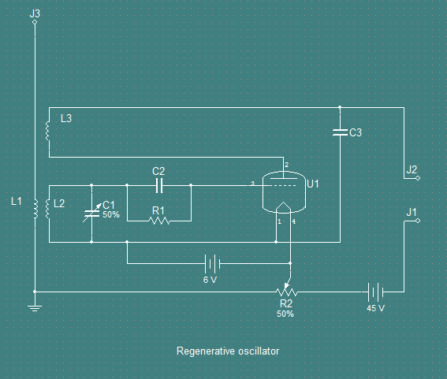

Fig.2.6. The regenerative oscillator.

On examination of Fig.2.6, the driving force of the vacuum tube U1 is carried across a pair of inductances, a coupling coil, L2, and tickler coil, L3, along with tuning capacitor, C1. The capacitors C2 serves to suppress leakage from the grid of U1, capacitor C3 for frequency bypass. The application of dc power to the triode amplifies the signal incoming to terminals J1 and J2 treating the beat frequency of the antenna scheme and power impressed on it as if the entire package was a combination of source and oscillator amplifying the resonant frequency of the antenna. If the circuit is modified to split the antenna into two equal phases and the driving amplitude powering each 180° phase-shift, a circuit with twice as much applied power could be constructed. Such a circuit is the push-pull oscillator.

The push-pull oscillator is a type of electronic circuit that can drive both a positive and a negative current phase-shift into a load. Appearing in the early 1920s, later described in detail by Hoag [[52]], the model is a highly-efficient oscillator which contains a complementary pair of power-drivers, one dissipating or sinking current from the load to the negative power supply, and the other supplying or sourcing current to the load from a positive power supply over a center-tapped coil during a complete duty cycle. Because of the high-efficiency and the simplicity of the model, it is ideal for wireless power transmission shown in Fig.2.1. Since the scheme is based on induction, the oscillator will have to be modified to also phase-shift the antenna inductance through the cycle.

An inductively-coupled push-pull oscillator is shown in Fig.2.7. When voltage is first applied by the dc source, V1, the fluctuation of the voltage makes the grid of U1 positive and the grid of U2 negative. Because the current is lagging behind the voltage, it is expressed as changes in the plate current. The lag of the current is an important feature which is directly captured in this type of oscillator, the dipole is created on the plate. The resonance between the inductance and capacitance in the plate circuit causes voltage changes on the plate which, fed through the plate to grid capacitance or by magnetic coupling between the two tank circuits, reverse the polarity of the grids, switching them exactly opposite. As this continues, the tank circuit impresses the voltage changes of the grids and current on the plates, so that oscillations of increasing magnitude rise. The magnitude rises to the limit imposed by the magnitude of the source voltage and the energy is spread evenly across the circuit given its symmetry. Eventually, the rise reaches a magnitude where the dipole breaks and energy is released. This makes the circuit particularly useful for driving currents at frequencies in the medium frequency (MF) range. The push-pull oscillator is a balanced oscillator. This type of circuit is able to deliver larger outputs with less distortion than single-triode amplifiers. The output is a sinusoid relating the opposing forces of absorption and dissipation in the tank circuit created by the coupling of coils and a capacitors across the amplifiers.

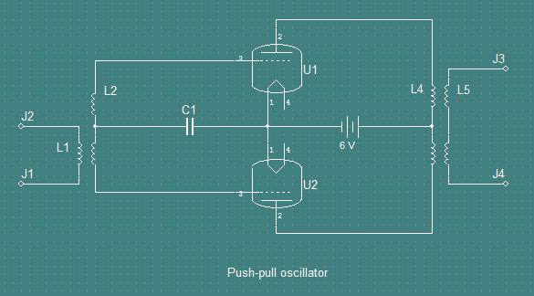

Fig.2.7. Inductively-coupled push-pull oscillator.

Having satisfied the conditions of finding a suitable oscillator to drive the scheme, it is necessary to recast the circuit of Fig.2.7 since the antiquity and power needs of the vacuum-tube triodes make recreating the circuit impractical. What is more applicable is to replace U1 and U2 with something like a semiconductor triode which has the ability to impress a high level of amplitude with fast switching speeds. Such an item that is very advantageous for this purpose is the n-MOSFET manufactured in a TO-220 case.

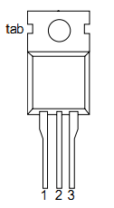

In this form, it is expected to have a wide application and is suitable for rough-duty in a compact circuit. Since this is a field-effect transistor, dependent upon high-speed, electric field switch-transitions, the n-MOSFET has coupled-modes. The mode relevant here is the triode mode or linear region, also known as the ohmic mode [[53]]. The architecture of a n-channel MOSFET shown in Fig.2.8. A metal-oxide-semiconductor field-effect transistor has three terminals: the source, the gate, and the drain. In an n-MOSFET, both the source and the drain are n-type and the substrate between them is p-type, shown in Fig.2.8. The gate and the p-type substrate is insulated by a thin layer of silicon dioxide. Due to this insulation, there is no gate current to either the source or the drain.

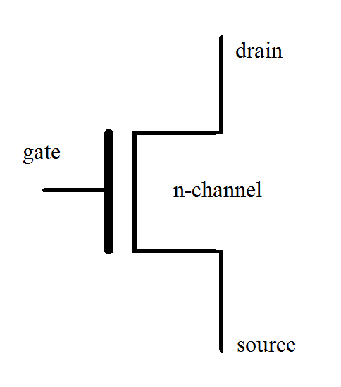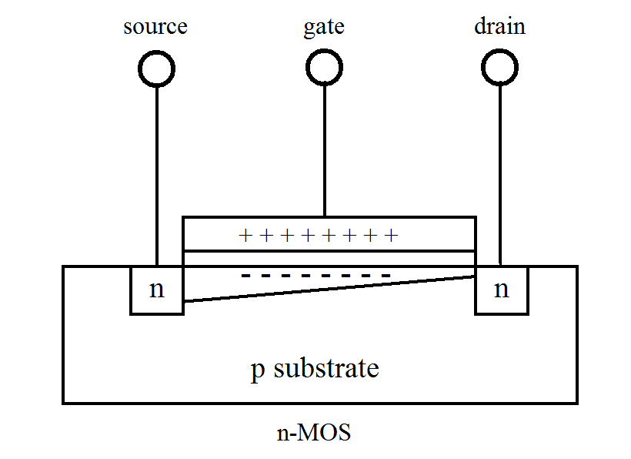

Fig.2.8. The n-channel MOSFET structure.

The n-MOSFET can be equated with a voltage-controlled switch. When a sufficient voltage  is applied between the gate and the source, the positive potential at the gate will induce enough electrons from the p-type substrate to form an electronic channel creating an inversion layer between the source and the drain, and a current  between the source and the drain is formed. The behavior of a n-MOSFET can be described by the function  with a threshold voltage . These properties can be taken advantage of in the wireless power scheme by placing the n-MOSFET in the circuit in such a way as to split oscillations into two groups: those of the transmission antenna and those between the pair, illustrated in Fig.2.9, and the steps through each phase, illustrated in Fig.2.10.

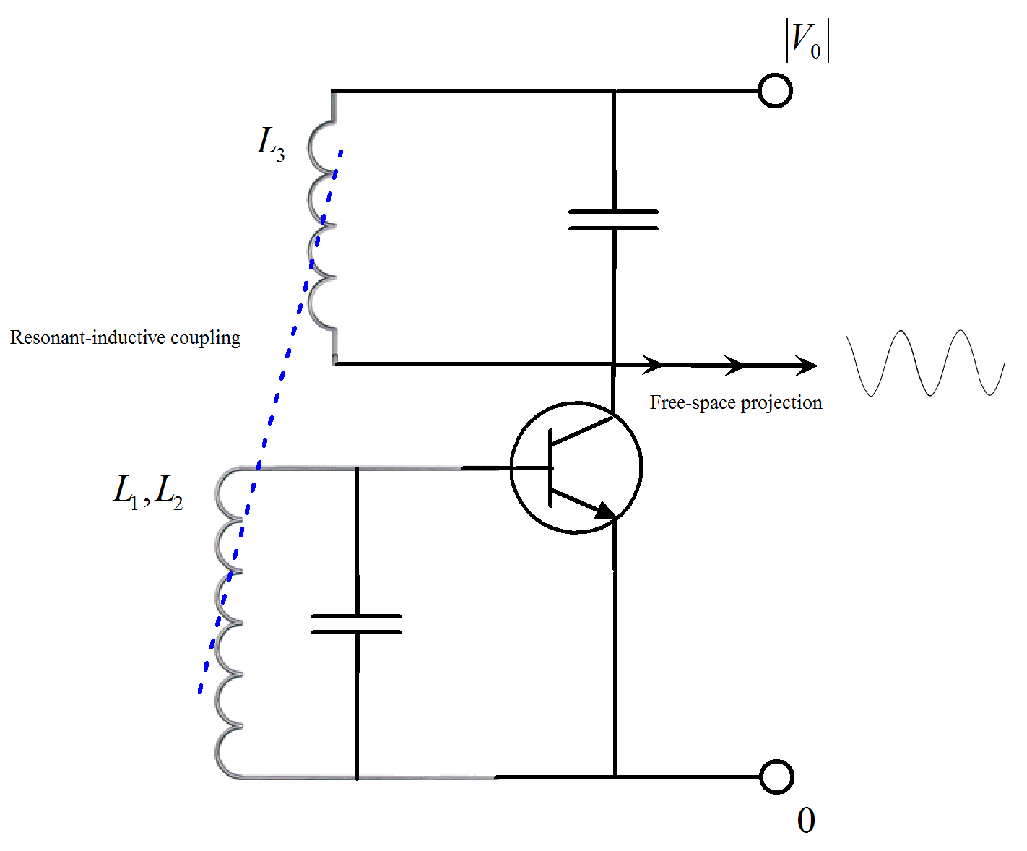

Fig.2.9. MOSFET powering a split across a tank circuit.

The ability to phase-shift between each part of the cycle synchronizes with the shifting phases of the potential will close the circuit periodically and allow energy to transfer. Free-space wave projection is possible when the synchronization is with any one of the rest-state potentials. Although the specification of these potentials is outside the scope of this thesis, suffice to say the synchronization satisfies the presence of the antenna as analogous to coupled-modes, merely by inspection. It is the time between the shifting phases where the interfacing takes place.

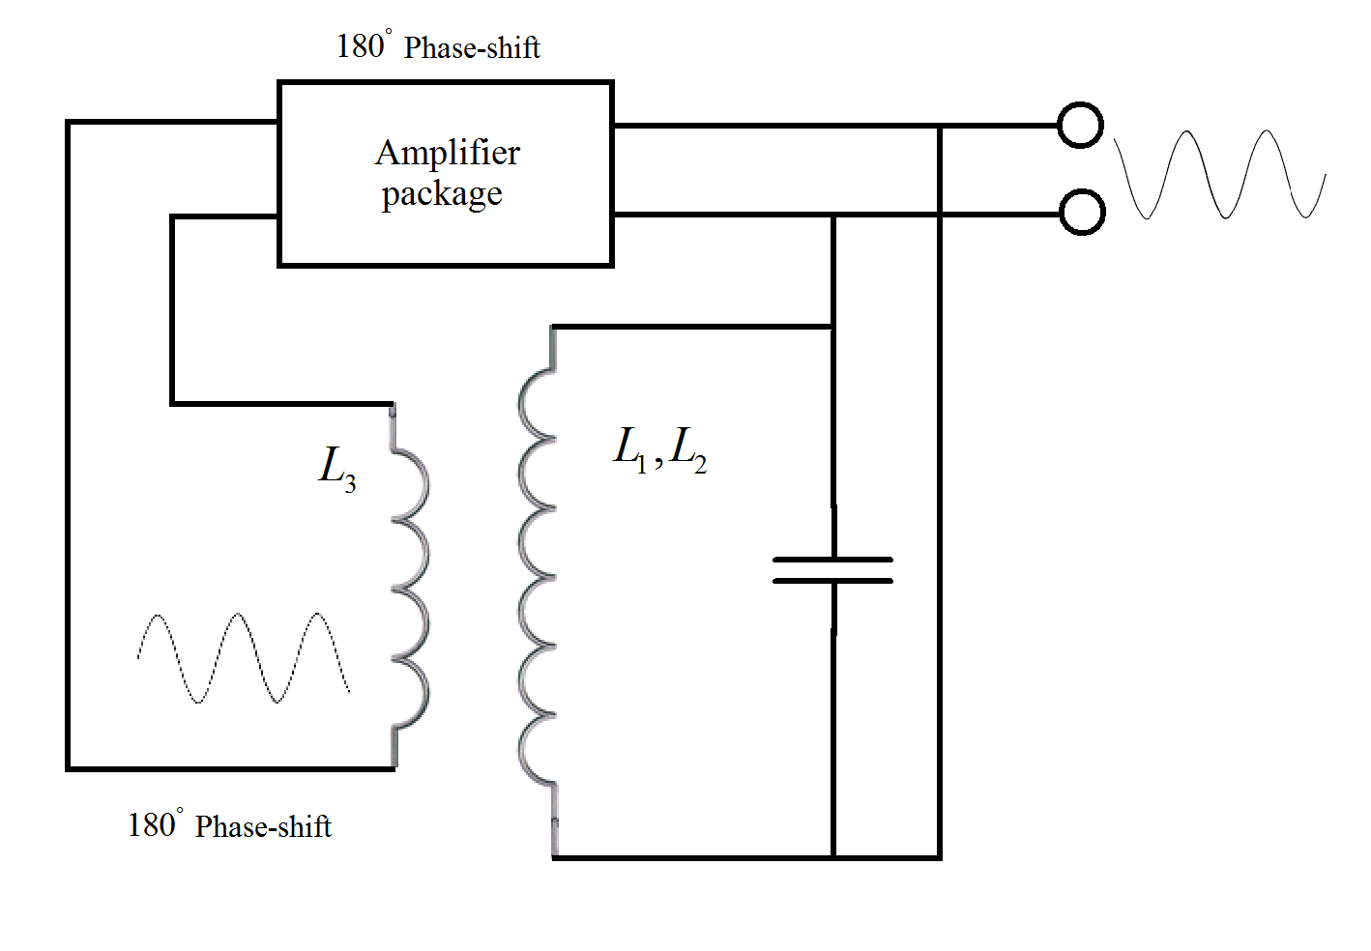

Fig.2.10. Phase-shift amplifier on coils.

A deeper analysis of phase-shifting on circuits is out of the scope of this thesis. What is reasonable is that a power n-MOSFET is a suitable component to replace U1 and U2 of Fig.2.7. The arrangement of Fig.2.7 is altered to Fig.2.11:

* Coil L2 becomes the antenna, and is connected across the drain of Q1 and Q2 to split in half the antenna circuit including the feed from the power supply, polarity opposite,
* plate terminals U1 and U2 are tied together and connect to the negative feed from the power supply, and,
* coil L4 is the receiver antenna, shown in Fig.2.12.

A schematic of the oscillator to drive the circuit is illustrated in Fig.2.11.

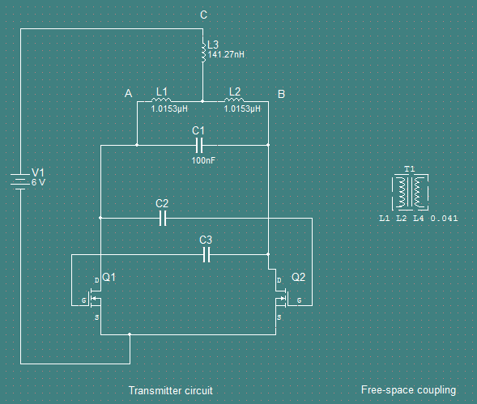

Fig.2.11. The transmission element with a coupled-mode.

This model contains only a simple description of the dipole but it is suspected such a description could go deeper, briefly examined in the Appendix. Regardless, the circuit will create and destroy its dipole in a cycle releasing its energy. The source is the six volt dc power. Since destruction of the dipole is occurring by the current returning to the source in the form of feedback power from the antenna, excess energy will bleed off as heat. The component that absorbs the bulk of the heat is the capacitor C1. At higher source levels, heating of Q1 occurs; heat-sinks for both Q1 and Q2 and a metalized capacitor will keep the circuit from burning out. The author strongly suggests future research be conducted on Joule heating in the circuit.

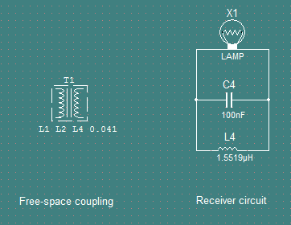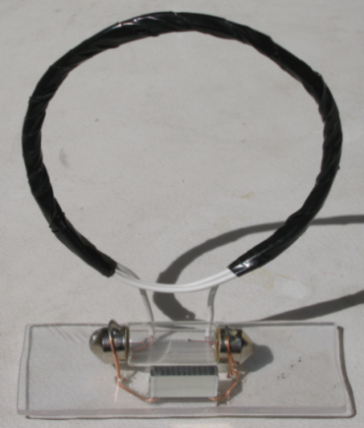

Fig.2.12. (a) The receiving element with a coupled-mode, (b) an example receiver.

Using a suitably constructed receiver, illustrated in Fig.2.12, a simulation of the circuit is conducted. The driving function of the circuit in the simulation will be a pulse. As the theory suggests that a “ringer” is required to start the oscillator. A pulse current  will be used in substitution of V1, shown in Fig.2.13. This is similar to the use of the spark-gap. One of the amplifiers must be shorted while power is applied in order to ring the resonator strongly enough for oscillations to be sustained. A momentary short is placed between the gate and the drain of Q1. The oscillator is self-sufficient requiring only phase offset amplifiers to sustain the oscillations through the cycles thereafter. This is an ideal representation of a kick-start because when the pulse current is adding energy, it forms a closed circuit. Simply stated, the oscillator requires priming. To simulate a momentary burst of energy to the oscillator, the settings of the pulse current are listed in Table 2.2‑1.

Table 2.2‑1. Simulation circuit properties.

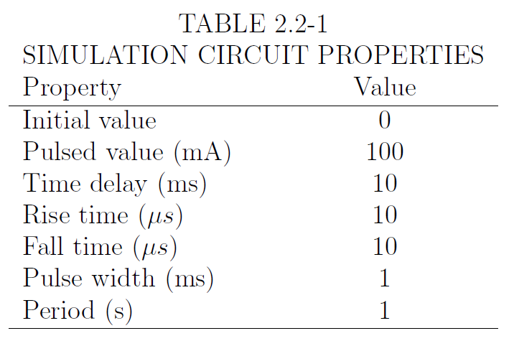

The broadcasting model these settings are applied to is shown in Fig.2.13.

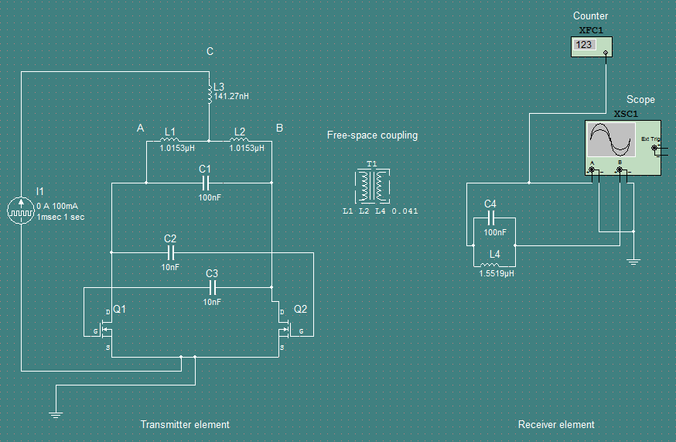

Fig.2.13. The broadcasting model for simulation.

The frequency counter reads 435 kHz, the output signal at the oscilloscope is shown in Fig.2.14.

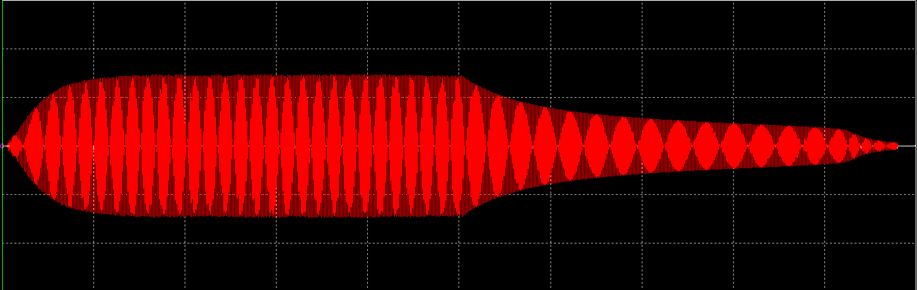

Fig.2.14. Simulated signal seen by the receiver.

The simulation refers to both the transmitter and receiver elements first illustrated in Fig.2.1. What is discovered during simulation is that

* L3 contributes weakly to the inductance of the loop,
* I1 acts as a ringer for the circuit,
* Components L1, L2, L3, and C1 simulate the one resonator; likewise, L4 and C2 simulate a second resonator, they are coupled across free-space at the calculated coupling coefficient from ,
* Q1, Q2, C3, and C4 constitute the oscillator driven by voltage source V1,
* The system transmits energy given the theoretical predictions. Variation of the coupling coefficient  shows the various circuit responses, shown in Fig.4.1 in the Appendix.

It is expected that a sinusoid to be emitted from the transmission antenna with both a positive and negative group velocity outward from the loop surface. Alignment of loop centers, or axial alignment, will yield the highest magnitude of energy transmitted. Efficiency of the amplification is ideal when the node C is placed to as exact to one-half the length of AB. The cyclic quality,  is relevant to describing the internal quality of the oscillator at any particular time *t* when



Equation infers a complex set of amplitudes present across the field object. The effective quality factor  along with the effective damping factor  satisfy the traveling wave solution. These properties are based on the states of the oscillator for each instance of the antenna elements as



for each of the antenna elements  The states describe behavior of the system when there are small changes in , given . The transmission circuit is a series circuit and the addition of  would make  smaller. The receiving circuit is arranged in parallel so that changes in  will make  larger.

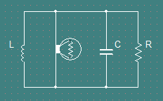

A plot or table to show the effect of R on Q?

A circuit is constructed based on the schematic used in the simulation wherein to test the hypothesis. Measured with a frequency counter, the broadcasting frequency,



It is anticipated that if the dipole is preserved after each cycle, that efficiency would increase. The transmission circuit including the antenna discussed in §2.3.1, is shown in Fig.2.15.

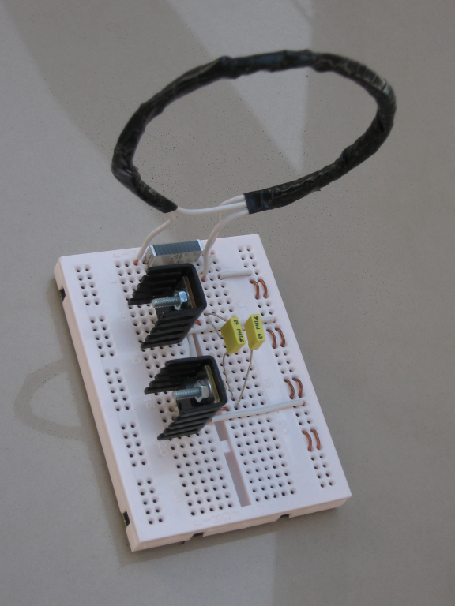

Fig.2.15. The constructed oscillator.

## The propagation model

The transportation of energy across free-space occurs in a pair of tuned circuits, symmetric and set a distance apart, when one of the circuits is electrically stimulated. By amplification, the resonance frequency can be used to accelerate electrons in a coil. Power is then transferred via magnetic fields in the form of photons by an electromotive force around a closed path: the two coils coupled in free-space and proportional to the rate of change of magnetic flux through any surface bound by the path. In practice, this means an electric current will be induced in any distant circuit where the magnetic flux intersects with an appropriate conductor in the path of the oscillations. The placement of the resonant objects in the scheme will be in the path based on the projections of their antenna, coupled to their resonant circuits.

The quarter-wavelength magnetic loop antenna is a useful device to transmit significant quantities of electrical current at reasonable efficiency. For simplicity and brevity, this is a fundamental artifact of the scheme presented in this thesis. The complete range of behavior available is exclusively due to the interface between a set of electrical charges and an ambient structure of free-space at normal temperatures and pressures, for the purposes here of atmospheric air with a characteristic impedance. The antenna has very sharp nulls at right angles to the plane of the loop.

The mathematical components needed to describe the problem at hand: currents in the conductive media and currents in the dielectric. If the medium inside the waveguide is homogenous and isotropic and if the surface impedance at the boundary is zero, the method of separating variables enables us to obtain a set of normal, that is, uncoupled modes of propagation. Any irregularity or discontinuity in the waveguide provides a coupling between some, or all, modes of propagation [21]. This implies that a conductive current in air as occurring in a closed system, being transported on a transmission element whose radius << than the dielectric space, whose waveguide is sufficiently infinite, to impose ideal planetary electrical characteristics.

A necessarily narrowband antenna with steep nulls is required to allow the power to transmit in the signal while rejecting spurious noise and other transient phenomena the magnetic fields could be subject to, including solar radiation.

These nulls can be very useful for suppressing radio interference. A rotation of the loop will reduce noise. Because the nulls are sharp, small changes in antenna orientation can make a large change in signal or noise received from the direction of the nulls allowing the interference to bleed into the field. The nulls are sharpest on the smallest loops at a perimeter approximately  which linearly increases to  at the periphery.

A magnetic loop whose wavelength is a at ratio of its circumference to the resonance frequency of the propagation circuit allows the full degree of a sinusoidal disturbance projected into space. Such a loop sufficiently small is preferred subject-study for mid-size applications. The description is contained in the remainder of this section.

Consider a circuit consisting of a single loop of insulated wire wound in such a way as to create a circular loop of a few turns. This loop and its capacitor become one-half of a resonant circuit forming a transmitter . The length of this wire loop  is then duplicated to construct a similar loop of identical characteristics  along with a capacitor forming the second-half of a resonant circuit forming a receiver . This relationship is illustrated in Fig.2.1.

When energized, this circuit induces an electrical field in the loop , creating a magnetic field which is coupled to the loop . By placing the load in parallel to the voltage gap in loop , magnetic energy is drawn into the gap and converted into electrical current. Inclusive in the loop is a voltage gap of width  no greater than the loop radius, so that . The coil  is positioned in such a way that the  axes form the loop surface and the axis the trajectory out from the loop in the directions of the group velocity of the radiation—positively for right-handed, negatively for left-handed. This relationship is illustrated in Fig.2.16.

If coil loop is wound at a specific ratio of circumference to wavelength, it is equivalent to an antenna connected to an electrically-short transmission line [27]. To maximize the emission of (black-body) radiation, the loop should have its circumference one-tenth of a quarter wavelength or less of the circuit’s resonance frequency. Such a magnetic loop has the “golden” ratio is when circumference to wavelength is on a logarithmic ratio, e.g., tenths. As the thesis is interested to study loops a compact size, the chosen ratio  is



The chosen frequency computes to be approximately 450 kHz.

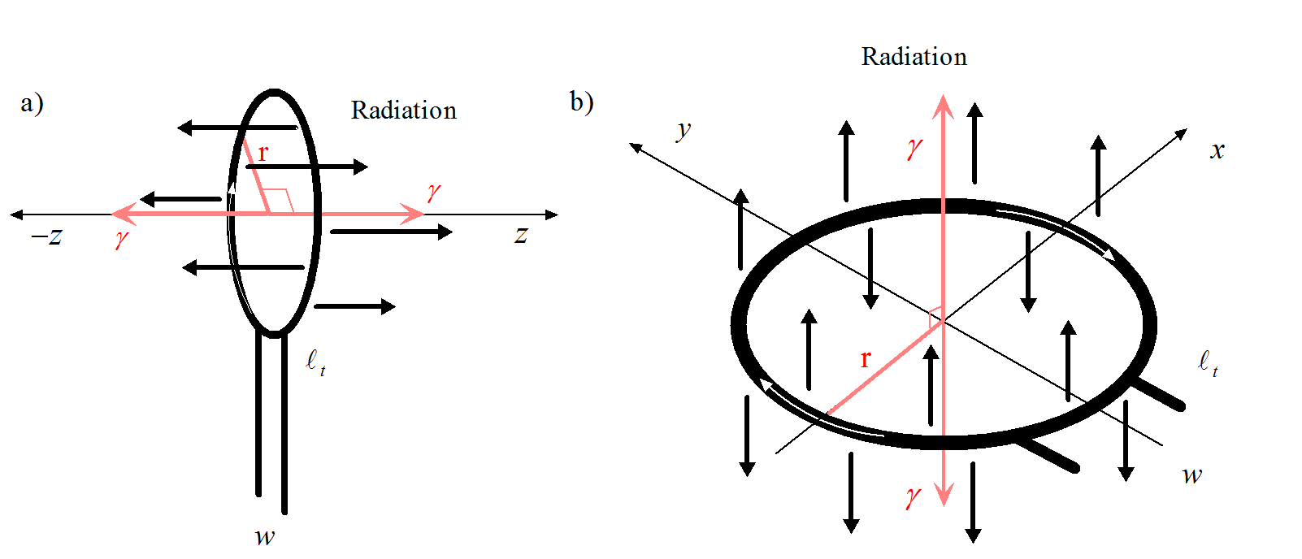

Fig.2.16. Radiation emissions of a magnetic loop antenna.

The antenna loop is excited by the acceleration of electrons on its curvature, driven by the current  from the amplifiers in the circuit. The positive group velocity emits radiation in the form , the negative group velocity emits radiation in the form , illustrated in Fig.2.17.

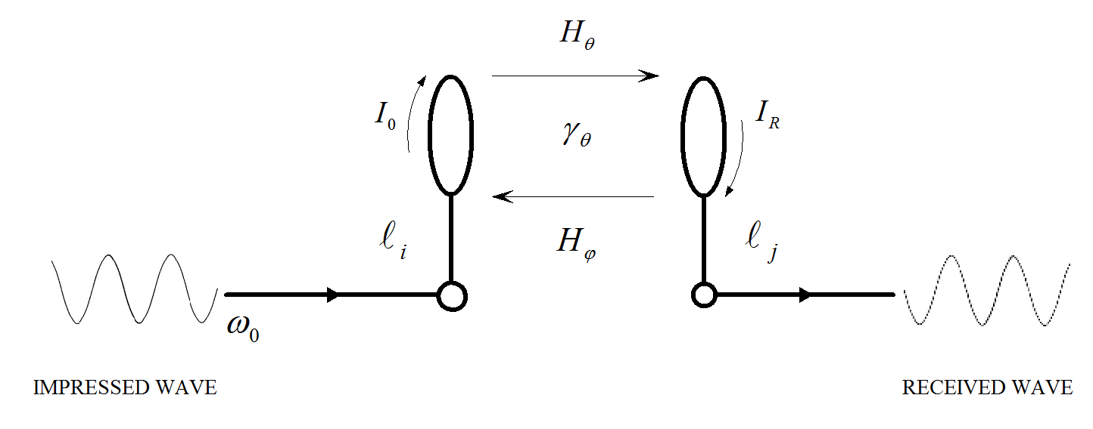

Fig.2.17. Wave propagation for the modal coupling scheme of wireless power transfer.

Because of symmetry, magnetic waves in the form of charged photons of a given angular frequency  flow positively  from coils  and negatively  from coils  with an efficiency . The negative of quantized energy  refers to the direction of flow and not the energy value since the photonic currents appear equal for either motion.

From the circuit point of view, antennas appear as a resistance  called radiation resistance. It is not related to any resistance in the antenna itself, rather, a resistance coupled from space to the antenna terminals. Active radiation raises the ambient temperature of . This temperature is equivalent across the circuit because the temperature of the distant antenna (respectively from the transmitter) can only see its symmetric analogue due to the nature of inductive coupling in that the photons extant in the magnetic field only react with like or other resonant objects [28, [54]]. Under such conditions,  is quantified by the region of space inside the loop as a function of the virtual transmission line linking the antenna to the distant region, shown in Fig.2.18.

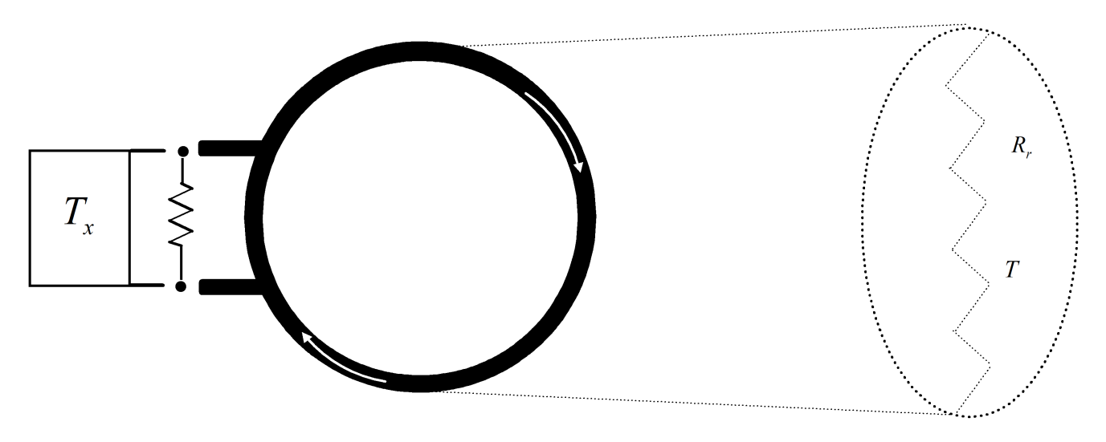

Fig.2.18. Schematic representation of a virtual transmission line of an antenna to a region of space.

The loop will operate using a single-band transmission with regard to the antenna impedance, directivity, and gain. The antenna analysis is essentially equivalent to that for a curved dipole and projected magnetic field given the (Biot-Savart law). The computation of the antenna will target electrically small loop antennas in the normal and axial mode of operation. Radial mode is an advanced topic. Multiple modes are exhibited in §2.4.

Following the discussion of the circuit properties in §2.2, and the schematic shown in Fig.2.11, the transmission antenna coil must be designed to conform to the shifting phase of the amplifiers. The phase is visualized as moving through each segment of  through the circle’s circumference where the radius  is the magnitude of the electric field , and  the velocity of the shifting phase through . The motion of the currents are shown in Fig.2.19.

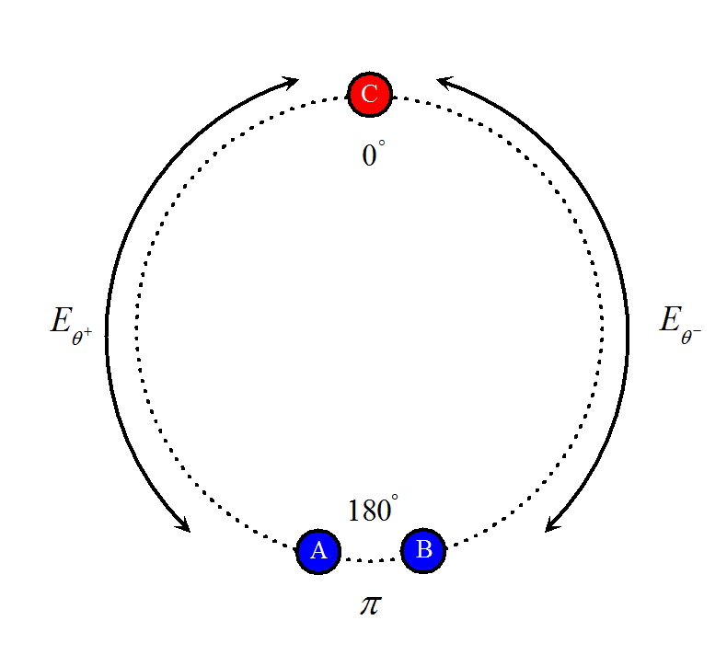

Fig.2.19. Angular motion of the oscillator transition phase.

The material of the coil should sustain the angular velocity of the currents  oscillating through integer multiples of . Copper is sufficient, artificial materials could substantially improve the reactance at the atomic level. An insulated length of wire, , given by A, B, is wound into a loop of a chosen specification. It has a break cut into its insulation at the midpoint in the loop, where and , and a third wire follows the loop forming an extra number of turns, , and an extra standing length, or leg, illustrated in Fig.2.20.

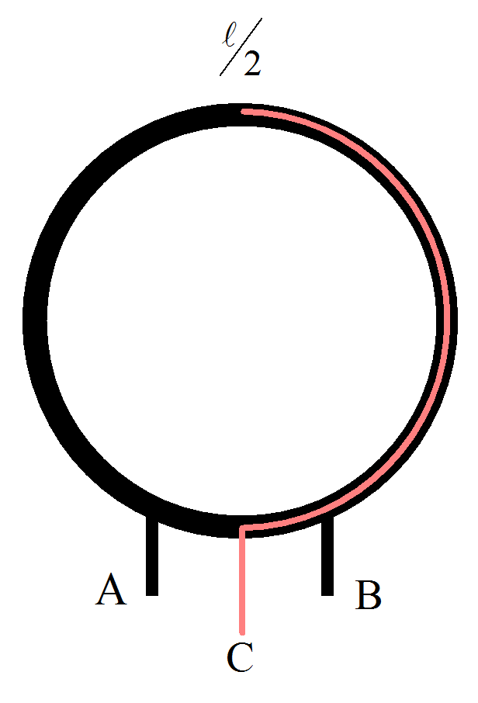

Fig.2.20. The transmitter coil.

The transmission antenna in now a three terminal coil with L1, L2, and L3 behaving as an oscillator when connected directly to an amplifier. Terminals A (L1) and B (L2) are connected across a capacitor to the corresponding drains of two n-MOSFETs whose sources are connected to the negative terminal of the power supply. Terminal C (L3) is connected to the positive terminal of the power supply.

A generalizable computation, the method of moments, will be fitted to solve the problem of the circular loop antenna as a function of the scattering of the field emitted by the transmitter. The computational structures will be Matlab scripts [[55]]. These scripts and what they contain are listed in Table 2.3‑1.

Table 2.3‑1. Computational elements from mesh to field solutions.

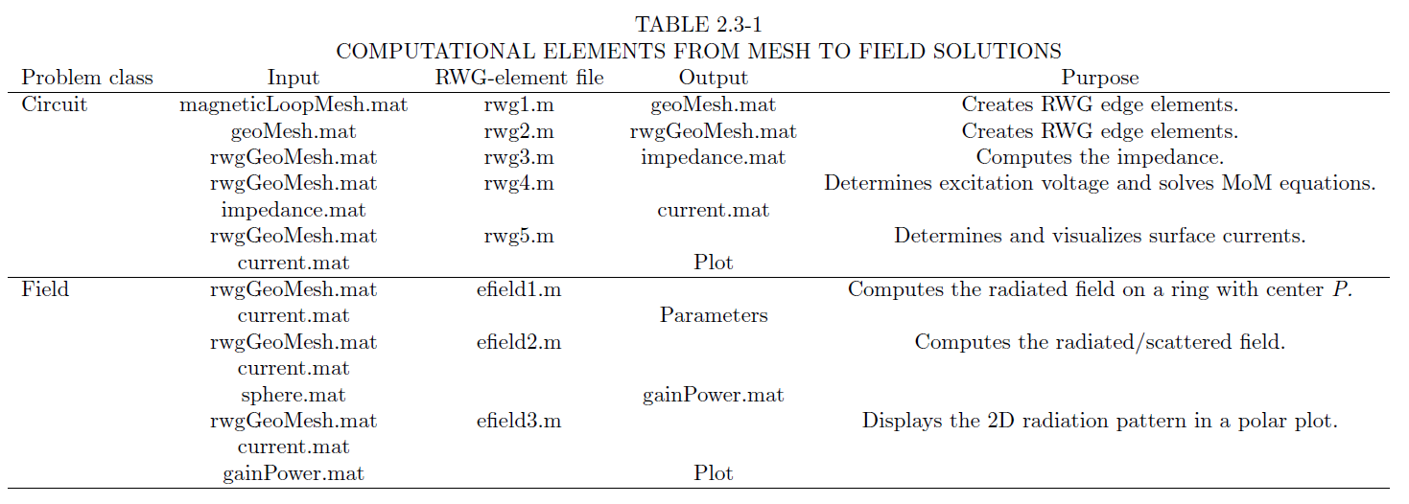

Each of the element files were compiled against the mesh files created in each progressive step. The antenna was solved for and its properties computed. These theoretical results and comparison to the measured results will be discussed. The physical characteristics of the antenna will be discussed in the next section.

The antenna is the sole artifact of wireless power transmission and relies on no other analogue. If wireless energy transfer is to become more useful, it is necessary to establish a set of generalizations regarding specific conditions of operation.

### The receiving antenna

A receiving antenna may be viewed as any metal object that scatters an incident electromagnetic field from a transmitting antenna which propagates a single-band signal. As a result of scattering, an electric current appears on the antenna’s surface. That current in turn creates a corresponding electric field. If a capacitor is attached to the free ends of the loop, as shown in Fig.2.21b, a voltage difference appears at the terminals. The terminal voltage constitutes the received signal; power is extracted through the voltage and fed to an incandescent lamp, shown in Fig.2.12. Analytically speaking, it is ideal if the scheme could be addressed as surface current distribution over the antenna as a three-dimensional oval surface using its edges as propagation of the magnetic field expected in a Boltzmann distribution. The description here will be for a two-dimensional flat surface antenna.

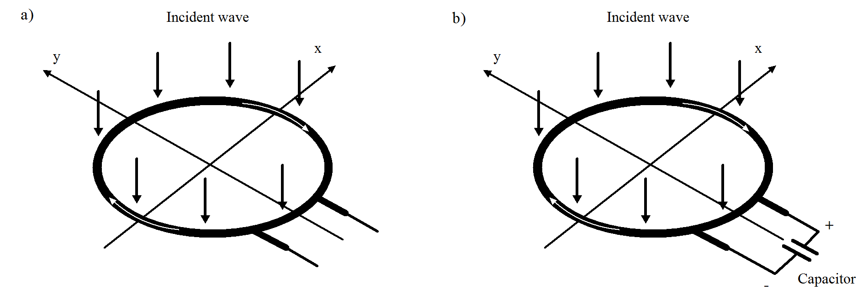

Fig.2.21. (a) Schematic of the receiving loop antenna. (b) Loop antenna connected to a capacitor at the voltage gap. The white arrows are surface currents.

Considering solely the viewpoint of energy transfer, an antenna in the receiving mode collects electromagnetic energy over a certain area, shown in Fig.2.21a, extracts the captured power while both absorbing and reflecting the energy back into free space, behaving like a signal repeater. The specifications of the coils, as illustrated in Fig.2.1, are shown in Table 2.3‑2.

Table 2.3‑2. Transmission and receiving coils physical specification.

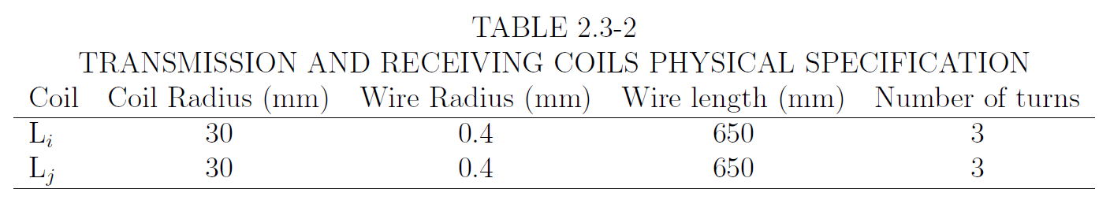

To computationally solve for the antenna, the method of moments is solved for the antenna surface using Rao-Wilton-Glisson (RWG) edge elements. The surface of an insulated metal loop antenna divided into separate triangles as shown in (Fig.2.22a). Each pair of triangles, having a common edge, constitutes a corresponding edge element, see (Fig.2.22b). One of the triangles has a plus sign and the other a minus sign indicating the direction of the current . A vector basis function



is assigned to each edge element where  is the edge length and  is the area of triangle . Vector  connects the free vertex of the plus triangle to the observation point , shown in (Fig.2.22b). Vector  connects the observation point to the free vertex of the minus triangle [[56]].

The vectorized surface electric current on the antenna surface, shown in Fig.2.22a, is a sum of the contributions over all edge elements with unknown coefficients. These coefficients are found from the moment equation . The surface current density on a surface  of a perfectly-conducting structure is given by an expansion into RWG basis functions over  edge elements. The moment equations are a system of linear equations with the impedance . The basis function of the edge element corresponds to a small but finite electric dipole of length  shown in Fig.2.22b and c [19]. Index  denotes the center of triangle  for the division of a loop antenna structure into elementary electric dipoles, shown in Fig.2.22d.

The approximation here is similar approach to describe the currents according to Maxwell’s equations [[57]].

The current density  and the antenna impedance  is represented on surface  If  is open,  is regarded as the vector sum of surface currents on opposite sides of ,



while  expresses the vector voltage from expansion coefficients  forming the impedance moment,  A more detailed discussion can be read in [54], suffice to say, what is interesting here is the derivation of the impedance matrix of the RWG edge elements for the electric field integral equation is given by [55]



where indexes and  correspond to two edge elements.  is the edge length of the element  are vectors between the free vertex point, , and the centroid point, , of the two triangles  of the edge element  respectively.  is directed away from the vertex of triangle , whereas  is directed toward the vertex of triangle . The vectors  are not yet included in the set of key arrays discussed in the previous section. However, they are easily expressed through the known quantities



As discussed in §0, the computational expressions for magnetic vector potential  and the magnetic scalar potential  have the forms [55]:



where



is derived from the integral



To the scattering problem, the antenna voltage is expressed by [55]



where  is the electric field on an incident electromagnetic signal. The voltage excitation vector is analogous to the circuit voltage. The surface electric current on the antenna surface is a sum of the contributions over all edge elements, with unknown coefficients.

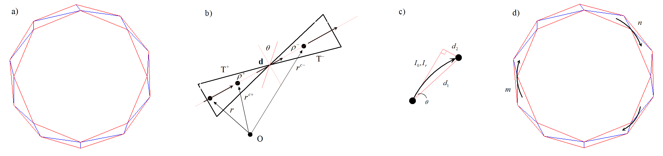

Fig.2.22. Modified schematic of RWG edge element and the dipole interpretation for curvature .

In this manner, the impedance matrix will describe the interaction between neighboring elementary dipoles given over the length of the conductor. If edge elements and  are also dipoles, the element  describes the contribution of dipole , through the radiated field, to the electric current of dipole . The size of  is equal to the number of edge elements. This contribution is calculated using the electrical field integral equation [[58], [59]].

The antenna was constructed and simulated using Matlab while theoretical equations were computed using the *Circuit calculator*. Using Matlab 2009b with the PDE toolbox, the surface mesh is designed by creating a model of the loop and creating RWG triangles. Visually, one can create the meshes based on a 2-D model approximation of a loop surface, shown in Fig.2.23a for 180 nodes and 288 triangles and Fig.2.23b for 648 nodes and 1152 triangles. A step-by-step description is contained in Table 3.2‑2.

a)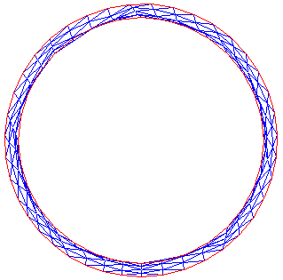b)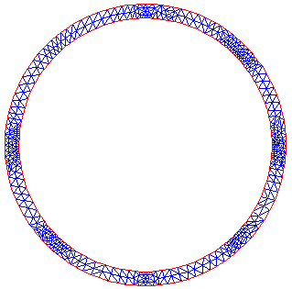

Fig.2.23. Two loop meshes: (a) 288 triangles and (b) 1152 triangles.

During the process of creating the mesh, checking the triangle quality will provide an average characteristic before continuing with the RWG analysis. The triangle quality of both meshes shown in Fig.2.24a while the expected current density, shown in Fig.2.24b, is confined to the inner edge of the loop.

The RWG edge elements are more advantageous than the simple finite dipoles. In particular, they support a uniform axial electric current along a thin metal strip, approximating for curvature [[60]]. For help calculating in Matlab for the desired antenna characteristics from the constructed meshes, code from [[61]] will be used to perform the computations.

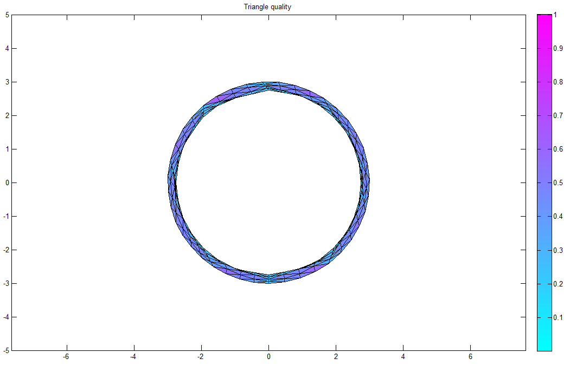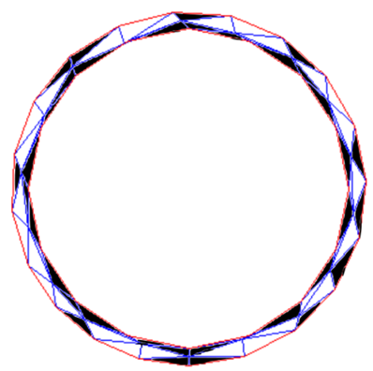

Fig.2.24. (a) Triangle quality of the loop mesh, (b) current density on the loop.

The .mat files containing the compiled mesh of the antenna structure is used as input to the edge generator rwg1.m and to the rest of the code sequence listed in Table 2.3‑1. The PDE tool is used created compiled mesh “magneticLoopMesh.mat” with 288 triangles. Using the input characteristic antenna data

* ,
* observation point: 50 cm on the  axis,
* radiation sphere radius: 100 cm,
* feeding edge [-1,0,0], dipole,

resulted the sequence for output data is listed in Table 2.3‑3.

Table 2.3‑3. Matlab computed input characteristic antenna data.

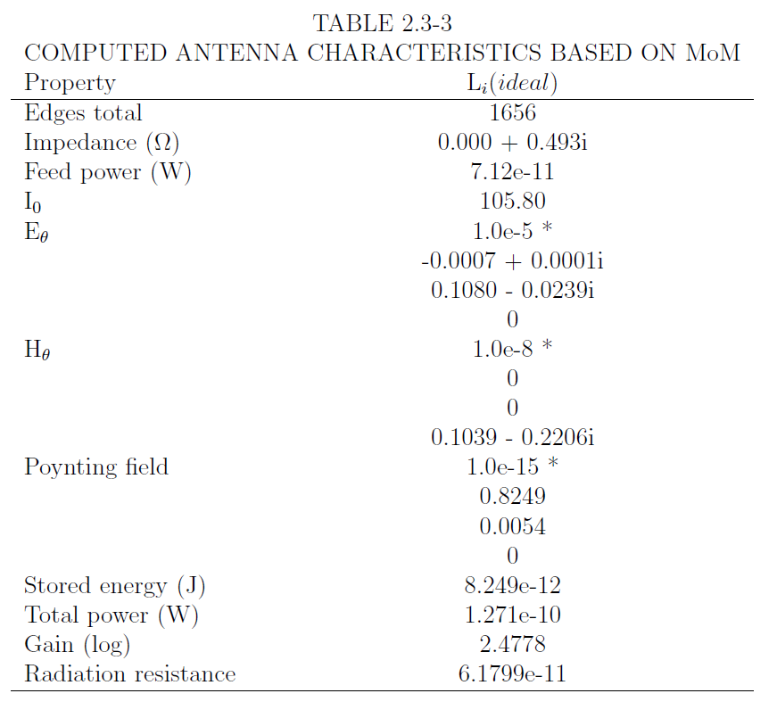

The computation of the model suggests that the structure of the radiation is purely a property of the geometry of the coil, as expected. A map of the spherical power at the observation point is shown in Fig.2.25.

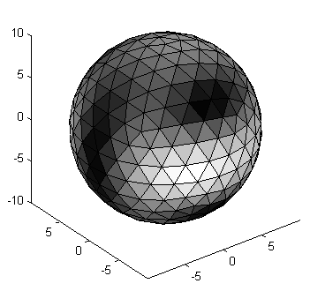

Fig.2.25. Directional density of field, white triangles shower higher power.

It is interesting to now compute the equations to find the power and radiation resistance of the field where its intensity is at peak, given the distance between the antenna, shown in Fig.2.28.

### Radiated power

How do we want to write this, reading Kraus?

In terms of the circuit model and the physical antenna, energy and power are computed using the C# program *Circuit calculator*. The voltage and current are related via the impedance of the loop In the case of electrically-small loops, impedance is the series combination of the reactance of the external inductance  and radiation resistance  and ohmic resistance of the conductor



and voltage operating on the loop have the forms,



where  is the current in the short-circuit at  and  is the length of the attractive transmission path. The impedance, , is calculated by



The average stored magnetic energy in the loop in its single mode at resonance is



The average stored electrical energy does not need to be calculated separately since the system is at resonance. i.e., . So



One interpretation that can be drawn from the mathematics is energy can be applied to the system to the point as the waveguide, in this case the environment of free-space, can sustain.

A discussion of the calculation of the potential of free-space is well outside the scope of this thesis, however, suffice it to say, it is expected this number to be very large given the radius of the coils.

Finally, the dissipated power, while a property of the load present, is also a property of the power sustained in the magnetic field. However, because of the proceeding, any electric current input will flow to the load across free-space as



This is equivalent to the relationship of the stored energy at resonance and that a complex resistance is attenuating the transmission, contributing to both the impendence  and admittance  simultaneously.

For a non-isotropic radiator if the emitted power is , at a distance *d* meters from the source, the magnitude of the wave’s Poynting vector (power per unit area) is



The radiated power  may be replaced by , where  is the power delivered to the transmitter antenna by the amplifying switches in the circuit and  is the transmitter antenna gain. The electric field intensity, the result of active coupling, at the antenna interface is



where , the impedance of free-space, is given by



At a relatively large distance from a non-isotropic radiator, the electric field intensity, or the simple magnitude of the disturbance, is



If the electric field intensity and power at the receiving antenna are  and , respectively, the maximal useful power that could be intercepted by the receiver is



For a non-isotropic antenna with antenna receiver power gain , the received power is, following ,



yields,



The ratio of received power to transmitted power is found to be



Plot and talk about radiation resistance from the snaps and add to circuit calculator!

The average radiated power can be considered to be lost as far as the source oscillator is considered, therefore, the antenna behaves similar to a resistor as dissipating power from the source. The resistance, called radiation resistance, is defined as an average quantity



where  is the input power to the transmitter coil, see Fig.2.1 and Fig.2.17. Modifying , assuming a uniform current (Boltzmann) distribution,



where  Solving for radiation resistance of the antenna specified in Table BLAH,



This comes from the REMAINING TODO folder.

To insure maximum performance, the power-transfer efficiency  verses the normalized distance  (the ratio of separation between the coils and the geometric mean of the primary and secondary coil radii  will be the measure of this maximum gradient along the length away from the coil along the x axis, referring to Figure 1. It is the gradient that will be analyzed experimentally in the next section.

The potential coupling  changes the further the distance away as a measure of 1-dimensional coordinates along it. This is visualized as:

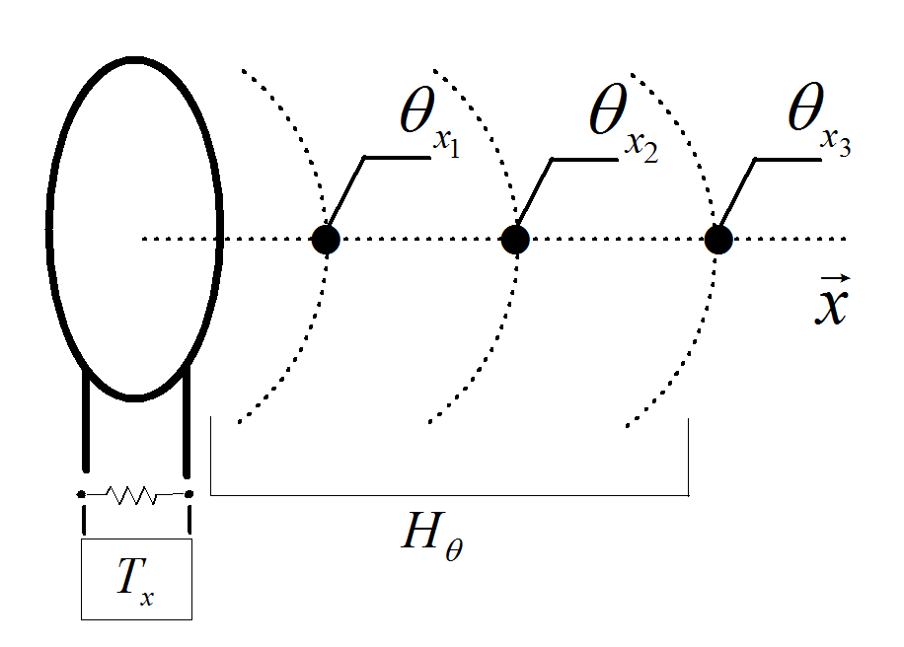

Fig.2.26. Projection of magnetic currents with highest potential coupling points .

In the space containing the energy, the intensity of the magnetic field can be known in advance given the distance between the coils and the radius of the primary coil. In a multiple-turn Litz-wound coil of turns  with radius , the magnetic field strength  at distance  from the center of the coil along the axis can be written as [[62]]



Differentiating with respect to  shows that for ,  will be maximized. Therefore, a good choice of diameter  for the primary coil, as a measure of its distance  from the secondary coil (receiver)  is .

Check for help with this piece [[63]].

In the design chosen for experimental verification (in mm), the diameter  at distance . While this will show an optimal value, the maximum range of this design is approximately 100 mm, dependent upon the power at the source driving the antenna. The magnetic flux linkage and field intensity at the optimal distance is illustrated by Fig.2.4.

The presence of currents on the wire give rise to the magnetic fields propagated into free-space because the antenna is purposefully designed to be am emitter of electromagnetic photons.

The results from the simulation suggest the design is sound and can discuss the last theoretical piece before defining the antenna to be connected to the circuit.

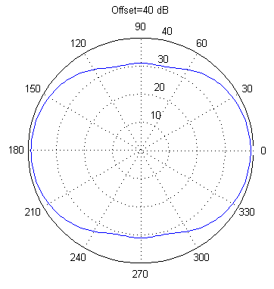

Fig.2.27. Antenna radiation pattern.

### The field emissions

At distances where , the near field, where , will be discussed only briefly as a plot of energy intensity over distance, shown in Fig.2.28.

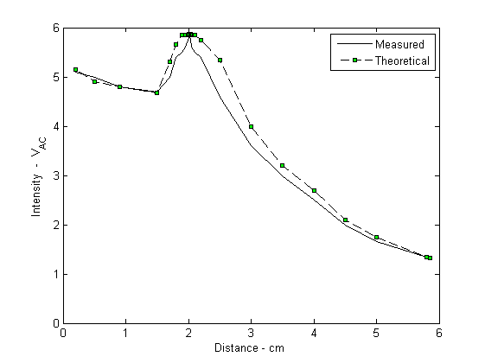

Fig.2.28. The ac power intensity seen by the receiving antenna with axial alignment.(NEW DATA)

Pertaining to the measurement of the intensity (I?), shown in Fig.2.28, Radiation patterns for observation point of 20 cm (photometric peak intensity), 50 cm, and 1 m.

For the incident wave:



the reflected wave is given by:



Where the quantity *к* is the vacuum wave number. The plane-wave fields are transverse and only the tangential components exist at the boundary plane of . Equations and represent the electric field present as a result of the reflection of the wave. By inverting the relationships of the equations, determine the strength of the electromagnetic field surrounding the coil winding. The electric field generated by the Litz winding is



where,



The quantity *I* is the intensity, *a* is the spacing between the wires, *d* is the diameter of the wires, *θ* is the index of refraction, and *λ* is the wavelength. The profile of the antenna and the pattern of the transmission energy is illustrated in Fig.2.29.

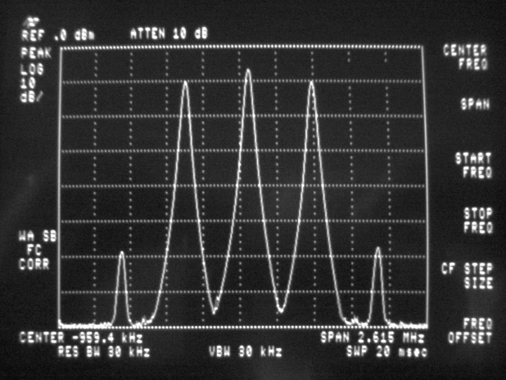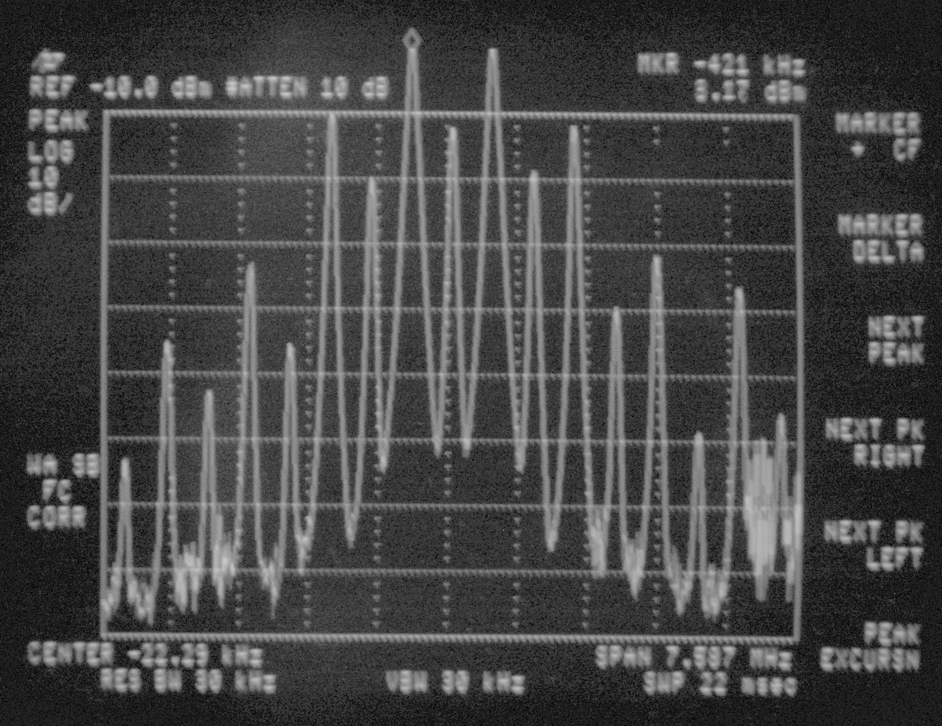

Fig.2.29. Radiation pattern observed at the receiver.

The radiation pattern of Fig.2.29 is observed where  is proportional to the field intensity approaching maximum at a distance from the transmitter. The pattern has its main-lobe maximum in the  direction  with minor lobes to the left and the right in other directions. Between the lobes are nulls in the directions of zero or minimum radiation.

Discuss the radiation pattern.

To specify the radiation pattern with respect to the field intensity and polarization requires three features: The  component of the electric field , the  component of the electric field , and the phases of these fields as functions of the angles  and  or  and . Dividing a field component by its maximum value will reveal a normalized field pattern, a dimensionless number with a maximum value of unity. The normalized field pattern for the  component of the electric field is



At distances relative to the size of the antenna and small compared to the wavelength, the field pattern is expressed in terms of power per unit area, or the Poynting vector . Normalizing the power with respect to its maximum value, as in the electric field example, yields a normalized power pattern as a function of angle, which is a dimensionless number, with a maximum value of unity. The normalized power pattern is



where , the Poynting vector equals



expressed in rectangular coordinates on a decibel scale



of Fig.2.29. The efficiency of the transmitted power in the primary mode is given by the ratio of its total beam area  consisting of the main-lobe area  plus the minor-lobe area . The ratio of the main beam area is the beam efficiency



while the ratio of the minor-lobe area to the total beam area is the stray factor



with a total efficiency of



In experiments, this value is shown to be [0.94].

Directional finding [[64]]. Table of radiated power characteristics for the antenna.

Table 2.3‑4. Radiated power characteristics.



The operational circuit including the antenna powering a lamp a distance is shown in Fig.2.30.

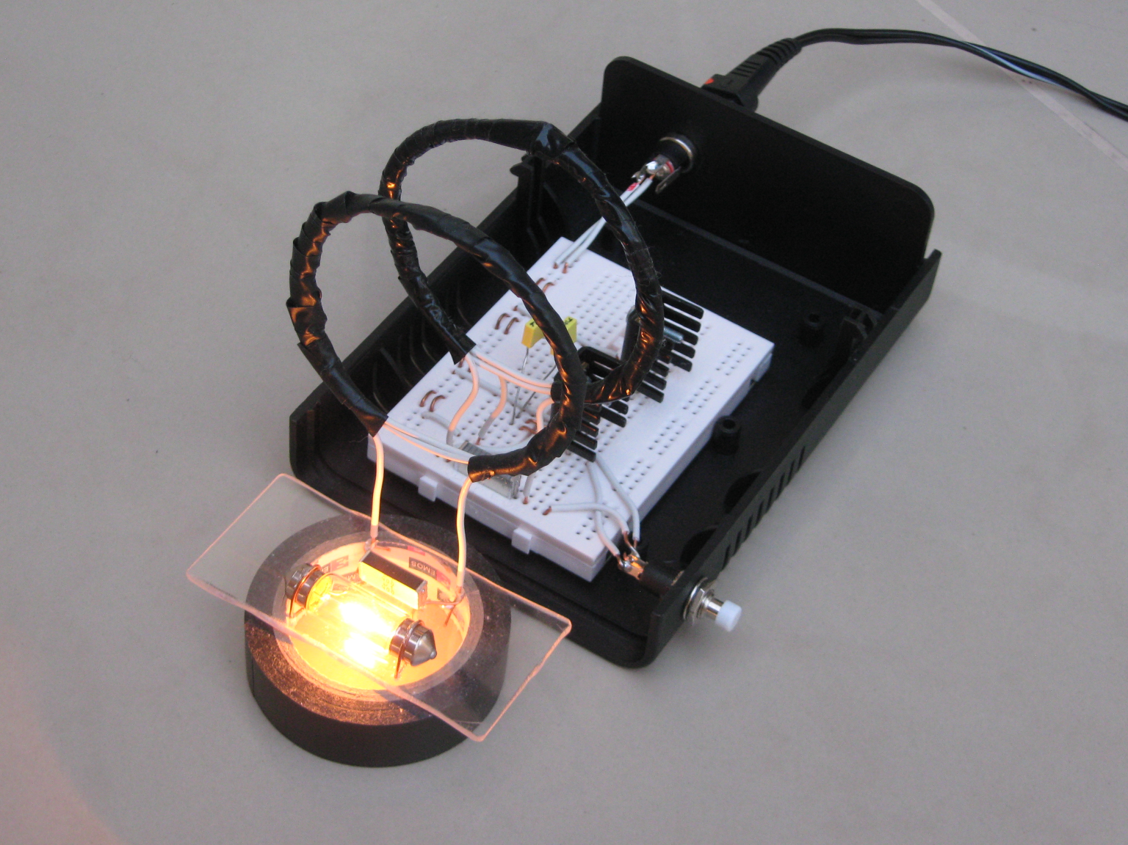

Fig.2.30. Operational oscillator demonstrating the wireless power scheme.

This is for a single loop power scenario.

## Multiple loop receivers in human proximity

Power delivery for biomedical implants is a major consideration in their design for both measurement and stimulation. When performed by a wireless technique, transmission efficiency is critically important not only because of the costs associated with any losses but also because of the nature of those losses, e.g. excessive heat can be uncomfortable for the individual involved. In this paper a method and means of wireless power transmission suitable for biomedical implants is both discussed and experimentally evaluated. The procedure initiated is comparable in size and simplicity to those methods already employed however some of Tesla’s fundamental ideas have been incorporated in order to obtain a significant improvement in efficiency. The paper contains a theoretical basis for the approach taken however the emphasis here is on practical experimental analysis.

Implantable biomedical devices have, particularly in recent years, received much attention with regard to their application for a variety of uses involving both stimulation and monitoring. In direct contrast to wearable monitoring healthcare systems [[65]], one of the key issues for implanted devices is the satisfactory provision of power on an ongoing basis. For short term experimentation it is quite possible for sufficient power to be provided transcutaneously, a good example of this being in the 3 month implantation testing of the Utah Array [[66]]. For long term implantation however power needs can vary considerably [[67], [68]].

Implants such as the Utah Array have in fact been used for a variety of applications, including an alternative sensory input and neural control of prostheses as well as a new means of communication [[69]]. Transcutaneous power delivery for any long term employment will however always carry with it the chance of infection for the recipient as well as the possibility of mechanical leveraging. Clearly an onboard/on chip power pick up device that avoids transcutaneous power supply is an attractive alternative which will most likely result in more widespread use of the technology [[70]].

Some devices, which require several milliamps of stimulating current, such as those used in the deep brain stimulating electrodes for the treatment of Parkinson Disease, need full battery implantation [[71]]. This technique then suffers from the requirement of periodic battery replacement. On the other hand, it is possible to consider energy harvesting within the body. This approach is however still in its infancy and its practical usefulness is yet to be fully realized [[72]].

Wireless power delivery offers the advantages that it reduces the risks (particularly due to infection) associated with either battery replacement surgery or a transcutaneous supply. Inductive coupling can be employed for such power transfer, but the efficiency of transfer is a (very sensitive) function of coil dimensions and the distance between them. Resultant efficiencies for biomedical implants are, as a result, generally very low [[73]], particularly so in a practical, working environment. The most attractive scheme is arguably therefore coupling between magnetically resonant objects [[74]].

While the idea of wireless power has been explored extensively in the literature with several competing power delivery techniques being considered, the most directly relevant are those in which power is not directed, but rather is absorbed [[75], [76]]. In essence, the required load or draw-down current is determined by the operational constraints and not by the beaming method employed. This feature allows magnetic currents to exist in a passive mode, i.e., the energy does not persist in the environment continuously but rather is tapped into on-demand. As a consequence of this, less energy is consumed to drive the circuits.

In this section we discuss a method for the transmission of power by magnetic resonance in order to power biomedical implants. What is made apparent here is the small size and relatively few components required in the method described as compared to the relatively large and efficient amount of power transmitted.

The transmission frequency selected for the system is 450 kHz, due primarily to the fact that that no adverse biological effects have thus far been reported at this frequency [31]. Nevertheless, in the scheme of magnetic resonance for power transmission, it has already been determined that the transmission does not interact with off-resonant objects [28].

Using an on-board miniature solid-state high-power amplifier, we demonstrate here a prototype capable of delivering reliable operating characteristics suitable for practical implants requiring a steady power supply of anything from 4.5 to 12 volts dc.

Contrary to the purposes of other implementations [[77], [78], [79], [80], [81]], of specific interest here is to question whether a scheme could be accomplished using small coils of a few turns driven by a simple amplification circuit. The goal of this exercise is therefore to establish a driving circuit with a minimum amount of components, thereby reducing device complexity and emitted heat.

As a physical demonstration of the operating characteristics of the method described, we have set a requirement to maintain a sufficiently high-powered signal to reliably power a lamp and motor. The reasoning being that if the technique can function well in terms of such external requirements, it will certainly perform adequately in the case of an implant specification.

In this regard, it has not been our goal to deliver power at the sort of distances reported on in such as [78, 77] where efficiencies of 40% are perhaps the upper target. Rather here we attempt to compare directly with transmission over relatively short distances (a few cms), as reported on in such as [[82]], with a high efficiency of transmission (over 90%) being our target.

An overriding aim is to overcome power supply issues, eminently apparent in the study of biomedical implants, by realizing a wireless scheme which is sufficiently powerful such that an implant can reliably receive its power remotely. Hence direction of power transmission as well as the size of technology involved has been important in our studies.

Firstly, in the section that follows, we give a theoretical underpinning of the scheme. Following this we provide some experimental power transmission results. It is worth stressing that these have been obtained from an actual prototype transmission network rather than a computer simulation.

The concept of wireless power transfer, first described by Poynting and experimentally verified by Tesla, has been illustrated in the literature as a viable method to transport electrical current between distant points [21, 73, 81, [83], [84], [85]]. The extension of this method herein maintains a significant amount of useful power transmitted at intensities of less than 15 volts in which, across a volume of air, magnetic waves are exchanged between two or more coupled resonators.

Consider a circuit consisting of a single loop of insulated wire wound in such a way as to create a circular loop of a few turns. This loop, connected in parallel to a capacitor, becomes one-half of a resonant circuit. This is designated as the transmitter . The length of the wire loop in  is then replicated to construct a similar loop placed on an independent circuit board positioned a distance away and which is connected in parallel with a capacitor of the same reactive value and a load. In its entirety this becomes the second-half of a resonant circuit, designated the receiver .

Each half of the resonant circuit is placed a distance from the other. The transmitter is connected to a power source such that the LC circuit is excited. Because of the symmetry between each half of the circuit, magnetic waves flow from  at resonance frequency  with an efficiency . When energized, this circuit engages an electrical field in the loop in , creating a magnetic field which is coupled to the loop in . By placing the load in parallel to the loop in , magnetic energy is converted into electrical current. The arrangement is illustrated in Fig.2.1.

A number of receivers can though be fed from one common transmitter, thereby opening up the potential to power mobile robotic platforms by this means. A theoretical configuration of the circuit in a robotic implementation is a single fixed-position transmitter  delivering energy to distant receivers  and . Such a circuit has been constructed and tested for the intensity of the induced current at different distances away from the transmitter. The receivers are grouped into two categories:

1. ac mode: lighting an incandescent lamp, and,
2. dc mode: turning a motor.

Either of the receiver  or  is a lamp or a motor; these become synonymous platforms in what platform they are required. The experimentally-tested range of this method is illustrated in Fig.2.31 and Fig.2.32.

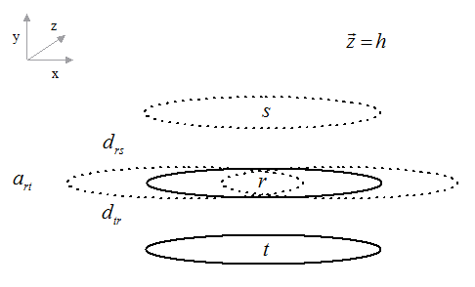

Fig.2.31. Experimentally-tested orientation of multiple receivers  and  with reference to each position at the transmitter  when there is no angle of rotation away from axial alignment . The standing height of all coils are equal.

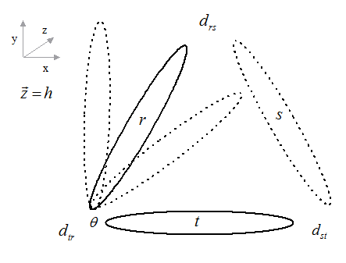

Fig.2.32. Experimentally-tested orientation of multiple receivers  and , through with an angle of rotation  away from axial alignment, with reference to each position at the transmitter . The standing height of all coils are equal.

Using two or more receivers,  will be additive to the solution for each receiver from the perspective of the entire efficiency calculation. If interaction *between* the receivers is considered, modifying then gives [73]

Overall however, although the separation distance examined here was relatively short (albeit appropriate for biomedical implants), given the radii of the coils, a high amount of power was delivered at high efficiency.

Using three receivers, Q will be additive for each receiver from the perspective of the entire efficiency calculation of equation (1); modified given [73]:



If it is desirable to consider the interaction of the magnetic fields each of the elements: transmitter, receiver one, receiver two, or more operating on each other. If the consideration is given that the operation is limited to between a transmitter and receiver one, receiver two *exclusively* (i.e., not interested in the coupling between each receiver but noticing the increase in  as then the total is given [48] by:



The loaded qualities, ,  as a property of the capacitance , , resistance , , and inductance ,  of the circuits containing the coils are defined in . The coil properties are shown in .

Table of three coil properties, real.

When using two AC modes, quality values in respect of the second receiver are additive to the overall calculation. In this geometry, multiple receivers will exchange magnetic energy with the transmitter and each other. The quality factor, with reference to (equation), is based on those properties—inductance, capacitance, and resistance—which allow it to manifest a state of resonance between each half of the circuit. By inspection of the equation—and when compared to SOMETHING—the amount of energy available to each receiver is due to the energy consumed in the work being performed given the system’s ability to send a limit of quantity of energy given the arrangement within the oscillator. Therefore, a system with multiple receivers will have an “additive” quality in that the transmission will support more than one receiver equally subject to its orientation and position; further, a second receiver (either loaded or unloaded) placed between the transmitter and single receiver, in both AC and DC modes, will allow the amplification of signal over the distance given its ideal position between each, which in experiments is shown to be one-half the distance. Practically speaking, this is a means of extending the magnitude of the transmission beam over a longer distance by “chaining” the receivers together.

Talk about this in terms of spherical coordinates.

An interesting observations: is it this lack of mass, to do real work, of the reason can’t turn a motor while a nearly dead 1.5V AA cell will? In the battery case, dealing with real electrons; in the wireless case, dealing with photons.

### Coupled-power modes

The physical properties of the circuit constructed for experimental purposes are shown in Table 2.3‑2.

The experiment was aimed at answering three questions:

1. What are suitable geometric positions for the coils in order to deliver power to sufficiently drive a 10 gram motor at 6 volts, with an operating torque of 3400 g-cm?
2. What are suitable geometric positions in order to deliver power to sufficiently drive a 12 watt incandescent lamp?
3. What is the consequence in terms of power availability and draw down of adding multiple receivers?

The quantities of measurement required are:

* Intensity by voltage present in the receiver, in the case of dc mode, from a minimum to maximum position,
* intensity by photometric intensity of a lamp, in the case of ac mode, from a minimum to maximum position.

The goal is to calculate the physical properties of the system and see if practically measured efficiency agrees with the theoretical quantities. To accomplish this we employed two sets of receivers: one pair of lamps and one pair of motors.

Each receiver was operationally tested in one of two modes:

* ac mode. Receiver  contains a capacitor and a lamp.
* dc mode. Receiver  contains a capacitor, a full-wave rectifier bridge and a dc motor.

Each mode can be used separately or combined.

The receiver circuits in each mode were constructed differently although each used a coil loop wound with the same physical characteristics as the transmitter coil. Each had a capacitor of the same value placed in parallel.

For one of the ac modes, a bias resistor was added in parallel to increase the Q value. For all DC modes, converting the radio-frequency signal to direct current was straightforward. Using 1N34 germanium diodes as a bridge rectifier resulted in minimum voltage drop.

The behavior of the received current was contrastingly different between each mode. In AC mode, there is a measure of feedback reflected across the circuit, which in this case, would initially suggest an improvement of performance, as illustrated in Fig.2.34.

However, this comes at a cost. The distance from the transmitter was reduced to 7 cm in AC mode while it was held at 10 cm in dc mode.

Using the modes illustrated we next describe here the operational freedom of the mobile receiver.

### ac mode

It can be seen, from Fig.2.28, that when using one ac mode, signal performance of a receiver  was maximum when its distance  from  was 2 cm and its axial difference  was no greater than 3 cm to the left or to the right of , as was illustrated in Fig.2.31. Meanwhile the maximum distance for the receiver when the lamp was absorbing enough power to ignite its filament, was observed at 6 cm.



Fig.2.33. The ac power intensity seen by a receiving antenna with axial alignment.(NEW DATA)

When using two ac modes (meaning the use of two receivers in ac mode – essentially two lamps operating simultaneously), the signal performance of one receiver , while comparable to one AC mode, consumed power relevant to its proximity with , as expected, but attenuated by a distant receiver . In our experiments the maximum distance when the lamps were absorbing enough power to ignite their filaments, was observed at 6 cm. However by lining up  and  with minimum axial displacement, the currents constructively interfered creating a solenoid structure. This method extended the range of useful induced current to 8 centimeters.

When using one ac mode and rotating at an angle , as illustrated in Fig.2.32, the signal performance of a receiver was observed when  was between 40 and 90 degrees offset from . In this range, the luminescence falls off and remains steady at = 90.

At a distance , = 60, the lamp was at peak brightness within 1.5 cm, movement along the axial length reduced the signal to its minimum at 3 cm. However, movement along the trajectory of  reduced the signal to a minimum at 2 cm. Exactly the same behavior was observed for receiver . Tentative results suggest that the field is consistent across its manifold, i.e., consisting of a finite spatial geometry symmetric along its axial length.

When using two ac modes and rotating at an angle , signal performance of the receiver , while comparable to one ac mode, it was found that for segments of its rotation through  energy was exchanged between the two receivers.

When introducing a third and fourth ac mode, e.g., adding a third and fourth receiver, the geometric positioning of the intensity of the magnetic field object remained constant and, relevant to the position of the other receivers, more energy was absorbed at the peak, as already described.

### dc mode

When experimenting with one dc mode, using a germanium rectifier bridge, the signal performance of a receiver  was maximum when the distance  was at its minimum proximity to  and the axial difference  was no greater than 1/3 of the radius to the left or to the right of , as illustrated in Fig.2.34.

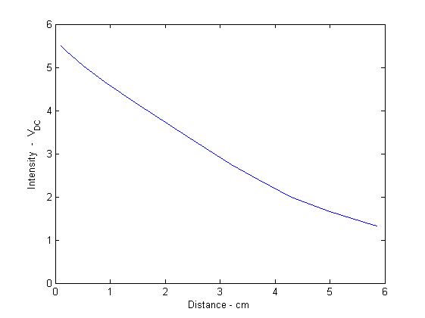

Fig.2.34. The dc power intensity seen by the receiving antenna with axial alignment.

In the experiment motor performance was observed at the receiver with sufficient torque to drive the wheel of a robot when the receiving coil was closest to , with the power induced falling off steadily up to a distance of 4 cm, where it was just sufficient to do the same. When the motor was not loaded, it exhibited a similar performance up to a distance of 9 cm.

The next experiment involved using two dc modes (meaning the use of two receivers in dc mode – essentially two motors operating simultaneously) in a germanium rectifier bridge. Results were found to be comparable to one dc mode in terms of power consumption relevant to its proximity with , as expected, but the power was attenuated by the effects of the distant receiver .

The maximum distance, when there was found to be enough power to drive a loaded motor, was observed at 9 cm. By lining up  and  with minimum axial displacement, the currents were made to constructively interfere, creating a solenoid structure. In this way sufficient induced power to drive a motor could be extended to a distance 12 cm.

When using one dc mode and rotating at an angle , as illustrated in Fig.2.32, signal performance of a receiver was observed when  was between 40 and 90 degrees offset from . In this range, the luminescence fell off, remaining steady at = 90.

When using two dc modes and rotating at an angle , signal performance of the receiver , while comparable to one dc mode, exhibited segments in its rotation through  where energy was exchanged between the two receivers.

When using one ac and one dc mode, signal performance of the receivers was found to be comparable in each characteristic performance based on experimental observations. Energy is exchanged so that it is distributed by the position of the receiver relevant to its multiple based on the total energy available in the circuit. By increasing power to the source, higher intensity currents are available to each receiver.

While demonstrating the transmitter generates magnetic waves which can pass through walls and does not interact with off-resonant objects such as humans or animals, there are reasons where it is undesirable to exchange energy with a circuit which shares characteristic properties of the resonant circuit. In such cases, shielding of a resonant object is possible by enclosing the machine in thin metallic foil. It was observed magnetic waves present in the system cannot penetrate such a substance.

*Information transfer*

Although not directly examined in this paper, information transfer is also possible by means of the same circuitry, given the sinusoidal nature of the power transmission. Additions to the amplifier circuit would however be required where a modulation signal is introduced to the carrier. Modifications to the receiver would however also be required.

*Optimization*

On examination of , and discussed in §2.2, it can be seen that it is possible to affect the quality factor of the coil by adding resistance into the receiver circuit. This is achievable particularly when using high-wattage resistors at low quantities of resistance.

For example, by adding a 500Ω resistor in parallel with the load this raises the quality factor of the circuit thereby causing the lamp to give off a brighter luminescence. In doing so it also improves the efficiency of the circuit. It has to be said however that the addition of resistance into a dc circuit was not tested here. Adding series resistance is supported by work in [77].

By increasing the length of wire after the rectifier circuit, the useful range of the dc signal was extended out to 12 cm.

At higher voltages, i.e., those at 9 volts and greater, the heat given off was found to be minimal in the circuits tested. What heat there was found to be concentrated around the capacitor in parallel with the loop and was linearly related to the input current.

The maximum power was transmitted in this experiment by driving the amplifier circuit at 12 volts. At this level, there was found to be significant heating of the transmitter’s capacitor. Changing the input voltage altered the output voltage, i.e. there was no apparent storage of magnetic energy in the magnetic field.

Any increase or decrease in power supplied does not alter the locations where the coils achieve a maximum or minimum in their resonance coupling, rather it increases or decreases respectively the available power at those locations.

The maximum energy transmitted in our experimentation was 36 kJ. The apparent limiting factor in this scheme was the number of amplifiers we employed. It would be of interest to apply further amplifiers, thereby increasing the power in the system, in order to understand how much current can be practically transported in the geometric space.

Perhaps the most significant results obtained in our experimentation were those relating to the efficiency of power transfer. Here we have aimed to use small, simple and efficient means, at directly comparable distances to those reported in [47, 73, 81]. The main goal of our research program being to ultimately deliver power for biomedical implants – as described in those papers.

In our case, with two coils, both of radius 3 cm, set 2 cm apart, a measured power transfer efficiency (at peak) of 91% was achieved. This compares directly and extremely favorably with the 82% reported in [73] and the 80% reported in [47]. It is worth adding that it compares even more favorably with the 45% reported in [81] although it is worth stressing that the goal in that paper was not merely high efficiency.

As an interesting aside, it is also apparent that the same method of power delivery, as tested in our experimentation, can also be employed in the case of multiple receivers. With the addition of additional receivers, the transfer efficiency still remained at a minimum of 82%, whilst dividing the power – this being based on the position of the receivers relative to the transmitter. Clearly this can mean that the method introduced here could be useful to power several measurement and/or stimulating points within one body, without significant power degradation, from one single external transmission source.

Power issues faced by [[86]] deal with system consisting of modes—active and sleep—and are concerned with power consumption of a circuitry at random intervals, such as when a vibration triggers the piezoelectric response to generate voltages and currents. Regarding [[87]], the notion of beacon-delimited, ultra-low body network is comparable to the research here in that they share two common themes: 1. sending power for medical implants or body monitoring apparatus, 2. Sending information at an appreciable data rate, however, the current research only acknowledges the apparatus has the *ability* to transmit data given the waveform is a steady-state sinusoid.

Because of the importance of the subject area, a body of research both theoretical and experimental has appeared, particularly in the last decade, on this topic. As a result we have attempted to make it clear in the paper how our work compares favorably with that of others in terms of the results obtained. It is important however to also give an indication of how these improvements in results have been achieved through original differences in fundamental design.

It must be realized that the basic ideas underlying the differences have been sparked by returning to some of the fundamental work of Tesla and Poynting. As such it is made clear in this section that the geometry of the magnetically coupled coils we employed was not ‘standard’ but rather exhibited differences to that used in other work [73, 74, 75, 80, 83, [88]]. Here we point out some of the differences.

Firstly we made use of a Litz winding, not wound in any particular orientation. This same approach was in fact used in [73], but not so in [47, 81]. Secondly the radius of the receiver and transmitter coils in our experimentation was the same (3 cm), others meanwhile used one radius for the transmitter and another for the receiver [47, 74, 75, 87]. On top of this we used very few turns on both coils (n=3) and did not use a secondary coil. This is in direct contrast to [73, 81].

Also diverging with previous work, we used an analog oscillator, integrated with the loops, i.e. the inductor and capacitor formed a resonant circuit. We also used plain, circular loops, whereas [47, 67, 72] all used flat coils whilst in [73] the authors used a staggered arrangement. In this way the loops consume the entire ac cycle. We also used a lower resonant frequency, i.e. longest wavelength, than that in previous research.

Overall however the key to our approach was simplicity. We appear to have used, by quite some way, the fewest number of components (13 in total for the oscillator) and yet generated a clean sinusoidal waveform at 450 kHz. On top of this our receiver contained only 3 components. By contrast, in [47] the authors employed a noisy digital driver which also required supplemental circuitry.

The operational circuit including the antenna powering multiple lamps a distance in approximated rotations away from axial alignment, is shown in Fig.2.35.

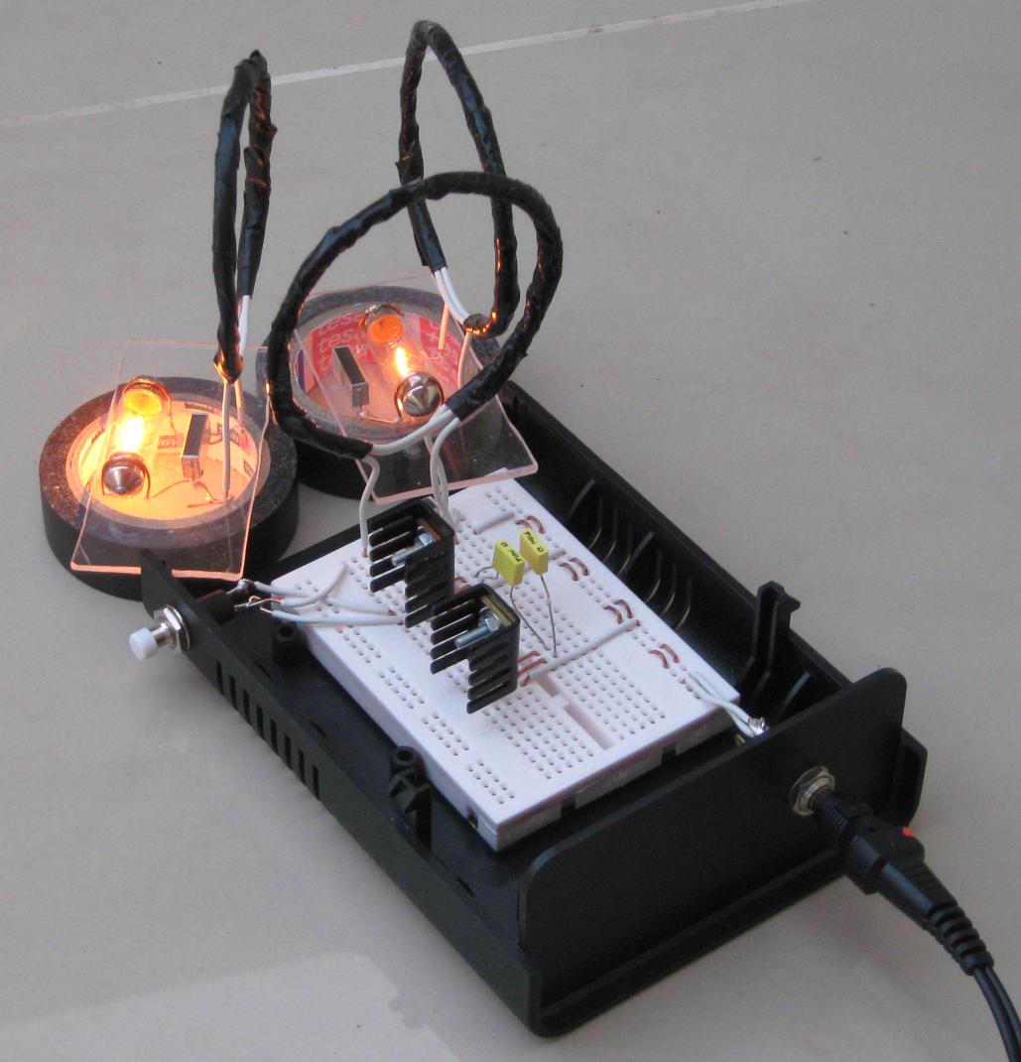

Fig.2.35. Operational oscillator powering multiple lamps.

# Conclusions

In this thesis, the method and means of effective wireless power for the purpose of powering biomedical implants has been described. The focus of this paper is on the description and experimental testing of power delivery for such an application area.

However, the method of power delivery is general and can be applied to other applications which require wireless power transfer on scales both large and small [28, 83].

Experimental results show that significant improvements in terms of power transfer efficiency are achieved by directly connecting the LC circuit to an amplifier circuit instead of excitation being achieved from an external sinusoidal source.

The measured results were found to be in very good agreement with the theoretical models obtained separately and match well with simulation results. Our next step clearly will need to involve tests involving actual biological tissue. Although, by analyzing results from previous comparable studies [73, 47], it is not anticipated that there will be any issues of significance, nevertheless such a study is a necessity before actual practical application of the procedure can go ahead in situ.

In tests it was found that the efficiency of the energy transfer system can be improved by increasing the quality factor, , of the coils. In this way the prototype power transfer system experimented with here achieves at least 4x more efficiency and power density in watts per centimeter, given its small size, compared to prior inductive-link schemes.

Reasons behind the improved results, as reported in this paper, in comparison with previous work are not particularly due to the antenna type or quality factor of the coils, as one might expect. Rather, we feel it is a property of the oscillator driving the system under resonance. In our design we have used a "magnetic" loop which has the advantage when its circumference is at a ratio of the driving frequency (quarter) wavelength. The oscillator frequency has then been set so the loop can be small and non-toxic in human presence. It is the manner of how the driving frequency is realized, how clean the oscillator in synchronizing voltage and current in phase, that determines the quality of the energy exhibited in the receiver.

As reported in the theoretical section, efficiency results of 91% in power transfer over a range of 2 cm between transmitter and receiver coils are extremely encouraging. Our next step is to extend the length of transmission to over 7 cm in ac mode by the addition of a secondary coil whose winding is equidistant on the plane. For biomedical implants this then starts to look at the possibility of remote wireless power provision, in which case the opportunity for multiple recipients also becomes relevant.

The conclusions are divided into the sections of the thesis.

*Circuit conclusions*

This section investigated the coupled modes and energy exchange properties between two distant circular loops. By considering the geometry of a magnetic field as radiation, it has extended the basic concepts to a definition of power broadcast between antenna forming a closed induction circuit. The extension brought into the model properties of modal-modes as an hypothetical explanation of highly-efficient wireless energy transmission by magnetic resonance.

If the loops are magnetic dipole antenna of a size relative to their quarter wavelength, adjustment along a descending  scale will yield maximum power dissipation in the free-space between the antenna. In such a manner, the extant electromagnetic field, charged by photons, creates a spherical shell whose boundary conditions interact intrinsically with the conductive properties of the medium. Because of such a high conductivity in the scheme, supported by the high efficiency, these results lead the author to hypothesize further that at the boundary, the conductive medium on quantum scales consists either of those of the gases consisting atmospheric air or some interface of unity in the notion of space-time itself.

The model, in its simplicity, provides that the energies which consist it can be expressly quantified. It is therefore of interest to explore what further extensions can be applied and what further insights can be gleaned. Although it is very interesting to understand the physicality of what consists a coupled magnetic resonant mode, contrastingly, what reactive phenomena are responsible for providing the sustaining counter-force giving it such a strong linear equilibrium. The author suggests further research needs to be conducted on what consists the structure of “empty space”.

Whilst the results presented are of interest in themselves, they also throw up a number of intriguing questions which need to be researched. For example, in terms of performance over distance, how important are the shape and directional settings of the windings and the amount of power drawn by the load with regard to the transmission efficiency? What remains consistent is that an improvement of quality leads directly to an improvement of performance not only at the distances shown in the figures, but also at greater distances, as expected.

Clearly the approach described here has enormous potential for wireless power transfer from a central transmitter base to remote receiver stations, without incurring the losses due to wire resistance and the inherent costs of building physical transmission lines. The added advantage is that mobile devices within that environment do not need to carry their own power cells but rather can pick up power wirelessly from the transmitting station.

With increased power transmitted over greater distances this method could potentially also be used as a power source for external vehicles, each merely needing to house its own receiver unit in order to pick up power from a distant station. Contrastingly, its small size could be exploited to make miniature devices receiving power and instructions. In all these ways discovering what medium-range and perhaps longer distances by repetition are achievable with this method of power transfer would be of great interest to developing societies and highly advanced technological paradigms. The utility of the scheme illustrated in this paper presents many possibilities for the future of efficient wireless energy transfer.

It is interesting to examine more exotic computational methods to model the electromagnetic problem, in a translation from circuit form to field form, other than the method of moments [[89]].

For the purposes of the thesis, the behavior that is interesting to the present discussion is that the n-MOSFET is a high-speed switch at a suitable level of power, that is, about 100 watts.

It allows the investigation of the properties of what it is coupled to as well as some masses contributed by the free-space, this is the most interesting take-away knowledge and the true fun of the process.

The relationship between the loops and the amount of energy transported between them is described by how coupled they are to each other. Magnetic loops of a relatively small size and number of turns exhibit a magnetic field density accordingly and are excellent models for study. This is the coupled-mode of the arrangement. What is interesting is that coupled-mode theory [10] suggests ways to improve the scheme. This is accomplished essentially by increasing the magnetic flux across the free-space between the loops. By increasing the amount of magnetization “tubes” within the coil loop, more energy is delivered at a longer distance. In simulating the geometry and establishing a base-line magnetic performance, secondary loops were added to test the hypothesis.

Discussion of the theory verses experiment: The experiment matches the theory. Here is a table showing the differences between the theory and the experiment.

Table showing differences.

Final words.

Thank you to the University of Reading for supporting me in this research and to Kevin Warwick for mentoring me not to stray too far from the straight path. Thanks to Dr. Holderbaum for a sobering reminder of reality from time to time.

## Comments on the subject matter

The configuration of the circuitry described for a prototype exhibited in the model is the *characteristic archetype* of all of the classes for wireless power transmission methodology. Nearly all other schemes of comparable methodologies can be derived from it.

A source is universal in that anything which emits energy is considered a source of non-sinusoidal power, such as a dc current and voltage source.

The unity of the potential in context with the field object is observable under measurement of an unpowered antenna and is extant at the nulls to the left and right minor lobes. It is assumed this is a loose measure of confirmation of the existence of a structure of free-space that will inevitably lead to a more detailed future description. Additional laboratory resources would be required, more than the basic equipment available a member of the public.

The movement of the oscillation through , in consideration the antenna is coupled to an open system, suggests implications on the impedance of free-space of . Since each phase moves through , a total of 60 cycles would sum up the impression of a single complex wave on free-space.

Comment: Leaving the .mat files in the directory as the only alteration, besides a new mesh, is an alteration in the feed point position and the number of feeding edges, one for dipole, two for monopole in rwg4.m. Most of the changes will be in reporting the observation of the radiation and pattern as a function of the field emission, more interesting as the circuit experiments clearly demonstrate a strong field between the transmitter and receiver and that the emission of photons can be blocked by placing a metal sheet between. Other non-metallic objects do not destructively interfere with the radiation,

Although quantum Hall effects are best exhibited in MOSFETs with gallium arsenide GaAs channels, considered the “holy grail” in semiconductor research, the oscillator discussed in this thesis might be exhibiting some of these properties. It is suggested access to the quantized Hall states is accessible through the n-MOSFET architecture which are being manipulated on the antenna interface.

The author hypothesizes an oscillatory reaction force permeates the waveguide.

How does the increase in magnetic potential translate into observing higher performance?

## Future research

Future research could be very interesting to study:

1. It is interesting to carry out the Aharonov-Bohm experiments, and flavors of subsequent attempts to see if the problem can be modeled on larger scales, as , and at higher temperatures.
2. Detailed AB.
3. Metamaterials: The metamaterial concept has captured the imagination of a significant and growing pool of researchers from a wide range of fields, with the move toward practical applications perhaps most evident in the area of antennas and wireless propagation. The idea of using collections of sub-wavelength elements in a structured medium of three dimensions (volumetric metamaterials), two dimensions (meta-surfaces) and even one dimension (meta-wires) provides unprecedented control over medium properties. These mediums can have exotic properties, previously inaccessible, or common properties with uncommon control over spatial variation, polarization sensitivity and frequency dispersion. This expansion of the available parameter space of mediums has spurred engineers to reevaluate existing performance trade-offs and propose new devices. The impact on antennas and propagation includes: high impedance ground planes, engineered reflectance, matching and bandwidth enhancement, multiple-antenna interference reduction, compact resonators, transparent media and low aberration (high gain) refractive elements. In addition, resonator designs initially created for metamaterials have often been used singly or in small groups, as their characteristics became well understood and were found to be favorable. Analysis techniques, numerical methods and experimental characterization methods developed in metamaterial research have also migrated to engineering work not strictly incorporating metamaterials. We will welcome articles discussing such metamaterial-inspired designs and analysis.

# Appendix

How to handle computer files?

This work has described the principle of wireless energy transmission by magnetic resonance.

### Large figures and tables

Table 3.2‑1. Values of factor [29].

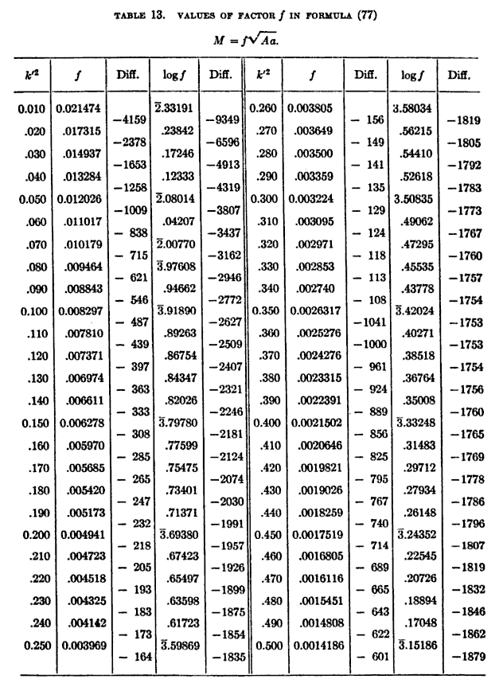

The variable names have been changed for consistency in the text. The names which are changed,

affecting Table 3.2‑1, are: 

Fig.4.1. Effect on the simulated output based on changing the value of the coupling coefficient : (a) , (b) , (c) , (d) .

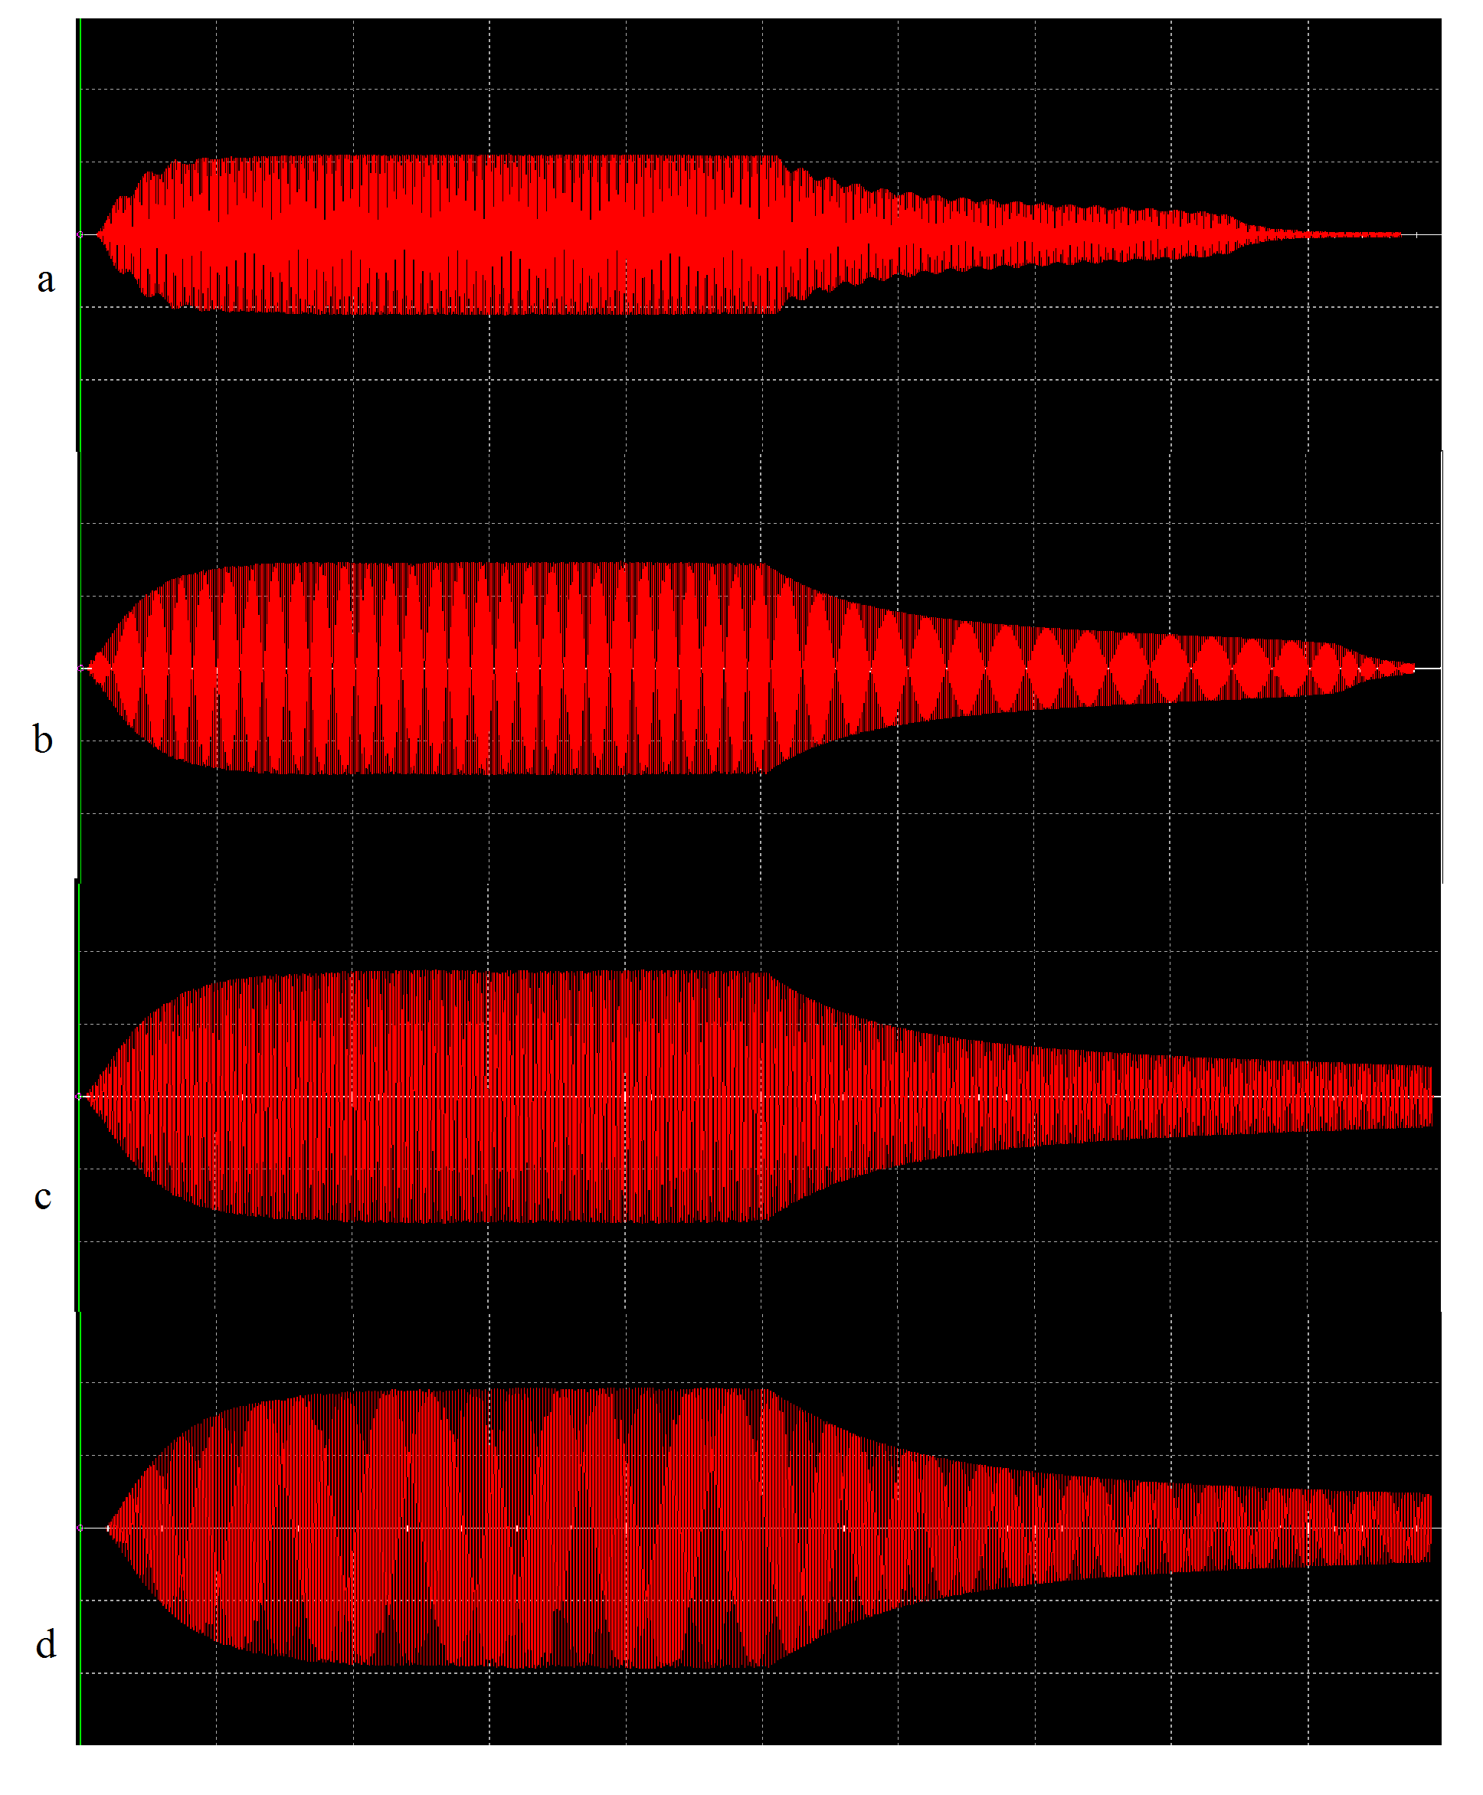

### RWG computational files

Here are the code files used during the computation of the antenna.

Table 3.2‑2. Instructions to create an antenna file.

Instructions to create an antenna file structure.

1. Open Matlab, type pdetool,

2. Click Options/Axes Equal,

3. Draw any ellipse, double-click on its surface,

a. Set X-center to 0,

b. Set Y-center to 0,

c. Set A-semiaxes to 3 (for a radius of 3 units),

d. Set B-semiaxes to 3 (for a radius of 3 units),

4. Draw a second ellipse, double-click on its surface,

a. Set X-center to 0,

b. Set Y-center to 0,

c. Set A-semiaxes to 2.75 (for a wire thickness of 0.25 units),

d. Set B-semiaxes to 2.75 (for a wire thickness of 0.25 units),

5. Set formula E1-E2,

6. Click Mesh/Parameters...

a. Set Maximum edge size to Inf,

7. Initialize the mesh,

8. Refine the mesh,

a. Refining the mesh twice, check triangle quality by clicking Mesh/Triangle quality,

9. The average quality should be 0.5 across the surface for an ideal mesh,

10. Save the file,

11. Export the mesh by clicking Mesh/Export Mesh,

a. Leave the variable names for mesh data (points, edges, triangles) p e t,

b. The Workspace now contains the data,

12. The array of boundary edges e is not needed,

a. type p(3,:)=0;

13. Save the compiled mat file,

a. Save filename p t

14. The antenna structure file has been created.

The meshes can be used in the Matlab scripts, run in order listed in Table 2.3‑1.

### A short discussion of a dipole model

The lag of the current is an important feature which is directly captured in this type of oscillator; the dipole which is created on the plate sending out the potential before power. The dipole is created on the plate.

A magnetic dipole is the limit of either a closed loop of electric current or a pair of poles as the dimensions of the source are reduced to zero while keeping the magnetic moment constant. It is a magnetic analogue of the electric dipole, but the analogy is not complete. In particular, a magnetic monopole, the magnetic analogue of an electric charge, has never been observed. Moreover, one form of magnetic dipole moment is associated with a fundamental quantum property, the spin of elementary particles. The magnetic field around any magnetic source looks increasingly like the field of a magnetic dipole as the distance from the source increases. A new analogy will be introduced in this section based upon *combining* the particle and wave attributes of the separation of charges [14, 43, 90]. The attention on this detail is due to a quandary of the electron having a magnetic dipole moment; that the electron’s magnetic moment is not due to a current loop, but is instead an intrinsic property of the electron [[90], [91]]. Conversely, the electron has not been observed to have an electric dipole moment [[92]].

It is orthodoxy in electrical engineering and a basic tenet of physics, that work is done in electrical systems by the separation of charges and energy is released when those same charges come back together, or an oscillation takes place along a line of trajectory.

Conservation laws dictate that the work done to separate charges is equal to the energy which is observed. While this understanding is convenient to finding solutions in “common” problems and has shown itself to be a rather useful tool as such [SOURCES], in itself, it is a hollow concept [SOURCES], not fully coming to terms with phenomenon often witnessed as a property of free-space [SOURCES].

Although several writers have espoused there is something “missing” in the inventory of matter and energized particles in free-space [SOURCES], insisting there is more to glean from the architecture of matter, how they have gone about verifying their claims is lacking. This is primarily due to the fact that most of these experiments approach the problem in exactly the wrong way. If it is logical to accept the concept of the dipole as well as the manner in which it comes to terms, one must assume that space-time and its curvature, in the Minkowski sense, is not uniform—in that the presence of charges relative to their polarized opposites do not exist analogous to points on a grid. While this assumption is not wholly surprising, the crux is: how often are particles of opposite electrical magnitude localized enough so that the force performing the work does not have to “reach” so far as to construct the dipole infeasible? A facetious answer would obviously be derived from probability and statistics but does not yield a proper explanation since the abstractions consisting such an argument are completely arbitrary. Therefore, there is but one possible explanation remaining: that the charges exist as a *property* of free-space. As a multi-dimensional manifold [SOURCE], free-space and the matter lying within it do not lie on a flat plane [SOURCE], rather, consist of layers upon layers [SOURCES].

Under such conditions, charges would “bubble” up, not unlike an effervescent depiction, to avail themselves to have work conducted upon them. Such an analogue would allow the “selection” of charges of equal magnitude yet opposite charge and polarization from the plethora wherein a force could be applied to separate (groups) of them [SOURCE]. They are still random in the statistical sense and would be drawn into the scheme by simple forces of attraction and repulsion.

In classical physics, the magnetic field of a dipole is calculated as the limit of either a current loop or a pair of charges as the source shrinks to a point while keeping the magnetic moment **m** constant. For the current loop, this limit is most easily derived for the vector potential. Outside of the source region, this potential is [[93]]:



and the magnetic flux density is



Given  is the direction of travel of the wave. It is more relevant to talk of the magnetic field in terms of , because of the interest in examining the potential. The scalar potential from the magnetic pole limit is



therefore, the magnetic field strength is



The magnetic field is symmetric under rotations about the axis of the magnetic moment **m**.

This section will discuss how it is applied to the image of a dipole, shown in Fig.4.2. This section will introduce the term “manifold” to describe the contiguous set of particles and energies lying in Minkowski space that produce radiant energies.

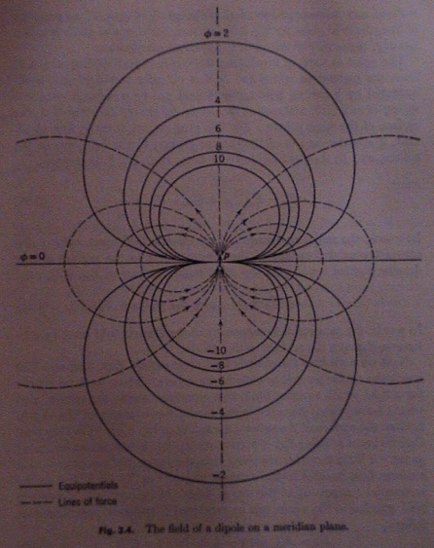

Fig.4.2. A common description of a dipole.

Fig.4.2 shows a point-charge emitting a field into free-space, illustrating the axial and lateral emission of energy: electrical for an electric point-charge, magnetic for a magnetic point-charge. While the pattern of the field emission is uniform over the axes of propagation, the depiction implies the point-charge is not moving. Since the Hertzian antenna is a dipole through the *separation of charges*, the dipole description is modified. The generalization implied in the illustration allows a further suggestion of the energetic state of a point-charge, shown in Fig.4.4. Since it is due to the conservation of energy and Gauss’ law that the length of propagation varies proportionally to the magnitude of the emission and that the length cannot extend forever, it is relevant to point out there is a formal boundary to the fields in both the axial and lateral directions. It is also relevant to consider that the energy moving toward the boundary does not necessarily disperse from the point-charge, if it is the assumption that the point-charge only *contains* energy. Because if it did, the point-charge would be exhausted after a given time. Since it does not exhaust, illustrated by the fact that electrical circuits still function, its internal modulation—or the frequency by which the energy shifts between moving toward and away from the boundary—is the attribute defining its state. Otherwise an unseen force is applying energy to the point-charge sustaining its state [SOURCES].

A modified description of the dipole…

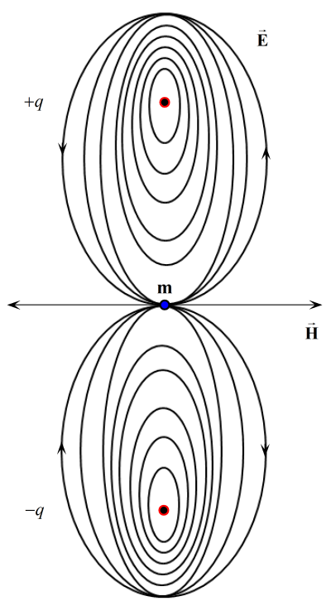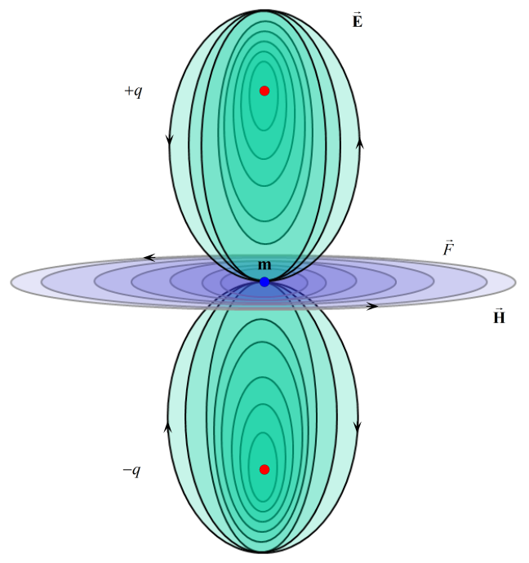

Fig.4.3. (a) Point-charges and the wake pattern of forces, (b) emitting a magnetic shearing force concentrated at the magnetic moment m.

Fig.4.3 Point-charges showing the wake pattern lines of attraction at the magnetic moment m and the depiction of a magnetic “shearing” force analogous to the Lorentz forces. Forces between the point charges…

Define the dipole description as per the antenna to be used in the oscillator.

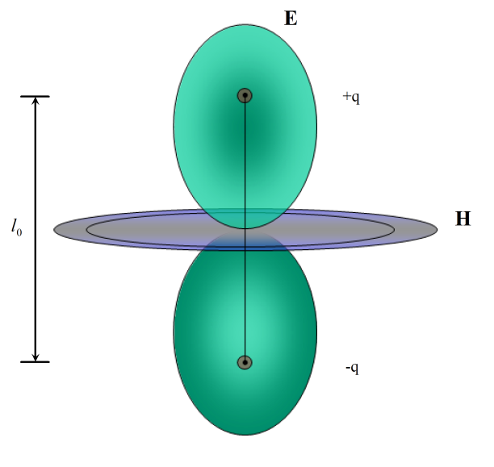

Fig.4.4. Wave-particle duality dipole.(needs arcs)

The separation of charges, the rippling of the charges, because of the forces of separation, the wake causes the elliptical feature of the effect of point charges on free-space. The energy from the wake is expressed at right-angles as the magnetic field.

It is a foundation of this concept of the dipole that energy is exchanged between it and other vectorial components in space-time [SOURCE]. Greater energies in higher concentrations act to influence other dipoles not unlike gravitational forces between celestial bodies [SOURCE]. As such, the architecture of the electrical particles is defined by absorptions and reflections of energy, in the form of electromagnetic photons. Therefore, point-charges on the manifold *define each other by the exchange of photons*, otherwise, they would be inert and unseen, or considered to be as a void.

Turning the description on its head (inverting the description of the dipole)…

The definition of objects on the manifold and how they exchange energy gives rise to the electromagnetic spectrum [SOURCE]. Here in this thesis, the result of the arguments thus provided, the electromagnetic spectrum is defined through two dominant processes: point-charges by photon reflection, point-charges derived by refraction.





On each spatial and temporal surface, a photon is represented as a packet of energy moving with a constant magnitude and direction, given its potential. The point where the photon changes direction by a factor of reflection or refraction indicates a radial point of accumulated energy by its shift in direction. This radial point is a point-charge because of the interchange of forces between the moving photon and the (nearly) stationary point-charge, which typically would be an electron. The radial motion of field creates a vacuous location on the point. For the purposes of this discussion and to simply the expression, the angle, , of the change of trajectory, or trajectory field, is only significant to the emission of fields described earlier in this section. The

In a one-dimensional system, the lowest dimension embedded in the manifold, the feature of this projection is the first member of the rule-set of the manifold. The first member assigned establishes the rule-set for the higher dimensions. By adding a second spatial vector, a second mass point, and a trajectory field, we have the relationship illustrated in Fig.4.3.

Fig.4.3 illustrates the resulting field exchange between the two point charges and a quantized component of energy traveling in the positive x-direction between the points. The repulsive forces between the points are balanced by the attractive forces folded in the motion of the passing energy creating equilibrium in the system. Since the system simply either reflects or refracts the passing magnitude of energy, there is no field interaction between the points. Because of this, the intersection of the attractive/repulsive fields with the magnitude of the passing vector results in a combinatorial point called a virtual point. This is also known as a sink, not unlike the point where energy enters and exits the arrangement.

The scenario illustrated in Fig.4.3 implies a simple interaction between these points inherent in the two-dimensional system. Because this model only considers static quantities, there is neither the exchange of frequencies nor resonance between the mass and virtual points. But if the system were to intersect with a stream of particles pulsed at a lower frequency, near the core frequency of the mass points, it would trigger a reaction in the following manner.

The interaction of the stream of particles with the radiated field will result in a graduated ellipsoidal field similar but smaller in magnitude to the original mass points. Instead of a static quantity, the momentum of the particle stream creates an elliptical area on the manifold where the relationship between the two mass points, the virtual and the passing field, are in resonance in regard to each other, creating a more dense form on the manifold. Some passing particles are temporarily trapped in the sink and orbit the central axis of the field along the x and y-axes. The radius of the field and the equilibrium of the system is dependent on the magnitude of energy stored as a resonance between all locations. This quotient of energy is trapped in the sink as long as the system remains stable in terms of its geometry and the resonance patterns can hold it together.

Since magnetic charges have not been observed, it is reasonable to assume this model is a suitable description. A magnetic dipole is the limit of either a closed loop of electric current or a pair of poles as the dimensions of the source are reduced to zero while keeping the magnetic moment constant. It is a magnetic analogue of the electric dipole, but the analogy is not complete. In particular, a magnetic monopole, the magnetic analogue of an electric charge, has never been observed. Moreover, one form of magnetic dipole moment is associated with a fundamental quantum property, the spin of elementary particles.

The application of force to separate the charges by the application of current, the current lags behind the voltage potential, the point charges are both particles and waves [[94]].

What this model ultimately does is contextualize energy not only of the particle but of its context to free-space. The assumption is introduced that there is a medium…

Write the modified math based on the interpretation of the magnetic dipole as an electric dipole analogue.

Not a series of short dipoles, rather, a chaining of polarization propagating the waveform (rise and fall of current from one polarity to the other) across the free space, with a given radiation resistance.

A solution to the modified interpretation of the dipole

Revised circuit:

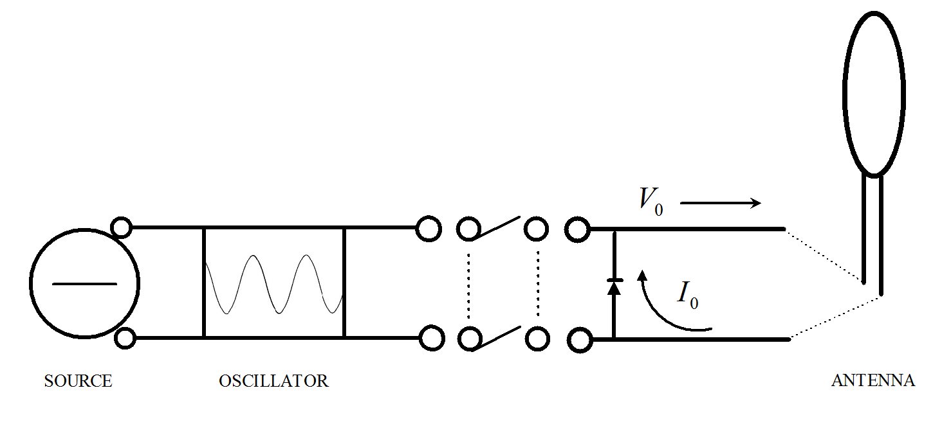

Fig.4.5. The revised circuit to reduce destruction cycles of the dipole and understand the potential field.

Words.

*The quarter wavelength*

An electrically short antenna, connected to a source of power, its characteristic impedance is trivial and the load’s impedance dominates the circuit, which is desirable for sending power over distances; i.e., the power is induced to traverse the free-space between the transmitter and receiver to the load at the receiver, where the impedance is located.

Typically, small loop antennas have a poor efficiency unless they are constructed at a ratio of their circumference to the wavelength of the transmission frequency. Considering , for further size reduction, the loop can also have similar power transmission efficiency if the ratio is also one-thousandth relative to the quarter wavelength with the circumference. It is suggested it would also be effective at one-ten thousandth given the scaling series progression



Applied to the physical antenna model, the antenna characteristics are truncated a quarter wave antenna, as , the experimental setup of the antenna is that it is mounted perpendicular to the earth and not connected to a ground plane. The ground plane is ignored and fed back into the amplifier synchronizing the phase with the impedance of the antenna. This allows the inductance of the antenna, coupled is series with its capacitor, to act as a resonator “floating” above ground, fully oriented in the impedance of free-space.

# Literature survey

Publications in support of this thesis:

C. Tucker, “Magnetic Resonant Modes in a Wireless-Powered Circuit,” *19th Telecommunications forum TELFOR*, pp.977-80, Nov. 2011.

C. Tucker, K. Warwick, and W. Holderbaum, “Efficient Wireless Power Delivery for Biomedical Implants,” *IET Wireless Sensor Systems,*  Vol. 2, Iss. 2, pp.132-140, Apr. 2012.

A survey of literature that served this thesis:

1. [] G. Reber, *Endless, Boundless, Stable Universe,* University of Tasmania, Tasmania, 1977.
2. [] B. Hunt, *The Maxwellians,* Cornell University Press, New York, 2005.
3. [] F. Warburton*,* “Displacement Current, A Useless Concept,” *American Journal of Physics*, Vol. 22, Iss. 5, pp.299-305, Oct. 1954.
4. [] W. Rosser, “Displacement current and Maxwell’s equations,” *American Journal of Physics*, Vol. 43, Iss. 6, pp.807-8, Jun. 1975.
5. The final disengagement of “vacuum” from real media occurred with the international agreement to use the material-unrelated terms *electric constant* and *magnetic constant* to replace the seemingly material-related terms *permittivity* of vacuum and *permeability* of vacuum. These constants have *defined* (not measured) values that refer to free space, which is viewed as an unattainable idealization; not as a real, observable medium, not equivalent even to a quantum vacuum.
6. [] P. Nahin, *Oliver Heaviside: The Life, Work, and Times of an Electrical Genius of the Victorian Age*, Johns Hopkins University Press, Maryland, 2002.
7. [] V. Stepin, *Theoretical Knowledge*, Springer, New York, 2002.
8. [] J.H. Poynting, “On the Transfer of Energy in the Electromagnetic Field,” Phil. Trans. 175, pp.343-61, 1884.
9. [] A. Kurs, *Power Transfer Through Strongly Coupled Resonances*, Masters of Science thesis, MIT, Sep. 2007.
10. [] K. Kodaira, *Complex Manifolds and Deformation of Complex Structures*, New York, Springer, New York, pp. 28-59, 1981.
11. [] R. Pfeifer, T. Nieminen, N. Heckenberf, and H. Rubinsztein-Dunlop, “Momentum of an electromagnetic wave in dielectric media,” *Reviews of Modern Physics*, Vol. 79, pp.1197-1216, Oct. 2007.
12. [] N. Tesla, “Experiments With Alternate Currents of High Potential and High Frequency,” IEE Address, London, February 3, 1892, contained in *Inventions, Researches and Writings of Nikola Tesla*, D. van Nostrand Company, New York , pp.186-91, 1894.
13. [] N. Tesla, *Apparatus for the Utilization of Radiant Energy*, U.S. Patent No. 685,957, Filed 21 May 1901, Awarded 5 Nov. 1901.
14. [] H. Yagi, “Beam transmission of ultra-short waves,” *Proceedings of the Institute of Radio Engineers*, Vol. 16, Iss. 6, pp.715-40, 1928.
15. [] E. Siering-Stumpf, “Shortwave DX Handbook: Your gateway to worldwide DXing,” Darc-Verlag, Berlin, 2005.
16. [] W. Teich and W.C. Brown, “Design of CW amplitrons for space-borne telemetry applications,” *IEEE Transactions on Electron Devices*, Vol. 10, Iss. 2, p. 108, 1963.
17. [] W. Brown, “Experiments involving a microwave beam to power and position a helicopter,” *IEEE Transactions on Aerospace and Electronic Systems*, Vol. AES-5, Iss. 5, pp.692-702, 1969.
18. [] J. Schuder, “Energy transfer into a closed chest by means of stationary coupling coils and a portable high-power oscillator,” *American Society for Artificial Internal Organs*, Vol. 7, pp.327-31, 1961.
19. [] M. Soma, D. Galbraith, and R. White, “Transmission of time varying magnetic field through body tissue,” *Journal of Biological Physics*, Vol. 3, pp.95-102, Jun. 1975.
20. [] R. Fano, L. Chu, and R. Alder, *Electromagnetic Fields, Energy, and Forces*, John Wiley & Sons, New York, 1963.
21. [] G. Fitzgerald, “The Ether and the Earth's Atmosphere,” *Science*, Vol. 12, Iss. 328, pp.390, May 1889.
22. [] H. Haus and W. Huang, “Coupled-mode theory,” *Proceedings of the IEEE*, Vol. 79, No. 10, pp.1505-18, Oct. 1991.
23. [] S. Schelkunoff, “General Telegraphist’s Equations,” *The Bell System Technical Journal*, Vol. 111, p.784-801, Jul. 1952.
24. [] R. Alder, L. Chu, and R. Fano. *Electromagnetic Energy Transmission and Radiation*, John Wiley & Sons, Inc., Cambridge, 1969.
25. [] S. Ilić, M.T. Perić, S.R. Aleksić, and N.B. Raičvić, “Quasi TEM analysis of symmetrical coupled strip line using new hybrid boundary element method,” *19th Telecommunications forum TELFOR*, pp.1008-11, Nov. 2011.
26. [] S. Manić, S. Savić, M. Ilić, and B. Notaroš. “Combining finite element method and Fourier transform to analyze waveguide transients,” *19th Telecommunications forum TELFOR*, pp.1004-7, Nov. 2011.
27. # [] Y. Aharonov and D. Bohm, “Significance of Electromagnetic Potentials in the Quantum Theory,” *Phys. Rev.*, Vol. 115, Iss. 3, Aug. 1959.

   
28. [] J. Kraus, *Antennas, 3rd Edition*, McGraw-Hill, Boston, 2001.
29. [] A. Karalis, J. Joannopoulos and M. Soljačić, “Efficient wireless non-radiative mid-range energy transfer,” *Annals of Physics*, Vol. 323, pp.34-48, Apr. 2008.
30. [] F. Grover, *Inductance calculations: Working formulas and tables*, New York, D. van Nostrand Company, 1946.
31. [] R. Elliott, *Electromagnetics*. New York, IEEE Press, 1993.
32. [] M. Soma, D. Galbraith, and R. White, “Transmission of time varying magnetic field through body tissue,” *Journal of Biological Physics*, Vol. 3, pp.95-102, Jun. 1975.
33. [] F. Neumann, “Allgemeine Gesetze der inducirten elektrischen Ströme,” *Abhandlungen der Königlichen Akademie der Wissenschaften zu Berlin,* 1845.
34. [] L. Hannakam, “Berechnung der Gegeninduktivitat achsenparalleler Zylinderspulen,” *Archivfiir Elektrotechnik,* Vol. 51, No. 3, pp.141-54, 1967.
35. [] I. Awai, Y. Zhang, T. Komori, and T. Ishizaki, “Coupling coefficient of spiral resonators used for wireless power transfer,” *Proceedings of Asia-Pacific Microwave Conference*, pp.1328-31, Dec. 2010.
36. [] I. Awai and Y. Zhang, “Separation of coupling coefficient between resonators into electric and magnetic contributions toward its application to BDF development,” *China-Japan Joint Microwave Conference*, pp.61-5, Sep. 2008.
37. [] V. Christianto and F. Smarandache, “A Note on Computer Solution of Wireless Energy Transmit via Magnetic Resonance,” *Progress in Physics*, Vol. 1, Jan. 2008.
38. [] H. Lorentz, “Attempt of a theory of electrical and optical phenomena in moving bodies,” *E.J. Brill*, Leiden, The Netherlands, 1895.
39. [] H. Lorentz, “Electromagnetic phenomena in a system moving with any velocity smaller than that of light,” *Procedures of Academic Science Amsterdam*, Vol. 1, pp.427-43, 1904.
40. [] H. Poincaré, “On the dynamics of the electron,” *Weekly reports of meetings of the Academy of Sciences*, Vol. 140, pp.1504-8, 1905.
41. [] J. Larmor, “On a dynamical theory of the electric and luminiferous medium, part 3, relations with material media,” *Philosophical Transactions of the Royal Society*, Vol. 190, 205-300.
42. [] H. Schey, *Div Grad Curl and all that: An informal text on vector calculus*, W.W. Norton & Company, 1997.
43. [] J. Roche, “The present status of Maxwell’s displacement current,” *Eur. J. Phys.*, Vol. 19, pp.155-66, 1998.
44. [] L. de Broglie, “Researches on the quantum theory,” *Annuals of Physics*, Vol. 3, No. 22, 1924.
45. [] Y. Couder and E. Fort, “Single-particle diffraction and interference at a macroscopic scale,” *Physical Review Letters*, Vol. 97, Iss. 15, Oct. 2006.
46. [] E. Post. “Interferometric path-length changes due to motion,” *Journal of the Optical Society of America*, Vol. 62, Iss. 2, pp.234-9, 1972.
47. [] T. Barrett. *Topological Foundations of Electromagnetism.* World Scientific Publishing Company. 2008.
48. [] E. Hochmair, “System optimization for improved accuracy in transcutaneous signal and power transmission,” *IEEE Transactions on Biomedical Engineering,* vol. 31, pp. 177-186, Feb. 1984.
49. [] C. Zierhofer, “Geometric Approach for Coupling Enhancement of Magnetically Coupled Coils,” *IEEE Transactions on Biomedical Engineering*, Vol. 43, No. 7, Jul. 1996.
50. [] K. Corum and J. Corum, ”RF Coils, Helical Resonators and Voltage Magnification by Coherent Spatial Modes”, *IEEE Microwave Review*, Vol. 7, No. 2, pp. 36-45, 2001.
51. [] E. Armstrong, “Operating Features of the Audion,” *Annals of the New York Academy of Sciences,* Vol. 27, No. 1, pp.215–43, Aug. 1917.
52. [] J. Hoag, *Basic Radio: The Essentials of Electron Tubes and their Circuits*, New York, D. Van Nostrand Company, 1942.
53. [] N. Malik, *Electronic circuits: analysis, simulation, and design*, Prentice Hall, New Jersey, pp.315–6, 1995.
54. [] A. Kurs, A. Karalis, R. Moffatt, J. Joannopoulos, P. Fisher, and M. Soljačic, “Wireless Power Transfer via Strongly Coupled Magnetic Resonances,” *Science*, Vol. 317, pp.83-86, Jul. 2007.
55. [] S. Makarov, “MoM antenna simulators with Matlab: RWG basis functions,” *IEEE Antennas and Propagation Magazine*, Vol. 43, pp.100-7, Oct. 2001.
56. [] S. Rao, D. Wilton, and A. Glisson, “Electromagnetic scattering by surfaces of arbitrary shape,” *IEEE Transactions on Antennas and Propagation*, Vol. 30, No. 3, pp.409-18, May 1982.
57. [] D. Sarkar, *Vector basis function solution of Maxwell’s equations*, Ph.D. dissertation, Rice University, TX, USA, May 1997.
58. [] B. Braaten, R. Nelson, and M. Mohammad, “Electric field integral equations for electromagnetic scattering problems with electrically small and electrically large regions,” *IEEE Transactions on Antennas and Propagation*, Vol. 56, Iss. 1, pp.142-50, Jan. 2008.
59. [] A. Peterson, S. Ray, and R. Mittra, *Computational Methods for Electromagnetics*, IEEE Press, Piscataway, NJ, 1998.
60. [] J. Shin, *Modeling of arbitrary composite objects with applications to dielectric resonator antennas*, Ph.D. dissertation, The University of Mississippi, MS, USA, Aug. 2001.
61. [] S. Makarov, *Antenna and EM modeling with Matlab*, Wiley-Interscience, 2002.
62. [] R. Paul, *Electrical fields and simple circuits*, 3rd Edition, Springer-Verlag, Berlin, 1993.
63. [] A. García, J. Carrasco, J. Soto, F. Maganto, and C. Morón, “A method for calculating the magnetic field produced by a coil of any shape,” *Physical Sensors and Actuators A*, Vol. 91, Iss. 2, pp.230-2, 2001.
64. [] R. Smith-Rose and H. Hopkins, “The application of ultra-short-wave direction finding to radio sounding balloons,” *Proceedings of the Physical Society*, Vol. 58, No. 2, Mar. 1946.
65. [] A. Pantelopoulos and N. Bourbakis, “A survey on wearable sensor-based systems for health monitoring and prognosis,” *IEEE Transactions on Systems, Man, and Cybernetics,* Vol. 40, Iss .1, pp.1-12, Jan. 2010.
66. [] K. Warwick, M. Gasson, B. Hutt, I. Goodhew, P. Kyberd, B. Andrews, P. Teddy, and A. Shad, “The Application of Implant Technology for Cybernetic Systems,” *Basic Science Seminars in Neurology*, Vol. 60, No. 10, pp.1369-73, Oct. 2003.
67. [] N. Neihart and R. Harrison, “Micropower circuits for bidirectional wireless telemetry in neural recording applications,” *IEEE Transactions on Biomedical Engineering*, Vol. 52, pp.1950–59, Nov. 2005.
68. [] M. Ghovanloo and K. Najafi, “A wireless implantable multichannel microstimulating system-on-a-chip with modular architecture,” *IEEE Transactions on Neural Systems and Rehabilitation Engineering*, Vol. 15, pp.449–57, Sep. 2007.
69. [] K. Warwick, M. Gasson, B. Hutt, I. Goodhew, P. Kyberd, H. Schulzrinne, and X. Wu, “Thought Communication and Control: A First Step Using Radiotelegraphy,” *IEEE Proceedings on Communications*, Vol. 151, Iss. 3, pp.185-9, Jun. 2004.
70. [] M. Gasson, B. Hutt, I. Goodhew, P. Kyberd, and K. Warwick, “Invasive Neural Prosthesis for Neural Signal Detection and Nerve Stimulation,” *International Journal of Adaptive Control and Signal Processing*, Vol. 19, Iss. 5, pp.365-75, Jun. 2005.
71. [] P. Limousin, P. Krack, P. Pollak, A. Benazzouz, C. Ardouin, D. Hoffmann, and A-L. Benabid,“Electrical Stimulation of the Subthalamic Nucleus in Advanced Parkinson's Disease,”*New England Journal of Medicine*, Vol. 339, pp.1105-11, [Oct. 1998](http://www.nejm.org/toc/nejm/339/16/).
72. [] E. Romero, R. Warrington, and M. Neuman, “Energy scavenging sources for biomedical sensors,” *Physiological Measurement*, Vol. 30, pp.R35-R62, 2009.
73. [] M. Baker and R. Sarpeshkar, “Feedback analysis and design of RF power links for low-power bionic systems,” *IEEE Transactions on Biomedical Circuits and Systems*, Vol. 1, pp.28–38, Mar. 2007.
74. [] A. RamRakhyani, S. Mirabbasi, and M. Chiao. “Design and Optimization of Resonance-Based Efficient Wireless Power Delivery Systems for Biomedical Implants,” *IEEE Transactions on Biomedical Circuits and Systems*, Vol. 5, No. 1, Feb. 2011.
75. [] J. Gao, “Inductive power transmission for untethered micro-robots,” *IEEE Industrial Electronics Society Conference*, pp.6–11, Nov. 2005.
76. [] T. Deyle and M. Reynolds, “Surface Based Wireless Power Transmission and Bidirectional Communication for Autonomous Robot Swarms,” *IEEE International Conference on Robotics and Automation*, pp.1036-41, May 2008.
77. [] Z. Low, R. Chinga, R. Tseng, and J. Lin, “Design and test of high-power high-efficiency loosely coupled planar wireless power transfer system,” *IEEE Transactions on Industrial Electronics*, Vol. 56, No. 5, May 2009.
78. [] J. Mur-Miranda, G. Fanti, Y. Feng, K. Omanakuttan, R. Ongie, A. Setjoadi, and N. Sharpe, “Wireless power transfer using weakly coupled magnetostatic resonators,” *IEEE Energy Conversion Congress and Exposition*, pp.4179-86, Sep. 2010.
79. [] K. O’Brien, G. Scheible, and H. Gueldner, “Magnetic Field Generation in an Inductively Coupled Radio-Frequency Power Transmission System,” *IEEE Power Electronics Specialists Conference*, pp.1-7, Jun. 2006.
80. [] K. Corum and J. Corum, ”RF Coils, Helical Resonators and Voltage Magnification by Coherent Spatial Modes,” *Telecommunications in Modern Satellite, Cable and Broadcasting Service*, Vol. 1, pp.339-48, Sep. 2001.
81. [] B. Cannon, J. Hoburg, D. Stancil, and S. Goldstein, “Magnetic Resonant Coupling as a Potential Means for Wireless Power Transfer to Multiple Small Receivers,” *IEEE Transactions on Power Electronics*, Vol. 24, No. 7, Jul. 2009.
82. [] L. Wu, Z. Yang, E. Basham, and W. Liu, “An efficient wireless power link for high voltage retinal implant,” *IEEE Biomedical Circuits and Systems Conference*, pp. 101-4, Nov. 2008.
83. [] L. Rindorf, L. Lading, and O. Breinbjerg, “Resonantly coupled antennas for passive sensors,” in *Proc. IEEE Sensors*, pp. 1611–1614, Oct. 26-29 2008.
84. [] J. Shipley. *Incorporating Wireless Power Transfer in an LED Lighting Application*, Master’s Thesis, Brigham Young University, Utah, Aug. 2006.
85. [] N. Hemche and A. Jaafari, “Wireless transmission of power using a PCB transformer with mobile secondary,” *IEEE Electrotechnical Conference*, pp.629-34, May 2008.
86. [] S. Barker, D. Brennan, N.G. Wright, and A.B. Horsfall, “Piezoelectric-powered wireless sensor system with regenerative transmit mode,” *IET Wireless Sensor Systems*, Vol. 1, Iss. 1, pp.31-8, Mar. 2011.
87. [] N. Timmons and W. Scanlon, “Improving the ultra-low power performance of IEEE 802.15.6 by adaptive synchronization,” *IET Wireless Sensor Systems*, Vol. 1, Iss. 3, pp.161-70, Apr. 2011.
88. [] C. Sauer, M. Stanacevic, G. Cauwenberghs and N. Thakor, “Power harvesting and telemetry in CMOS for implanted devices,” *IEEE Transactions on Circuits and Systems*, Vol. 52, Iss. 12, pp.2605-13, Dec. 2005.
89. [] H. Haus, *Waves and Fields in Optoelectronics*, Prentice-Hall, New Jersey, 1984.
90. [] D. Griffiths, *Introduction to Quantum Mechanics*, Prentice Hall, Boston, 1994.
91. [] D. Bohm, *Quantum Mechanics*, New Jersey, Prentice-Hall, 1951.
92. [] R. Stutz, *Towards measuring the electron electric dipole moment using trapped molecular ions,* Ph.D. thesis, University of Colorado, 2010.
93. [] T. Chow, *Introduction to electromagnetic theory: a modern perspective*, New York: Jones & Bartlett Publishers, 2006.
94. [] M. Abid, B. Andreotti, S. Douady and C. Nore, “Oscillating structures in a stretched-compressed vortex,”  *Journal of Fluid Mechanics*, 450*,* pp.207-13, May 2001.